EMPLOYMENT CONTRACT

Employer: Han-Yang University Continuing Education Center
Address: 17 Haengdang-Dong, Seoungdong-Gu Seoul, 133-791, Korea.

Employee:
Name of Employee:
Nationality:
Passport Number:

The above-referenced two parties agree on the following terms and conditions of employment contract.

Han-Yang University will recruit the following instructors as follows:

Qualifications as an English instructor at English Camp:
1) A four-year university degree or higher.
(English and Education majors or those with TESOL certificates are preferred.)
2) A native from an English-speaking country.
(U.S.A / Canada / U.K / Australia / New Zealand, etc)
3) Valid Passport
4) Applicants must be enthusiastic, patient, adaptive, responsible individuals who love children.

Terms of Employment

- Status of Employment
Employee shall be hired pursuant to this Contract as an English Teacher.

- Term of Employment
The Term of Employment shall be a period of 4 weeks: According to school schedules, orientation day can be changeable.
1) It shall commence on July 26th, 2010 and end on August 21, 2010
2) Teacher should attend orientation which commences on July 23, 2010

- Employee's Duties
The following policies have been established to assist the employee in the expected performance of his/her duties:
- During the employment, the Employee shall follow the class schedule and school policies of English Camp
- The Employer shall request the resignation of employee if the employee is found to be guilty of misconduct in the execution of his/her teaching duties. If this misconduct results in any negative impact upon the class, employer shall be free from any legal responsibility. However, prior written notice is required to ensure that employee is given adequate opportunity to correct his/her misconduct.
- Employee is required to participate in all staff meetings, opening and closing ceremonies, and outdoor activities during the camp as requested by employer.
- Employee has to have lunch with his/her students.
- Employee is required to make the mid-term and final test.
- Completing a final academic report for each student in teaching and homeroom class.
- Employee should be punctual and flexible.
- Employee is responsible for the performance of his/her own class.
- Smoking is banned in public areas and in front of students.
- Drinking alcohol is strictly forbidden on camp premises. If employee breaks this rule, a half days pay will be deducted from employee’s salary.
- Employee shall prepare adequate teaching materials for each class beforehand and will be honest and diligent in teaching students in all classes. Employee shall teach 7 hours a day. Class time will last for approximately 5 hours, 2 hours for Special classes, plus some additional duties for outdoor activities. Employee will participate in extracurricular activities with students.

Schedule (Sample) –Class subjects could be changeable.

Junior & Junior High
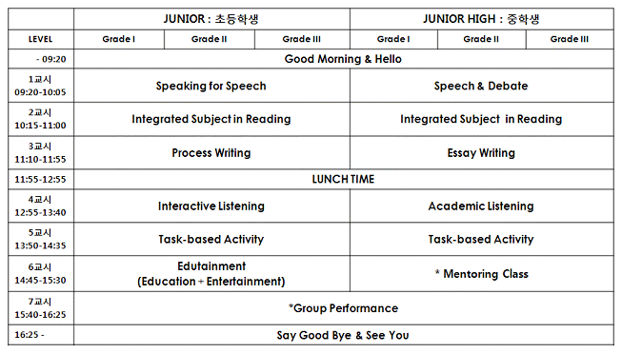

- Employee can be photographed at any time during class and camp activities for parents’ information on the English camp website.
- Employee will work from Monday to Saturday for classroom teaching and office hours. However, Employee shall be reasonably available to the students at all hours to assist with academic, extracurricular, and personal guidance particularly related to their collective life at school.
- Employee shall follow the school policy including Korean traditional values, national identity and leadership spirit, and shall be a role model for the students.

- Salary
- Employee shall be paid the total amount of 2.7 Million Korean won 4weeks. There are no more additional payments. Salary is based on actual classroom teaching hours. Employee is not paid extra for lesson plan preparation, daily marking, individual student report preparation, submission and special events etc.
- All costs incurred in obtaining the visa will be the sole responsibility of employee.
- Text book and teaching materials will be provided. (After camp, the employee must return to them.)
- Lunch will be provided by the school for the duration of the contract. Employee must have lunch with the students.
- Employee shall not claim, against Employer, any compensation and/or payment other than those provided for in this Contract.
- Any absence from a job due to illness must be supported by a doctor’s or university manager note. If unable to present a doctor’s or manager’s note, he/she will be penalized 30% from the salary.
- Shared accommodation near school for the duration of the contract. Employee will be provided bed, washing machine and all utilities except for long-distance phone calls.
- School do not cover teacher’s airfare

- Codes of Conduct
- Employee shall not behave in any manner, which may damage or tarnish the reputation of the teaching profession.
- Employee shall not engage in any other job (including a part-time job) during the Term of Employment.
- Employee shall not be involved with any activities, which may cause harm to the students or be of detrimental to the reputation of the school.
- Employee shall wear appropriate clothing while working on the campus
- Employee shall conduct himself/herself in a professional and courteous manner at all times.
- Employee shouldn’t show offensive behavior towards students and staff.
- Accommodation must to be clean and in good condition.
- No disturbing neighbors or other teachers by noise, such as loud music and etc.
- The teacher must be ready and on time for class and job.
- The teacher must follow additional rules of conduct determined necessary by university manager.

- Termination of the Contract

Employer may terminate or cancel this Contract upon occurrence of any one of the following events:
- If Employee violates the laws of the Republic of Korea.
- If Employee fails to perform or unsatisfactorily perform any of the duties stipulated in this contract.
- If Employee fails to perform continuously his/her duties for more than a week without any excuses.
- If at any occasion the instructor terminates the contract at his/her own will before it is over, there will be a reasonable deduction in salary in regards to lodging and wages.
- If any of the information provided in Employee’s application is neither true nor accurate.
- If it is determined that Employee is prevented from or incapable of performing his/her duties for medical reasons, whether it is a physical or psychological ailment. (If requested by Employer, Employee must be immediately available for a medical examination.)
- If any part of the above terms and conditions are breached or violated by the employee, employment will be terminated. The employee shall pay any damages incurred by such breaches to the employer.

- Indemnity
Employees shall indemnify for and keep Employer harmless from any liability or damages arising from or in relation to any negligent, intentional or illegal activity of Employee during the Term of Employment under this Contract.

- Governing Laws, and Venue
- The terms of this Contract and the rights and obligations of the parties hereto shall be construed, interpreted and determined in accordance with the laws of the Republic of Korea.
- If a dispute or disagreement arises in connection with or out of this Contract, the parties hereto shall first try to resolve it in accordance with a principle of good faith. However, if the parties fail to mutually resolve such disputes or disagreements or come to amicable settlements, their disputes or disagreements shall be finally resolved by arbitration in Seoul, Korea in accordance with the Commercial Arbitration Rules of the Korean Commercial Arbitration Board.

9. Signature
In witness hereof the employer and employee have agreed upon the stipulations above as of the date of this contract.

The proposed employer and employee agree to sign this contract.

Date: _________________

Teacher’s Name Signature: _____________________

Employer’s Signature : ____________________

