Avalon English-The Best Franchise English School in Korea,
Company Introduction
Avalon English
English camp positions for Native teachers! Starting from the end of Jul to Aug-APPLY NOW!

With our prestigious education Know-how and highly developed corporate culture, we educate students to be globally elite who can outreach to the world stage.
Avalon designs beyond English
Our result for sending the most students to distinguished specialized middle schools and high schools throughout the nation, people called Avalon “The Myth”. However, we are not interested in becoming No.1 in the market, but based on our prestigious education philosophy, we open up the world stage for young minds and build blocks to be a reputable and world class elite education corporation.

At Avalon, Faculty members are pleased
We sincerely believe that ‘humanity’ is the most important keyword for what we do.
Without our pleased teachers, we can’t satisfy our customers. That is why we are with over 100 branches and 50,000 students.
* Website www.avalon.co.kr (Brand website)
www.avalon21.co.kr (Corporate website)
www.avalonglobe.com (Int'l business website)

* Major Accomplishments
ISO9001:2000 certification
MAINBIZ-certified by the Small and Medium Business Administration Korea Education Industry Grand Prize(Korea Daily)–2006,2007,2008,2009
Korea Consumer Confidence Grand Prix(Korea Economic Daily)-2006~7

A Reputable and Global Investment Corporation AIG has admitted Avalon Education
- According to the AIG Investment, Avalon meets its best in the market for Company Philosophy, Education Contents and Methodology
- USD 60 mil investment from AIG, which is the highest investment ever in English Education market history in Korea

Job Description

First, we will hold two camps from July 28th, 2010 to August 22th, 2010.
Each camp’s schedule varies slightly. Please check the specific daily schedule listed below.
The other conditions are the same.

Classification | Details
No. of Teachers | 5 teachers
Pay | KRW 4,000,000 Won (Including round-trip air fare)
Location | Chung Ju – ChungCheongbuk do [1 hour from Seoul by bus]
Student | Kindergarten ~ Middle school
No. of students | Around 7-12 students
Duration | July 28th, 2010 ~ August 24th, 2010(2 days of orientation, 23 working days, 3 days off)  [Camp will be finished by Aug.22. We Provide Korean tour during the vacation days]
Orientation session | July 28th to 29th, 2010  - Must take the orientation sessions.  - You can’t sign the contract unless you agree that you will attend the orientation
Working Hours | Every day from 9 am to 8:30 pm  - Field Trip : Aug 2nd, 14th, 18th [only for those who want to go]  - No work on Aug. 7th  - Specific camp schedule is listed below
More details | * Meals, Transportation, Korean city tour 2 times, Field Trip 3 Times, Gym  * Accommodation: 2 teachers will share a room[2 beds in a room]  * Curriculum and schedule are all set.  * We prefer female teachers from U.S or Canada

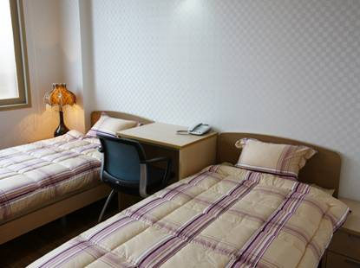
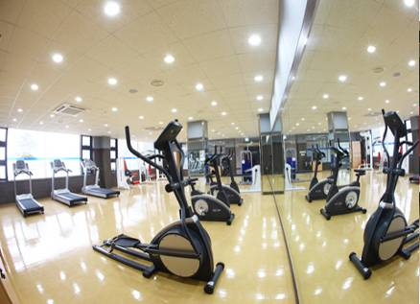
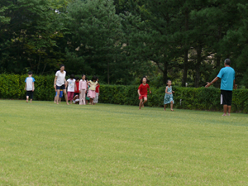
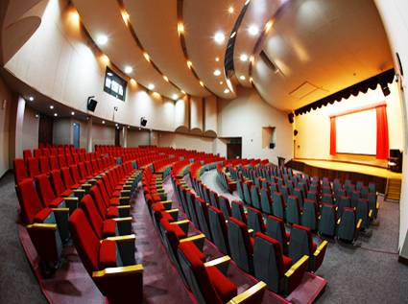
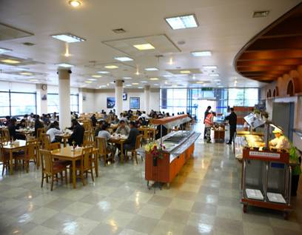
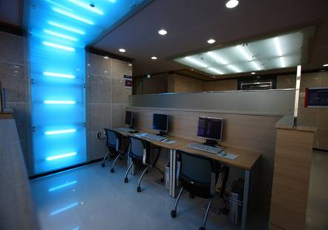
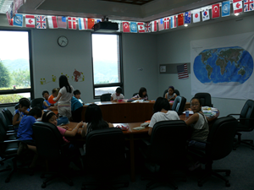
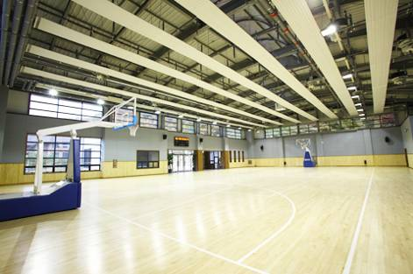
Facilities [website: http://edu.cgbest.co.kr]

REQUIREMENTS
- 4 year degree (B.A)
- must have quality experiences in teaching
- Love for kids is a must
- E-2, F-2 VISA holder

-If you are interested in this position, forward your formal resume with a recent photo of yourself to avalon.jp@gmail.com (reference letter from current employer (if possible))
Specific Camp schedule
**Native teachers are in charge of the time in the red box **

1st Camp [July 30th, 2010 ~ August 6th, 2010]
 | 7/28,29 | 7/30 | 7/31 | 8/1 | 8/2 | 8/3 | 8/4 | 8/5 | 8/6
 | Wed,Thu | Fri | Sat | Sun | Mon | Tue | Wed | Thu | Fri
7:30~8:00 | OT  &  Training | Prepare  to  meet  students | Wash up
8:00~8:50 | OT  &  Training | Prepare  to  meet  students | Breakfast
9:00~10:00 | OT  &  Training | Prepare  to  meet  students | Language Art  / Flying Pen |  | Rest | Language Art  / Flying Pen |  |  | Closing ceremony
10:00~10:50 | OT  &  Training | Prepare  to  meet  students |  |  | Field  Trip |  |  |  | Closing ceremony
11:00~11:50
12:00~13:00 | OT  &  Training | Lunch |  |  | Field  Trip | Lunch
13:00~14:00 | OT  &  Training | Opening | Presentation  /Debate |  | Field  Trip | Presentation  /Debate
14:10~15:00 | OT  &  Training | Interview | Western  School | Western  School | Field  Trip | Western  School | C.G Shop | Memory  Board
15:10~16:00 | OT  &  Training | Ice Break
 |  |  |  |  |  |  | Global  Festival | C.G Shop
16:10~17:00 | OT  &  Training | Fun  English | CG  Water  Park | CG  Water  Park | Field  Trip | CG  Water  Park | Global  Festival | Make-up
17:10~18:00 |  |  |  |  | Rest | CG  Water  Park | Global  Festival | Prom  Night
18:00~19:00 | OT  &  Training | Dinner Time |  |  |  |  | Global  Festival | Prom  Night
19:00~20:20 | OT  &  Training | Class AD | CG Town |  | Movie | CG Town |  | Prom  Night
20:30~22:30 | OT  &  Training | Self study/English Diary/Homework
22:30~ | OT  &  Training | Clean up, Roll call, Lights out
 | 8/8 | 8/9 | 8/10 | 8/11 | 8/12 | 8/13 | 8/14 | 8/15
 | Sun | Mon | Tue | Wed | Thu | Fri | Sat | Sun
7:30~8:00 | Prepare  to  meet  students | Wash up / Morning Mission
8:00~8:50 | Prepare  to  meet  students | Breakfast
9:00~09:50 | Prepare  to  meet  students | Presentation |  |  |  |  | rest | Presentation
10:00~10:50 | Prepare  to  meet  students | Language Art |  |  |  |  | Field  Trip | Language  Art
11:00~11:50
11:50~13:00 | Lunch |  |  |  |  |  | Field  Trip | Lunch
13:00~13:50 | Opening | Debate |  |  |  |  | Field  Trip | Social
14:00~14:50 | interview | Science | Social | Science | Social | Science | Field  Trip | Social
15:00~15:50 | Ice Break |  |  |  |  |  |  | Club  Activity
16:00~16:50 | Fun English | Splish! Splash!  (Aqua Activity) | Avalon  village | Global  Festival | Splish! Splash!  (Aqua Activity) | Avalon  village | Movie  Night | Club  Activity
17:00~17:50 |  |  |  |  |  |  |  | Avalon  Shop
17:50~19:00 | Dinner Time |  |  | Global  Festival | Dinner Time
19:00~20:20 | Speech Study
20:30~21:30 | English Diary, Snack Time
21:30~22:00 | 1:1 counseling
22:00~22:30 | Clean up, Wash up
22:30 | Roll call

2nd Camp [August 8th, 2010 ~ August 22th, 2010]
 | 8/16 | 8/17 | 8/18 | 8/19 | 8/20 | 8/21 | 8/22
 | Mon | Tue | Wed | Thu | Fri | Sat | Sun
7:30~8:00 | Wash up / Morning Mission
8:00~8:50 | Breakfast
9:00~09:50 | Presentation |  | rest | Presentation |  |  | Closing  Ceremony
10:00~10:50 | Language Art |  | Field  Trip | Language Art
11:00~11:50
11:50~13:00 | Lunch |  | Field  Trip | Lunch
13:00~13:50 | Debate |  | Field  Trip | Debate
14:00~14:50 | Science | Social | Field  Trip | Science | Social | Treasure  Hunt
15:00~15:50
16:00~16:50 | Splish! Splash!  (Aqua Activity) | Club Activity | Movie  night | Splish! Splash!  (Aqua Activity) | Splish! Splash!  (Aqua Activity) | Year Book
17:00~17:50 |  |  |  |  |  | Avalon  Shop
17:50~19:00 | Dinner Time |  |  |  |  | Prom  Night
19:00~20:20 | Speech Study |  |  |  |  | Prom  Night
20:30~21:30 | English Diary, Snack Time |  |  |  |  | Prom  Night
21:30~22:00 | 1:1 counseling |  |  |  |  | Packing Up
22:00~22:30 | Clean up, Wash up
22:30 | Roll call
22:30~23:30 | Self Study(Optional)

