Boran Moon | Mobile: 010–5671-8589  Email: belovedbug@hanmail.net  Date of Birth: 07 April 1977  *Objective  Seeking a challenging yet rewarding position as an interpreter
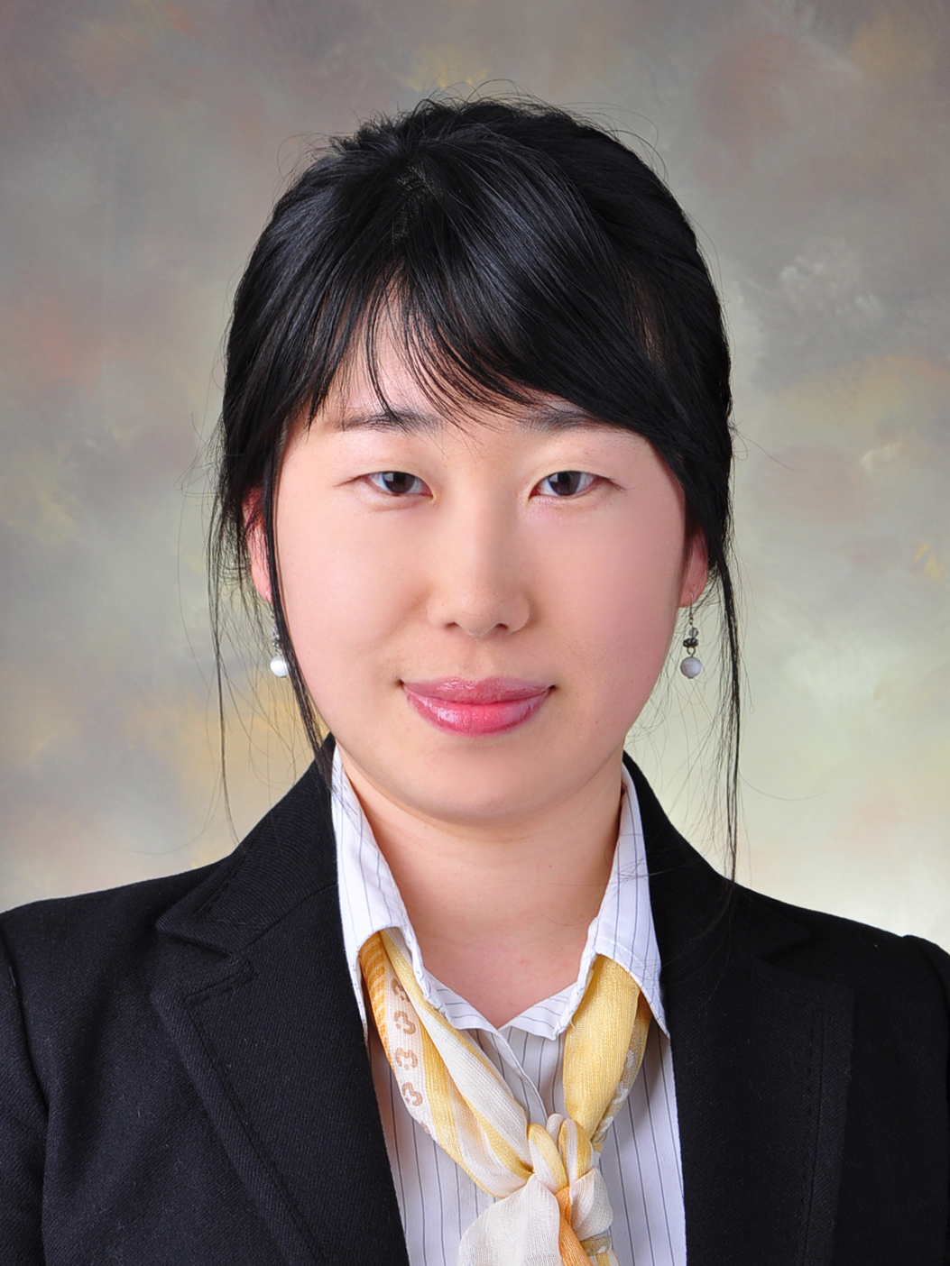

Highlights of Skills
• Fluent in both Korean and English
• Simultaneous, Consecutive and Whispering Interpretation and translation skills
• Three years of ESL teaching experience

EXPERIENCE
• May~Jul 2009: Developed Textbooks & Curriculums for overseas internship programs, taught Business English: Hanbit Education Center
• April 2009: Whispering & Consecutive interpretation for Executive meetings, Marketing report translation: Graco/Aprica (U.S. Manufacturing Company)
• Jan~April 2009: Translated Brochure, Financial Statements, Auditor’s Report, Project Outlines, Official letters, Directors’ meeting scripts, History of KAS, President’s Speech: the Korea-Arab Society
• Oct 2008: Consecutive Interpretation/ Receptionist: Seoul History Museum Seminar
• Aug 2008: Consecutive Interpretation, Writing Summary of the Conference: UN Global Compact meeting
• July 2008: Translated Official Letters, Telephone Interpretation, Slides Translation: East Timor Peace Project
• Jan~April 2009: Transcribed and edited English interviews with International Artists and Ambassadors: EBS the World Today
• 2003~2006: Bilingual English Teacher: Direct English Korea, Pagoda academy INC
• 2000~2002: Assistant Technician: Dr. Borden's Research Laboratory, SFU Biology Faculty
• 1997~2000: Customer Service/ Sales Assistant: Beaver Foods Ltd

Education
• Ewha Woman’s University, Seoul, Korea M.A., in Interpretation, February 2009
• Simon Fraser University, Burnaby, Canada
B.Sc., Environmental Science, June 2002
• Attended Special Lectures on Financial Statement, IFRS and the Capital Market Consolidation Act at Ewha Uni., Feb 2009

