Dr. Leticia Gerardina Patino, J.D.
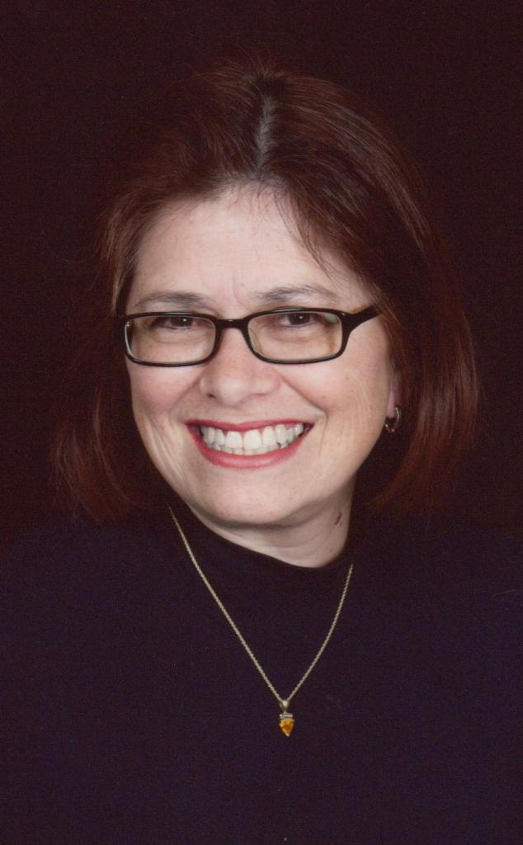
Lotte Castle Gold Park 1504/1503, Hwanggeum-Dong, Susong-Gu, Daegu-Si, South Korea / Phone: 010 2410 5220
Date of Birth: June 17, 1953 / Nationality: American

EDUCATION:
- TEFL BUSINESS CERTIFICATE April 2008
- TEFL CERTIFICATE (100 hours/20 units: Final exam available upon request.] January 2008
- TEFL DIPLOMA: IN PROGRESS (250 hours/tutor supported) EXPECTED 2008
- DOCTORATE: CATHOLIC UNIVERSITY OF AMERICA, Washington, D.C. J.D., 1981.
- BACHELORS IN EDUCATION: ST. JOHN’s OF CLEVELAND, Ohio B.S.Ed., 1975.
- CERTIFIED MEDIATOR: The city of Dallas, Texas and the State of Ohio 1999 & 2005

(May 2007-May 2008) ESL TEACHER, Gyeongsan Office of Education/ Gyeongsan English Town, South Korea.
ESL Teacher for Elementary, Middle School, High School, and Adult classes.

(October 2006- May 2007) ELS TEACHER, YBM, Daegu, South Korea.
ESL Teacher for Conversation, Business, and Screen English, and Writing to Adults and University Students.

(July 2006- October 2006) ESL TEACHER, Zenith Preschool, Daegu, South Korea.
ESL Teacher for children ages 3 to 8 years of age without assistance from a Korean teacher.

(2003-2006) ADJUNCT PROFESSOR, Tiffin University and ATTORNEY (PRIVATE PRACTICE) Tiffin, Ohio.
Professor of Law to University Students. LITIGATOR/MEDIATOR: Courtroom, Business Law and Lobbying.

(1998-2002) EXECUTIVE DIRECTOR, Casa Dallas Housing Center, Dallas, Texas. Developer: Built homes.
Teacher to Adults: Conducted Housing Seminars and Qualified homebuyers for mortgage loans.

(1989-1997) STAFF ATTORNEY, Bazelon Center, Washington, D.C. (1993-97) / ABLE, Toledo, Ohio (1989-93).
Teacher/Presenter/National Speaker at National Conferences on EDUCATION and EDUCATIONAL STANDARDS and Children issues. Developed federal and state policy regarding U.S. EDUCATIONAL Standards.
Teacher to Adults and Police about Domestic Violence and Children Issues.

(1982-88) ATTORNEY (Solo practitioner) and EXECUTIVE DIRECTOR, Ohio Commission SSA, Ohio.
Teacher for and conducted seminars for local Executive Directors (Adults) on issues and Business Management.
Teacher/Presenter/National Speaker on Education and Social Services before federal and state legislative committees and regulatory agencies. As Attorney, handled cases in the areas of Education, Family, and Children.

(1981-1982) LEGISLATIVE AIDE, House EDUCATION Committee, Ohio House of Representatives.

(1978 -1980) Legislative Intern, U.S. Congress, Washington, D.C..
Wrote laws and legislation on EDUCATION, public laws, administrative proceedings, tax policies and funding of EDUCATION formulas. Wrote the law on the 1982 Ohio EDUCATION Financing of School Districts.

(1977-78) TEACHER/SUPERVISOR OF PRIMARY GRADES, Pretty Eagle School, Crow Indian Reservation, Montana.
Supervising Teacher for Primary Grade Teachers and Aides. Modernized the curriculum for the primary grades. Taught reading to grades 1-4. Teacher for Adult teachers and aides in the use and creation of learning centers.

(1975-1977) ELEMENTARY SCHOOL TEACHER, St. Francis School, Cleveland, Ohio.
Began and taught an all day Kindergarten. Developed the curriculum. Supervised Aides and volunteers.
References:

Name | English Name | Occupation | Relationship | Phone Number | Email Address
James Benoit | James | Supervisor- YBM English Institute | My previous boss | 537414752  (Someone will answer in Korean but just ask for James. They will understand you.) | daeguas@ybmsisa.com
Lee Jaelk | Jack | English Teacher | He attended YBM while I was there & we have worked together | 1050912557 | none
Judy VanBruggen | Judy | Visiting Professors  Kyungpook National University | Taught together at YBM | 534254942  Or  1068704942 | jvanbruggenster@gmail.com
George  VanBruggen | George
BokHee (pronunciation: Bach He) | None | Housewife (3 children) | Parent of two of my past students | 185199966 | none
Cho Yunjeong | June | Piano teacher | Close friend – Personal reference | 167540540 | ddollykr@yahoo  .co.kr

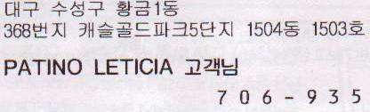
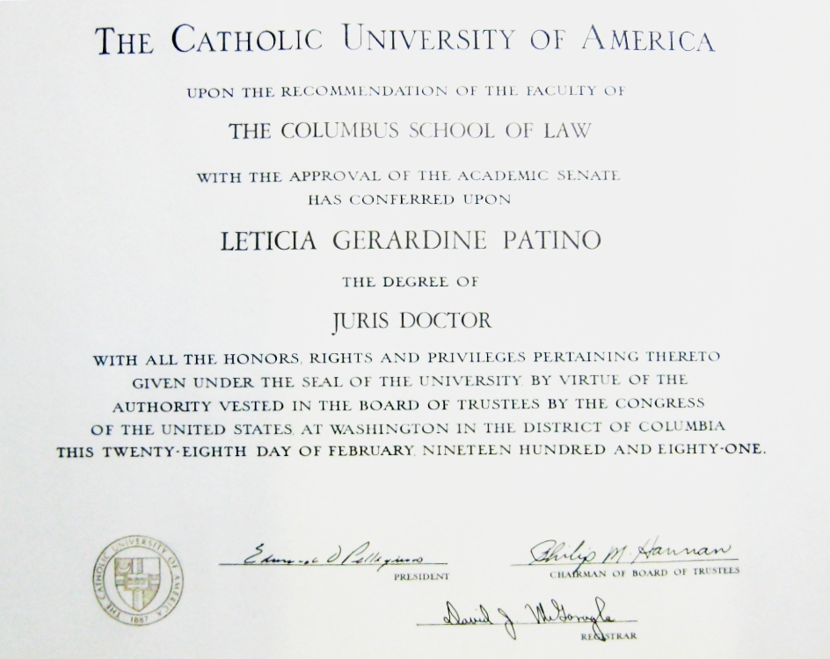
My home address:

