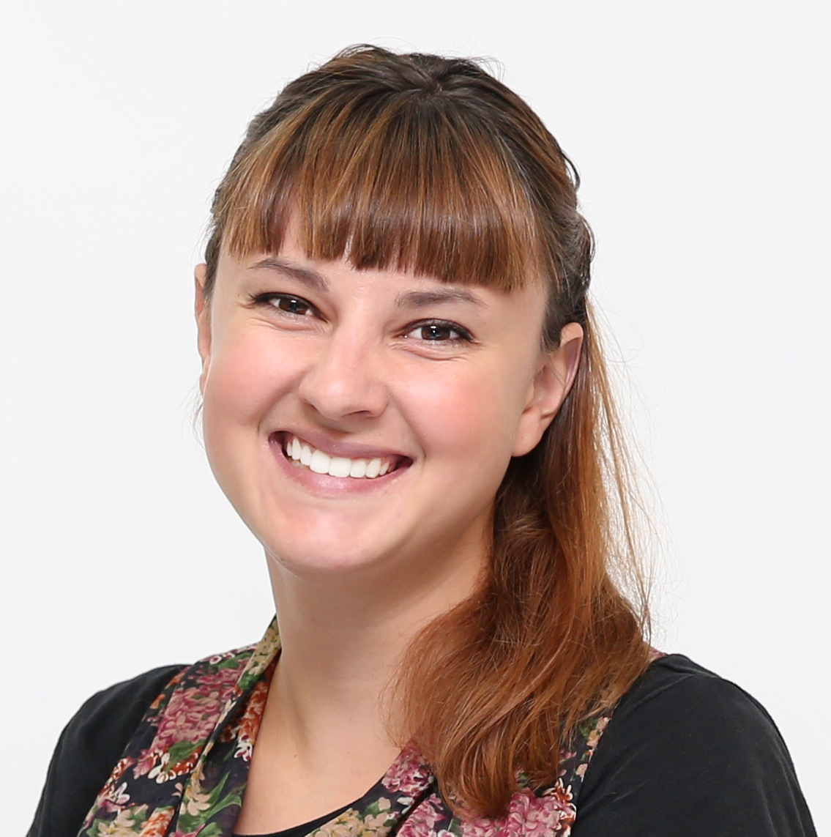

(010) 3011-3248 • kirstenmauro123@gmail.com
UI-Wang Si Gyeonggi Do South Korea Kirsten Mauro
objective
To attain employment an English instructor within Korea in an
environment which allows me to utilize my past teaching
experience, while still allowing me to adapt and acquire new
teaching methods.
Education
University of California San Diego
- Attained a B.A. in Communications with a Minor in International Studies
- Graduated in Spring of 2012
Fullerton College Study Abroad
- Lived and studied Spanish in Madrid, Spain in the Spring of 2010
Orange Coast College
- Attained A.A. degree in Fall 2010 in Liberal Studies
- President’s List Fall 2007
- Maintained 3.6 GPA
Employment
July 2012-November 2013
Avalon English Champ Elementary Campus
English Instructor
- Teaching children Speaking, Writing and Reading courses
- Adapting to different learning styles and shaping the material to cater to children’s needs
- Creating a theme class for advanced students accompanied with supplemental material

August 2012-September 2012
The Keunsaem School For North Korean Refugees
- Tutoring North Korean refugees from ages 4-40
- Preparing activities and unique material for students of different ages and comprehension
- Representing American culture and embedding Western customs into my lesson plans

January 2012-April 2012
La Clase Magica
After School Volunteer
- Assist children with homework while providing a fun environment where they feel comfortable and encourages
- Write and Research theories about bilingualism and standards of English in society
- Apply concepts of communication and learning acquired in my Communication as Media Methods course
Skills
- TEFL certified
- Worked with children in babysitting and afterschool environment

