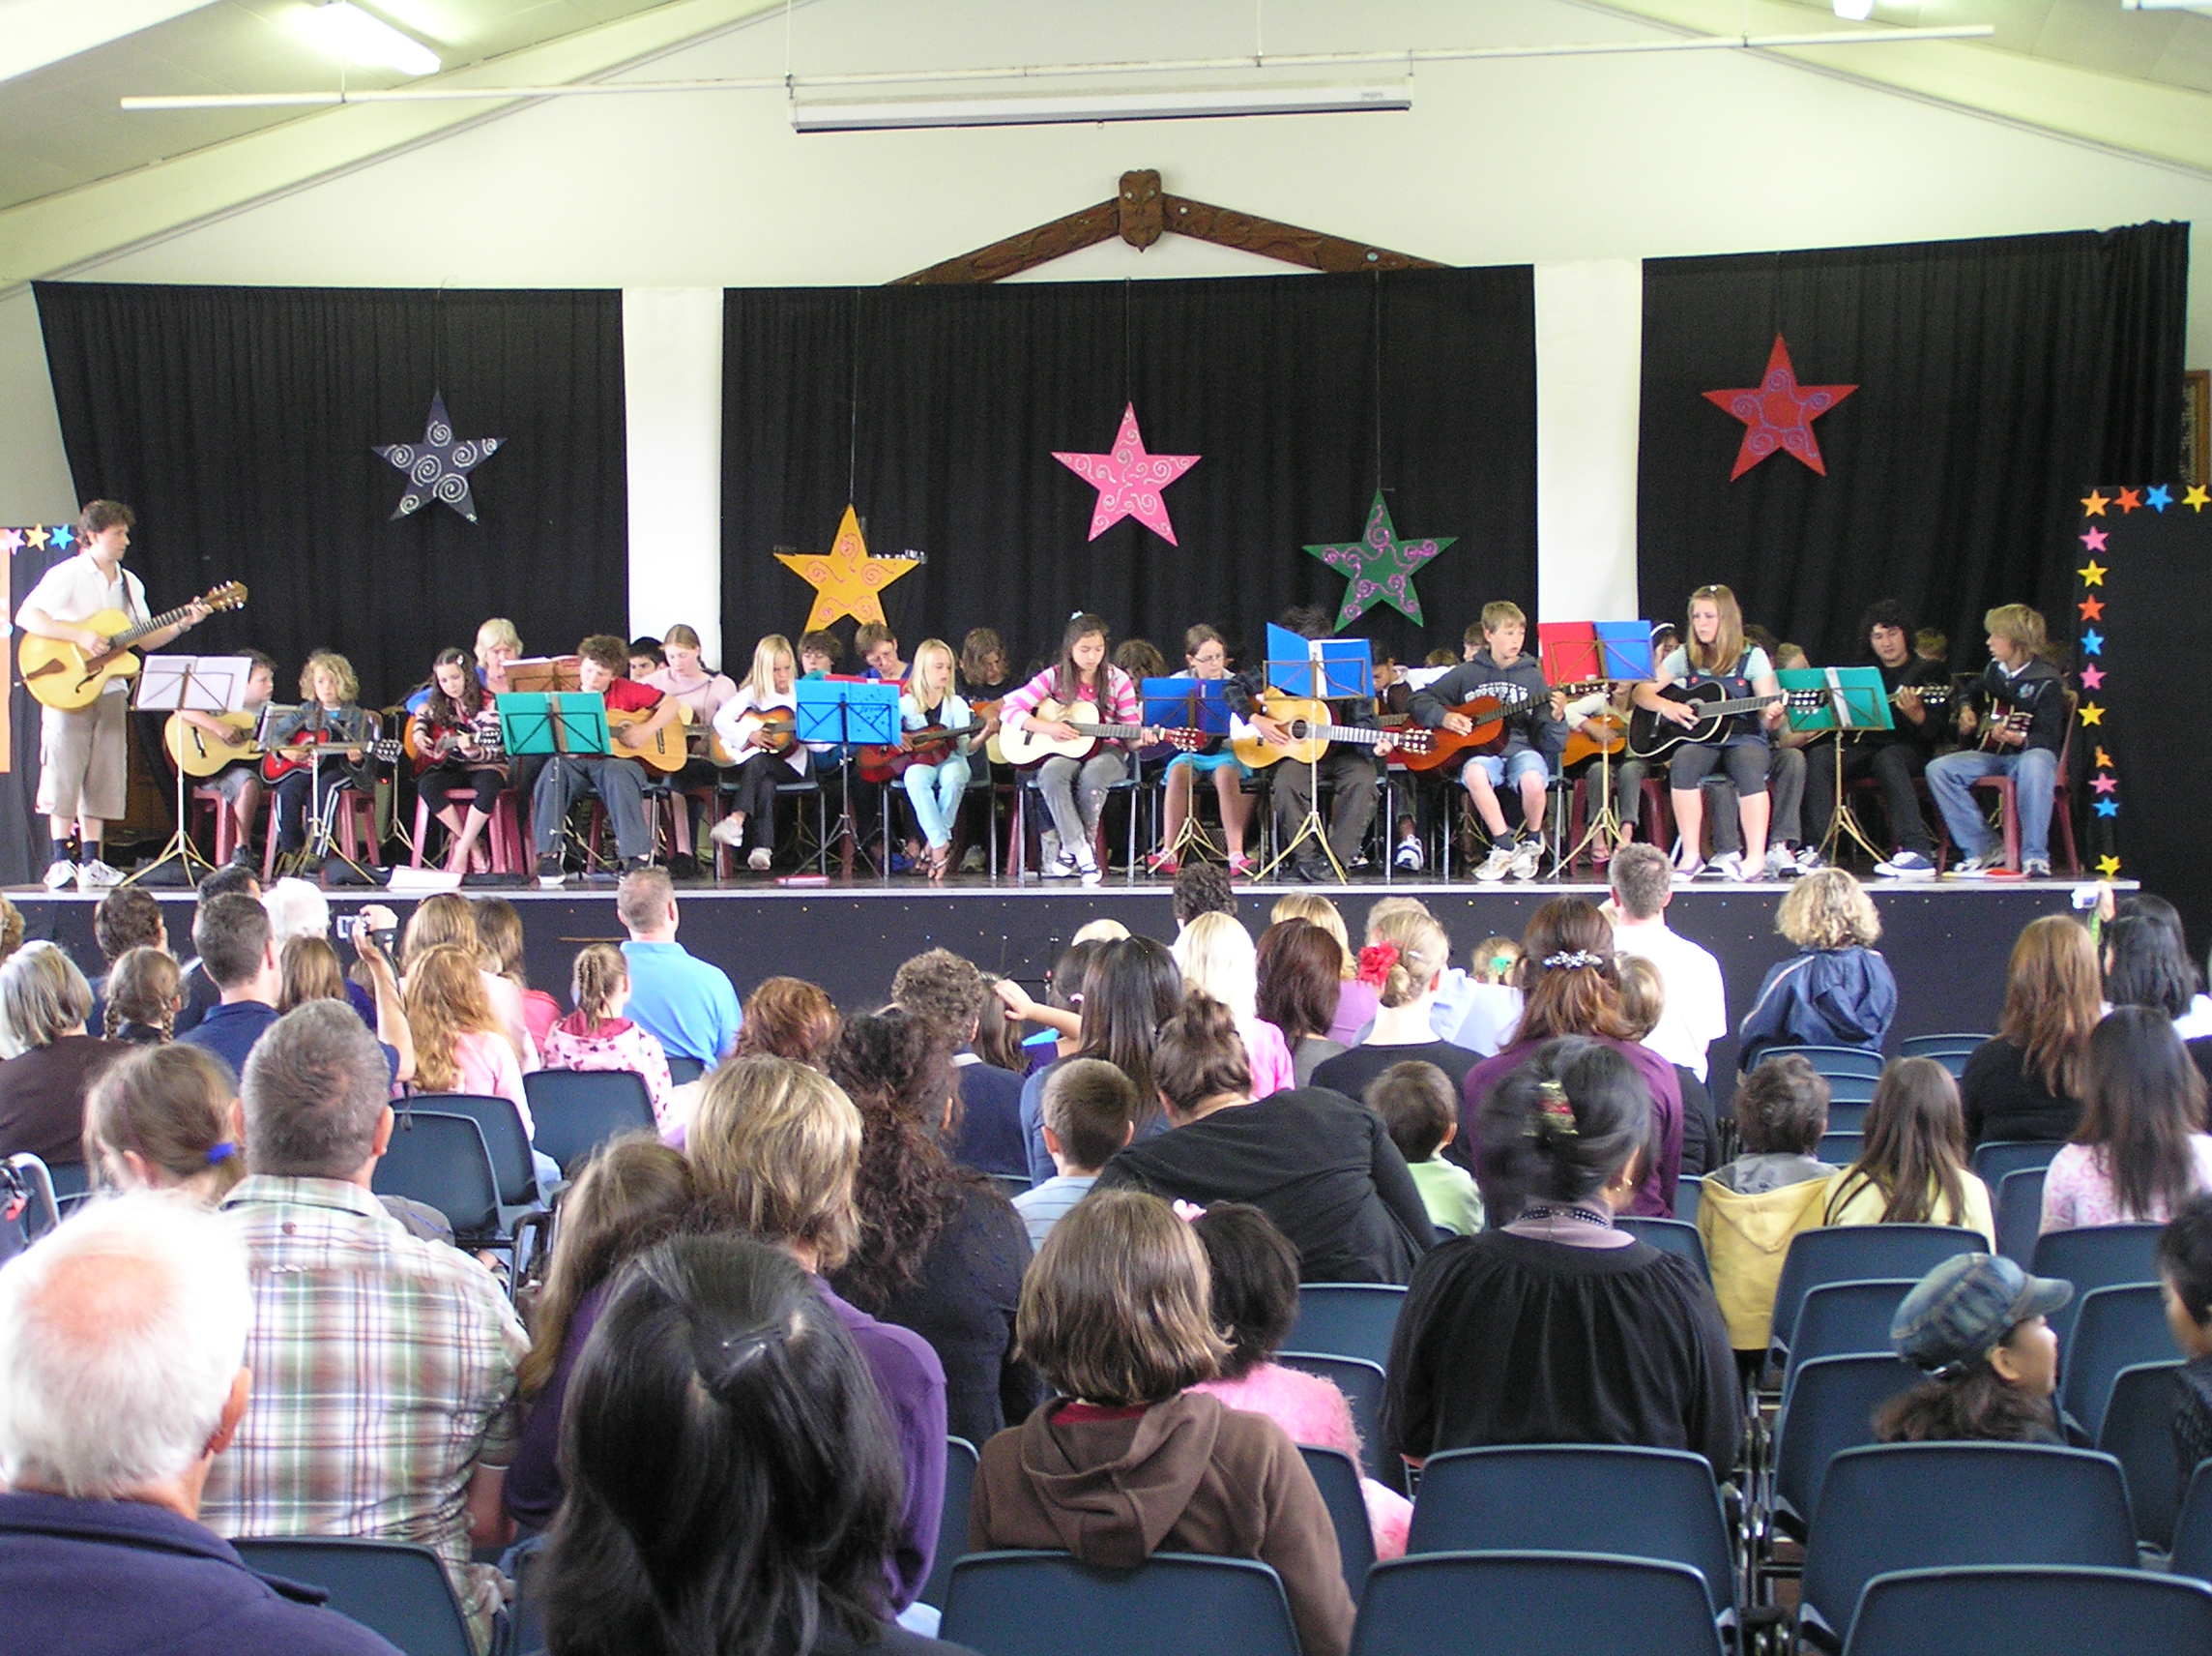

Cliff Leatherbarrow
BMus. Grad.Dip.Tchg. Dip.Media Compostion. Advanced TESOL Cert.
Practicing Certificate Teachers Registration: 241839
Website: nzcomposer.com

CC

V

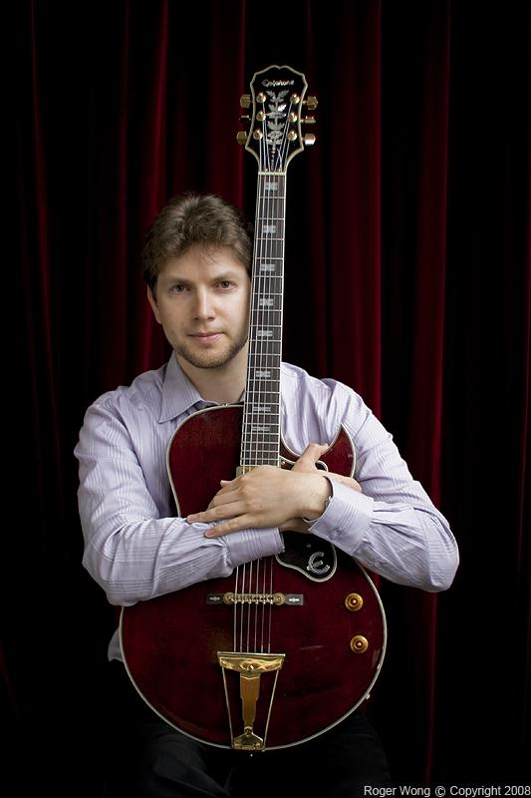

PERSONAL GOAL

“To instil a passion for music in learners, through the teaching of a program that nurtures, challenges and is innovative. Students will grasp essential skills and be inspired and extended to live out their music potential and help others along their journey of music discovery.”

What others say

"The music is well composed and produced, and fits the action well ...
with an effective use of contrasting style modules to tell the story.
I liked it when the music burst into the funkier modern style"

"Again the music is thoughtful, lyrical and subtly romantic (without being overly schmaltzy). Cliff's score is suitably atmospheric, understated, and subtle...
and beautifully played, recorded and produced."
Richard Atree - TV and Film Composer

“He was well liked by pupils and a very popular teacher at our school.”
Juhee Cha – English Teacher

“Cliff is an outstanding musician, one of New Zealand’s most versatile professional guitarists.”
Dr. Ludwig Treviranus - Concert Pianist

Cliff’s background

Cliff Leatherbarrow studied classical piano and classical guitar to a high level, but also completed a Bachelor’s degree in Jazz Guitar Performance in 2002.
While at university and working part time as a guitar tutor, Cliff realised he had ability to relate to young people and teach. He spent ten years working as a music tutor while also completing general classroom relief teaching.

Through Cliff’s practical studies and work with media composition he grew highly competent and extremely knowledgeable in the use of technology in music composition, arranging and production.

He taught English for a year in South Korea while completing a diploma in media composition in his spare time there. Cliff has also travelled to China and America where he had Jazz guitar lessons with professor Barry Greene at the University of North Florida.

In 2013 Cliff worked at Wellington College as a full time classroom music teacher while the HOD was on maternity leave.

Cliff has played, toured and recorded extensively with jazz and rock groups but is now focusing on developing musical skills within students and directing and enhancing their musical ability, through the teaching of this amazing curriculum area.

CONTACT details:

Contact details: Mobile: 021 027 23693
Email: cliff.leatherbarrow.music@gmail.com

Music Teaching experience

- Wellington College, New Zealand
Secondary School Music Teacher (year 9 to 13 – full-time)

- Chilton St. James Lower Hutt
Guitar tutor and Band coach.

- Maidstone Intermediate
Guitar, Bass and Ukulele tutor and band coach.

- Upper Hutt Music School
Ten years as a guitar tutor for ages 6 to adult.

- Private Guitar / Bass / Keyboard Tutor
Extensive experience working privately, teaching from home.

- Mangaroa School
Guitar tutor.

- Kelburn Normal School
Guitar, bass, Ukulele tutor, year 1 to 8, band coach and director of the guitar orchestra.

- Upper Hutt College
Three years as guitar / bass tutor teaching year 9 to 13 students.

Other teaching experience

2011 – 2012 JLB English Academy Yangsan, South Korea
English Teacher (EFL teacher)

2005 – 2010 Day-to-day Relief Teaching
(various schools in the Wellington region)
Saint Claudine Thevenet School
Heretaunga College
Upper Hutt College
Raroa Intermediate
Kelson School
Maidstone Intermediate
Fergusson Intermediate
Paremata School
St Josephs School
Avalon School
Muritai School
Ngaio School
Fernlea School
Rata Street School
Konini Primary School
Hutt Intermediate
Kelburn Normal School
Saint Francis De Sales School
Karori West Normal
Otari School
Tui Glen School
Eastern Hutt School
Trentham School
Sacred Heart School

2005 – 2005 Kelburn Out of School Care Trust
School Holiday Programme Director

Recent Work as a Professional Musician

- “Finger Snappin’ Goodness” – Jazz Trio
Guitarist and vocalist in jazz trio gigging regularly around Wellington

- Short films Music for the Media portfolio - “After Death”, director Yianna Americanou, and “The Phoenix”, director Chrid Barfoot. Music composer and music producer.

- “Tommy and the Fallen Horses” – Indie pop, Alt country rock band
Bassist, backing vocalist and Keyboard player recording and touring with this highly acclaimed Wellington based band.

Qualifications

- Advanced 120 Hour TESOL/TESL Certificate
Teflen Training College (2014).

- Diploma of Media Composition
Think Space, London Based Academy, London (2012).

- Graduate Diploma of Teaching
Victoria University of Wellington, New Zealand (2005).

- Bachelor of Music in Jazz
Massey University, New Zealand (1999 – 2001).

other skills

- Experience singing with choirs and in a barbershop quartet
Massey University Jazz Choir Paper, David Dell’s Singing for Adults Choir

- Experience conducting small orchestras and ensembles
Massey University Conducting and Arranging Paper

- Experience mentoring and leading young people.
12 years working with teenagers tutoring and coaching bands

- Cricket Coaching Certificate
NZ Cricket Have-a-go-cricket, 2005

- Kiwi Sports- Kiwi Starter Teacher Training Certificate
Kiwi Sport Wellington, 2005

- Swim Safe Training
Lotto Swim Safe Teacher Training Certificate, 2005

REFEREES

Professional Work Related Referees:

Mr Robert Anderson
Deputy Principal Wellington College
Telephone: +64212391702
r.anderson@wellington-college.school.nz

Mr Charles Bisley
Head of English/Performing Arts – Kelburn Normal School
Telephone: 0297771824
charlesb@kelburnnormal.school.nz

Mrs Ella Hanify BA, BMus, LTCL, Dip Tchg
Head of Music - Chilton Saint James School
Telephone: 0272938449
PO Box 30090, Lower Hutt 5040, Wellington

Kevin Ryan
Customer Relations Director
Teaching Recruitment Services
Email: info@teacher-recruitment.co.nz
Telephone: (04) 477 3147

Mrs. Virginia C. Philip
Supervisor / Violin Tutor
Upper Hutt Music Centre
26 Riversdale Road
Upper Hutt
Telephone: (04) 526 9643

Juhee Cha
Associate Teacher JLB English Academy Yangsan, South Korea
Deawoo Ian Apt-104-705,
Hwa-myoeng 3 dong, Buk-gu, Busan
South Korea
Phone: 82-10-3103-4578
Email: duhinim@gmail.com

Character Referee

Ross Andrew
Long term family friend and counsellor.
Piano teacher, book store owner/operator.
Heritage Books
44 Queen St
Masterton
Telephone: (06) 377 0147 work
0273550361 home

