RESUME
PERSONAL INFORMATION
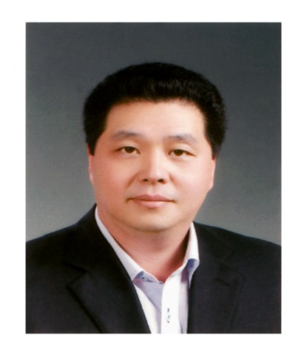 | Name | Jaehong Lee
 | Date of Birth | March 24, 1967
 | Nationality | Korean (Ex-Gyopo)
 | Current location | Changwon, Kyungsan south province
 | Teaching period |  | 11 years and 2 months
 | Period of Residence in Korea |  | 11 years and 7 months

EDUCATION
Attending Period | School | Major | Location | Degree
1990 ~ 1997 | University of Houston | Biology | USA | BS
1982 ~ 1986 | Northbrook high school | N/A | USA | N/A
1981 ~ 1982 | Travis secondary school | N/A | USA | N/A
1975 ~ 1981 | Colombia elementary and middle school | N/A | Paraguay | N/A

TEACHING EXPERIENCE (Teaching experience since August of 1999).
Currently looking forward to continue teaching at a new place and/or environment.
Wonjong Public High School: (1 year)
Since March 1, 2010 until end of February 2011.
In charge of first and second grades English conversation classes.
In charge of developing first and second grades English conversation curriculums.
In charge of English conversation club during lunch break.
Bucheon Public High School: (4 years and 10 months)
Since May 1, 2005 until end of February 2010.
In charge of first grade students Business English communication classes.
In charge of developing Business English communication curriculums.
In charge of third grade students English composition classes.
Assistant in developing and editing school's newspaper.
In charge of first grade students Daily English conversation classes.
In charge of teachers Daily English conversation classes.
In charge of first and second grade students English listening classes.
In charge of third grade students writing classes after school.
In charge of developing English conversation curriculums.
Korean English teachers assistant with English related tasks.
Dongducheon Information Industrial Public High School: (1 year)
Since May 1, 2004 until end of April 2005.
In charge of first & second grade students English conversation classes.
In charge of developing English conversation curriculums.
Nam-sung Private Elementary School in Busan: (2 years and 4 months)
Since November of 2001 until end of February 2004.
In charge of first and second grade students English conversation classes.
Dong-nae Office of Education in Busan: (2 years)
Since middle of August 1999 until middle of August 2001.
In charge of teachers training programs to improve their English abilities.
In charge of developing English conversation curriculums.
Korean English teachers assistance in Elementary and Middle schools.

OTHER EXPERIENCE
OTHER TEACHING EXPERIENCE:
Summer of 2009 at Korea Herald (The Junior Herald) in Jangyoo, Kimhae.
Winter of 2009 at David's Academy (Now CDI) in Busan.
Summer of 2008 at HIIC (English camp) in Kimpo, Gyunggido.
Fall semester of 2006 at Yeoungje academy in Bucheon, Gyunggido.
Spring semester of 2006 at Solomon academy in Bucheon, Gyunggido.
Winter of 2005 at Goose academy in Busan.
Fall semester of 2002 at Yeoungje academy in Busan.

CERTIFICATES
N/A

