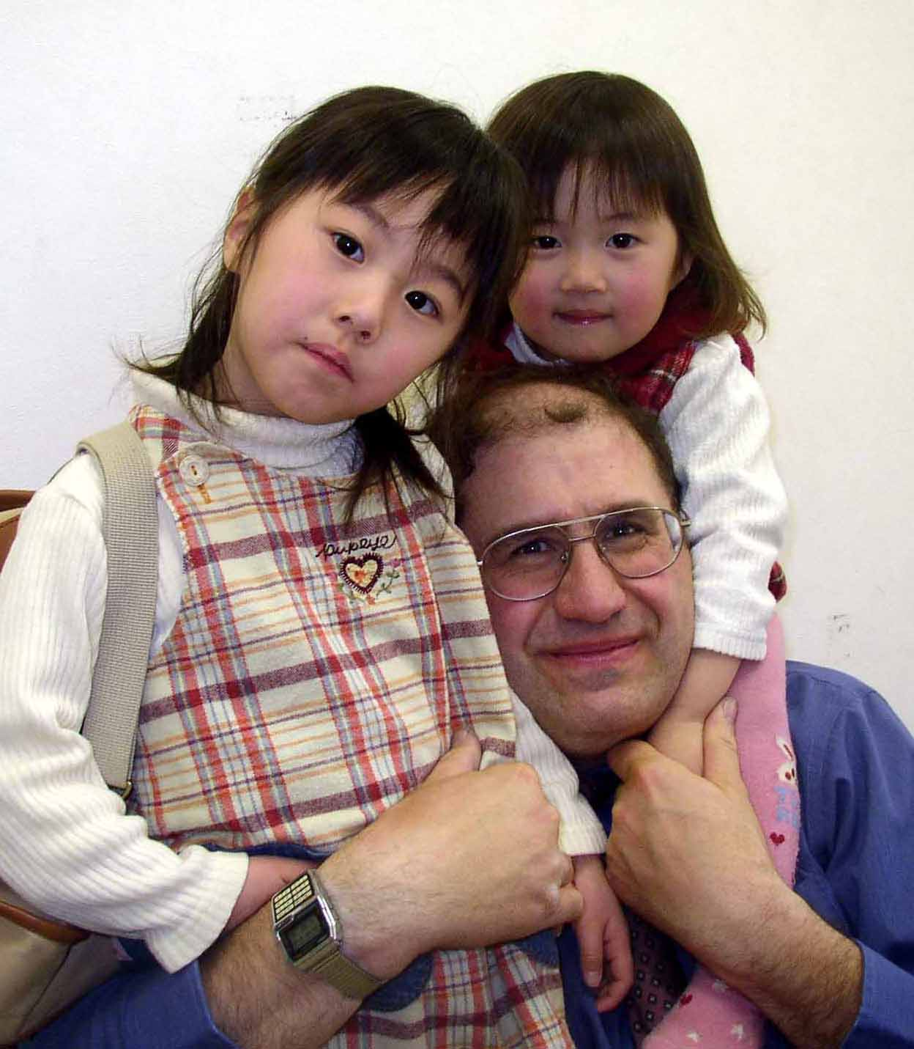
Resume of Bruce Myers

OBJECTIVE
To obtain ESL employment where I can uniquely express my unique ESL teaching abilities in a professional manner.

PERSONAL INFORMATION
959 NW Sycamore Avenue
Corvallis, OR 97330
541/752/3334 or 503/895/6043
louielandoregon@yahoo.com

Born in 1954, in California.
Present age is 56 and I am not presently married.
I have two adopted grown children, both age 27.

EDUCATION
Northwest University, Kirkland, Washington
BA Literature 1972 – 1976 (Four years)
Western Washington University, Bellingham, Washington
Elementary Education 1997 – 1999 (Two years of study).

Summary of Relevant Experience and Qualifications
•Eight years of fulltime ESL teaching experience. I have fully completed every ESL contract I have signed since I first came to Asia (Five years in Japan & three years in Korea).
•A passion for teaching with a creative flare for developing methods and teaching aids to fit the situation.
•A specialist with beginning ESL students. Students quickly develop real world English skills in a predictable time frame.
•Have developed an extensive interactive graphically based interactive program to aid students learning; especially those students who have zero knowledge of English. (Please see description below under ESL philosophy).
•A maturity that only comes with age and experience. A bad day for me doesn’t translate into a bad day for my students.
•An able creative teacher/trainer: Developed teaching curriculum and recruited teachers and performed job interviews.
•Twenty-five years of volunteer leadership working with children-Tutored at-risk children.
•College training in psychology, education, childhood development, and behavior management.
•Directed numerous children’s programs, presentations and activities.
•Excellent Desktop graphic skills: Have designed extensive promotional-educational materials via Adobe Photoshop, Adobe In-design, CorelDraw & Excel for extended periods of time.
•Strong communication skills: Ability to communicate with diverse populations- Have done public speaking on numerous and occasions.
•Team player: equally effective and motivated working independently.
•An able photographer with excellent Photoshop skills.
•Hobbies include graphic design, photography, puppetry, ventriloquism, and advanced balloon art.
•Have an absolutely clean criminal record in every respect.
•Have done volunteer work for the past 2+ years with the children of the Daedong orphanage in Daejeon.
•Old-fashioned Work-Ethic with a lifetime learner mentality.
•Computers: Very comfortable working with PC systems; Have frequently installed PC components including hard drives and assembled PC's from base components.
•Practical real world skills - Ten years of practical retail experience in the Hardware/Mechanical area.

Most Significant Employment History

ESL Teacher at a Hogwon 2008 to 2010
Daejeon
Taught virtually all the conversational classes at the Kids Club school for the past two years.

English Teacher in Korea 2007 to 2008
Chungcheongnamdo Office of Education-Gongju, Korea

Worked with 1st-6th grade elementary students at four different schools.

English Teacher in Japan 2001 - 2007

Maebashi and Masumoto Japan

I worked for the Amity/Aeon Corp for 5 years. While doing so I have developed many teaching techniques that are supported by custom developed graphics to accompany them. I think it is significant that during that time I did not missed one day of work for any purpose other than pre-authorized vacation days.

Children’s Director 1979 to 1982 and 1996 to 1998 Lynden and Bellingham WA

I taught groups of children up to 40 at a time. Produced graphic productions include news letters, brochures, transparencies, posters, newspaper ads, and radio press releases. Communicated to groups on a regular basis, working with vendors, recruited and trained workers, maintained data records using Excel, generated regular mailings, coordinated banquets, produced children’s theatrical / musical and puppetry performances, and community-wide events.

Retail Manager 1983 to 1986 and 1989 to 1992

Bellingham and Olympia Washington

Sales, dealt with vendors on a regular basis, managed and trained workers, promoted special sales and developed newspaper ads to accompany, trained and managed workers, facilitated returns and did purchasing.

Actual ESL and non-ESL work Further Expanded

Teaching Experience
I have been teaching a wide variety of people and ages for the past 3 decades both in paid and volunteer positions. Many of my teaching experiences have been in my church, but they also include public and private school settings as well. Quite often I have developed much of my own curriculum to fit my present situation.

ESL Teaching Experience
I have eight years of full-time ESL teaching experience that ranges teaching ages from twelve months through adult. I believe my most significant teaching attribute is the ability to reliably and predictably get beginning students quickly on their way to speaking English. I also believe it is fair to say that I have an excellent ability to quickly develop good relationships with young children. My past teaching experiences over the past eight years have given me the confidence to believe that I can make my future students successful in their language studies as well. When I prepare a lesson, I feel I can intuitively know ahead of time the areas that my students are going to find difficult for them in regard to vocabulary, comprehension, grammar and pronunciation. Over the past eight years I have developed an extensive program called "Real World English" that uses quite a few techniques and strategies to enhance my students learning in fun creative ways. These techniques include extensive graphics, hand signals, comprehensive dialogues that correlate with the programs, games, seminars, balloon art, videos, contemporary music, idioms, current events, key word lists such as the twenty-four key question starters phrases and the fifteen main conjunction words, and similar pertinent specific vocabulary lists and general conversation starters. I also feel I have developed a good ability to guide my students into developing good conversation and writing skills. In addition to this I also developed a full complement of extensive graphics to enable me to accomplish my teaching goals which many feel are quite well done. Lastly, I often use my extensive balloon making abilities to teach English concepts in a fun easy to understand manner that most children find attention grabbing. It also can be a good means to recruit new students into a program.
The long and the short of it is this. If you are looking for someone to just take some students through a series of textbooks with the hope that something will hopefully stick, I’m probably not the person you are looking for. If on the other hand you want someone with a proven track record with a program that consistently and predictably really works with all kinds of students to produce real English speakers, then I a lot of confidence I can be of some assistance to you. Please see my ESL Philosophy below if you would like a more detailed synopsis of my approaches to ESL teaching.

ESL Philosophy
If I could summarize my philosophy about teaching English with one phrase; it would be to teach "real time English." As a teacher I am not satisfied in just doing a lot of bookwork and lessons and just hope my students get it. For me to be truly satisfied as a teacher my students must be able to communicate their own genuine thoughts in real-time with authentic English sentence patterns.
Over the years I have become quite frustrated with most programs I have been involved with. For the most part they were based on a vocabulary program tied to a textbook. Surely textbooks have their place in the equation, but to be quite honest, I have yet to see one that produced students that were really ready to communicate in English in the real world. What I found in regard to the textbooks and the students I've taught with them are students is that they never seem to produce English speakers that can handle real time situations. I feel this is true not so much because they were necessarily poorly written but largely because of the time constraints and size practicalities inherent in books and their formatting. To me it seems like they usually cut English into pleasant looking bite size manageable pieces by teaching a concise new concept every week and then moving unto the next one whether the student really have gotten it or not. One of the things I really hate as an ESL teacher, is to arrive at the end of a textbook only to find that my students often couldn’t remember what they had learn in the first part of the book by the time we had gotten to the end of it. Why??? Why did we go though all that effort on my part and theirs too only get a mediocre result? While no-one puts a premium of disorganization, learning a language might be more accurately described in terms like that of giving birth; a somewhat intense, complicated and even a messy affair at times. Learning a language usually requires much more repetition and foundational work than a “proper” textbook can practically do. This is especially true when a student is first starting out.
To learn a language many interrelated elements and concepts much come together in the mind of the learner. Learning English is not simple a matter of memorizing a bunch of facts, rules, and vocabulary words. For a program to be truly successful it must integrate all the elements together in one place in real time. I meet students all the time that have been studying English for a multitude of years that in practical terms are not even close to being able to communicate what they are thinking or feeling in real terms even though they often have an enormous amount of English facts floating around in their head. Because of the frustration that many ESL educators feel when they see how daunting it can be to really transform students in to real English speakers, many often revert to what I call “feel-good” strategies. This usually means memorizing a lot of preplanned dialogues or highly scripted scenarios or super long vocabulary lists. I watched one of those scenarios played out one day. All the ESL teachers in our school district were summoned to watch what was called a “model lesson” that we were supposed to learn from and emulate. The lesson came off “perfectly!!!” Of course they had three teachers and only 10 students to work with while the school district was asking us to teach 30 or more children with no supporting teacher, but I digress. It was clear that the students had memorized their answers "perfectly." Anyway, after the lesson I went up to one of the students involved in the lesson and asked them a very basic question like “was it fun for you?” What I got in response to my question was the blank screen of death on the child’s face that all ESL teachers have come to know all too well and are loathe to see. Even though the child was able to perform at a high level during the very scripted "model" lesson, in real terms she was functionally illiterate in English in practical terms. In the ESL world it quickly becomes apparent even to the casual observer that it is one thing to teach a child to become a good parrot in a highly programmed situation and quite another to develop real English speakers who can truly express their feelings and desires in a variety of real situations.
I once taught a five year old child 6 vocabulary words just like I had been taught to using a variety of methods and games to accomplish it. It took thirty minutes to accomplish this. What I saw next on his face told was one of total relief. In his mind it was clear that he was done for the day. What he couldn’t have known was that we had finally only gotten to the point where I actually start to teach him to really speak English. For all intents and purposes, he was done for the day. Hardly the result his parents nor I were hoping for. A better approach would have been to start with the structures in the very beginning, with just enough key vocabulary words to get the structured learned. At the end of the lesson he could have gained something that he could have used in practical terms. When English becomes practical and something one can actually use the student starts to see it as useful and something to be desired. When English is taught in this manner, the vocabulary that they are exposed to is actually remembered because it was presented in a useable memorable context. The truth is that there are only so many useable minutes in a student’s mind, and when they get used up, your done whether the clock says your are or not.
After much thought and trail and error as a teacher I came to understand that we often fail to accomplish our goals because we don’t give our students a foundation and a structure to organize what they have learned into a useable interconnected form. We all know how important a foundation and a structure is to a building. In biological terms it is the skeleton that holds everything else together. Without one no building can ever be built. I finally came to the conclusion that if I didn’t find a way to help my students get those bits and pieces of English interconnected in a useable real-time format, my students would continue to give me those blank stares in the hallway no matter how long I taught them. From that point on I have dedicated myself to giving my students a firm foundation and an structure in English that would enable them to interconnect the concepts they were learning together into a useable form in “real time.” It takes a lot of time to set a foundation both in a building and in the mind of a learner, but wow what a difference it can and does make. I have truly been amazed at the difference in results from my first students when I first went to teach in Japan and the students I teach now.
When I get a new student now, I fully expect that they will start to express themselves in real English from the very first lesson. What I found with the new approach was that my students were now remembering what they were learning in their textbooks as well and they were finishing them early and going onto the next one. Once I found predictable ways to get students to start to simply expressing themselves even from day one, I found I could start building a foundation in English that will remain with them for the rest of their lives. Because the foundation and structure is the primary goal, vocabulary is no longer learned through boring repetition, but rather learned in a context within a sentence structure that they learn mostly as a part of the process. This saves a lot of time, is more natural, and actually is more effective in the long run. Vocabulary work is much less boring and words become much easier to remember because they are learned as they are used in real time meaningful communication. While key vocabulary words are stressed over and over until they are learned in depth, the majority of other words are learned in a context through a natural process. The key structural vocabulary words that are introduced are always supported with visual equivalents so the students really get the point of the vocabulary. For example, you can teach a student 29 different kinds of fruit or the seven key words “fantastic, great, good, okay, so-so, bad and terrible.” While the 29 different kinds of fruit may come in hand sometime in a person life time the seven words I listed above will definitely be used all throughout the day to greatly enhance a speakers ability communicate both in terms of feeling and describing things. In time students can and do teach themselves the majority English words they need though their own study. What they will likely never get on their own is the structures necessary to really become an English speaker. There are a few truly gifted students who will teach themselves these structures if you just expose them to English in general, but he majority of students really need some help in this area if they are ever really going to become an real-time English speaker. The true test of a program is not whether it is successful with the few really gifted students, but rather it is successful with the ordinary and even poor students in your class. It is fairly easy to get students to parrot what you say to them, but it's quite another to give your students the ability to truly communicate their inner thoughts in real time English. Those skills can only be imparted by a diligent patient teacher using the proper method. In practical terms I am happy to report that my students are now gaining more English ability in weeks and months than they used to gain in years. In real terms, I expect all my students, even my weak students to start communicating in English if they will make even a modest effort of time and attention.

In addition to my ESL work; I also have a large quantity of real world work experiences that are varied and broad that I feel help to make me a more complete and well rounded teacher.

Management
I have a proven track record of working with a wide diversity of people in terms of culture and personalities. I have supervised both paid as well as volunteer workers on numerous ongoing situations over the past twenty years. As the floor manager of a large hardware store for many years I was responsible for training and supervising all the sales people in a busy high pressure setting. I also was responsible for the negotiation of the majority of returns from customers. I know how to respond so as to defuse tense and potentially explosive situations. I have successfully communicated to both small and large groups on an on going basis.

Computers
I have an excellent adeptness in personal computers. I can install CD and hard drives, various cards, modems, printers, scanners, various peripheral equipment and assembled my last two personal computers from base components. I have extensively studied and used for many years Adobe-Photoshop, Adobe-In-design, CorelDraw, MS Word and MS Excel. I have been using them on a continual basis an extended period of time and I feel I have advanced graphic skills and thoroughly enjoy expressing my creativity for a variety of purposes. I have produced many attractive and useful graphic projects that have been well received by friends and associates in both the private and professional world. With my ability to self-train myself in computer software programs I believe I would come up to speed very quickly in whatever software you presently use as well as the inevitable upgrades that will be required in the future.

Mechanical/Real World Endeavors
While not directly connected I do have extended experience with mechanical area including auto mechanics, general mechanics, electricity, plumbing, all general hardware that do make me a more well rounded teacher from a practical aspect. I have ten years of full time experience in these areas of endeavor. Sometimes these skills help me to devise helpful teaching aids for the classroom.

