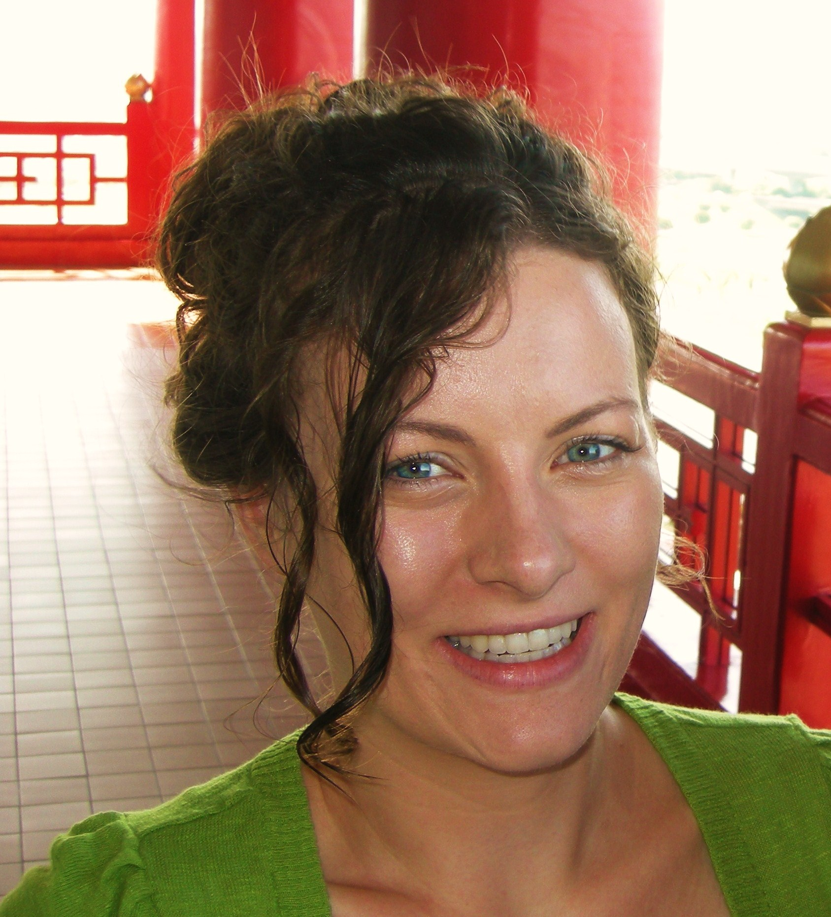
Lynn Bianca Kemmerer
14209 SE 41st ST, Bellevue, WA 98006, USA
(425) 296-7686 lynnkemm@hotmail.com

Summary
* Committed to bettering myself * 10 years experience teaching
* 2 ½ years teaching English in Korea * Sensitive to various cultures

Experience
9/08-2/10 Juckjeon Elementary School Juckjeon, South Korea
Title: English Teacher
Duties: Follow the standard curriculum for English Teachers. Plan lessons for students
ages 8-13 years old. Provide afterschool English classes as well as Winter and
Summer camps. Individual work with students who struggle with English.

8/07-8/08 Kids On Campus Suji, South Korea
Title: English Teacher
Duties: Teach English to children from ages 6-13. Create age-appropriate activities and
lesson plans, evaluate children’s progress, and provide an environment where
students are willing to participate. Subjects taught include conversation, grammar,
spelling, reading, writing, social studies, and vocabulary.

5/06-5/07 Visiting Nurse Services Everett, Washington
Title: Community Health Outreach Worker/Infant Case Manager
Duties: Interview pregnant or parenting women to assess their needs. Provide education
and/or connect them to resources in the area that will meet their needs. Visit clients
in their homes and find culturally appropriate services for them and their families.

1/06-5/06 Sea Mar Community Health Centers Marysville, Washington
Title: Health Educator/Tobacco Specialist
Duties: Educate the public about the dangers of tobacco products. Participate in Health
Fairs to reduce dependence on tobacco. Assist tobacco users in quitting through
counseling, education in use of patches or other medicines.

6/05-9/05 Cross Cultural Solutions Ayacucho, Peru
Title: Volunteer/Intern
Duties: - Worked in medical clinics, hospitals, orphanages, prisons, assisted living
facilities, and in the community on health issues, educating the public and designing
and implementing a health promotion program including the participation of 5
schools and 300 school-aged children from ages 5-17.

Education
9/03-8/05 Central Washington University Ellensburg, WA
- B.S., Community Health Education.
- Course work included Multicultural Education and various teaching courses within my major.

9/00-8/03 Bellevue Community College Bellevue, WA
- A.A. earned, appeared on Dean’s list.
- Credits in Intercultural Communication & the Teaching Academy

