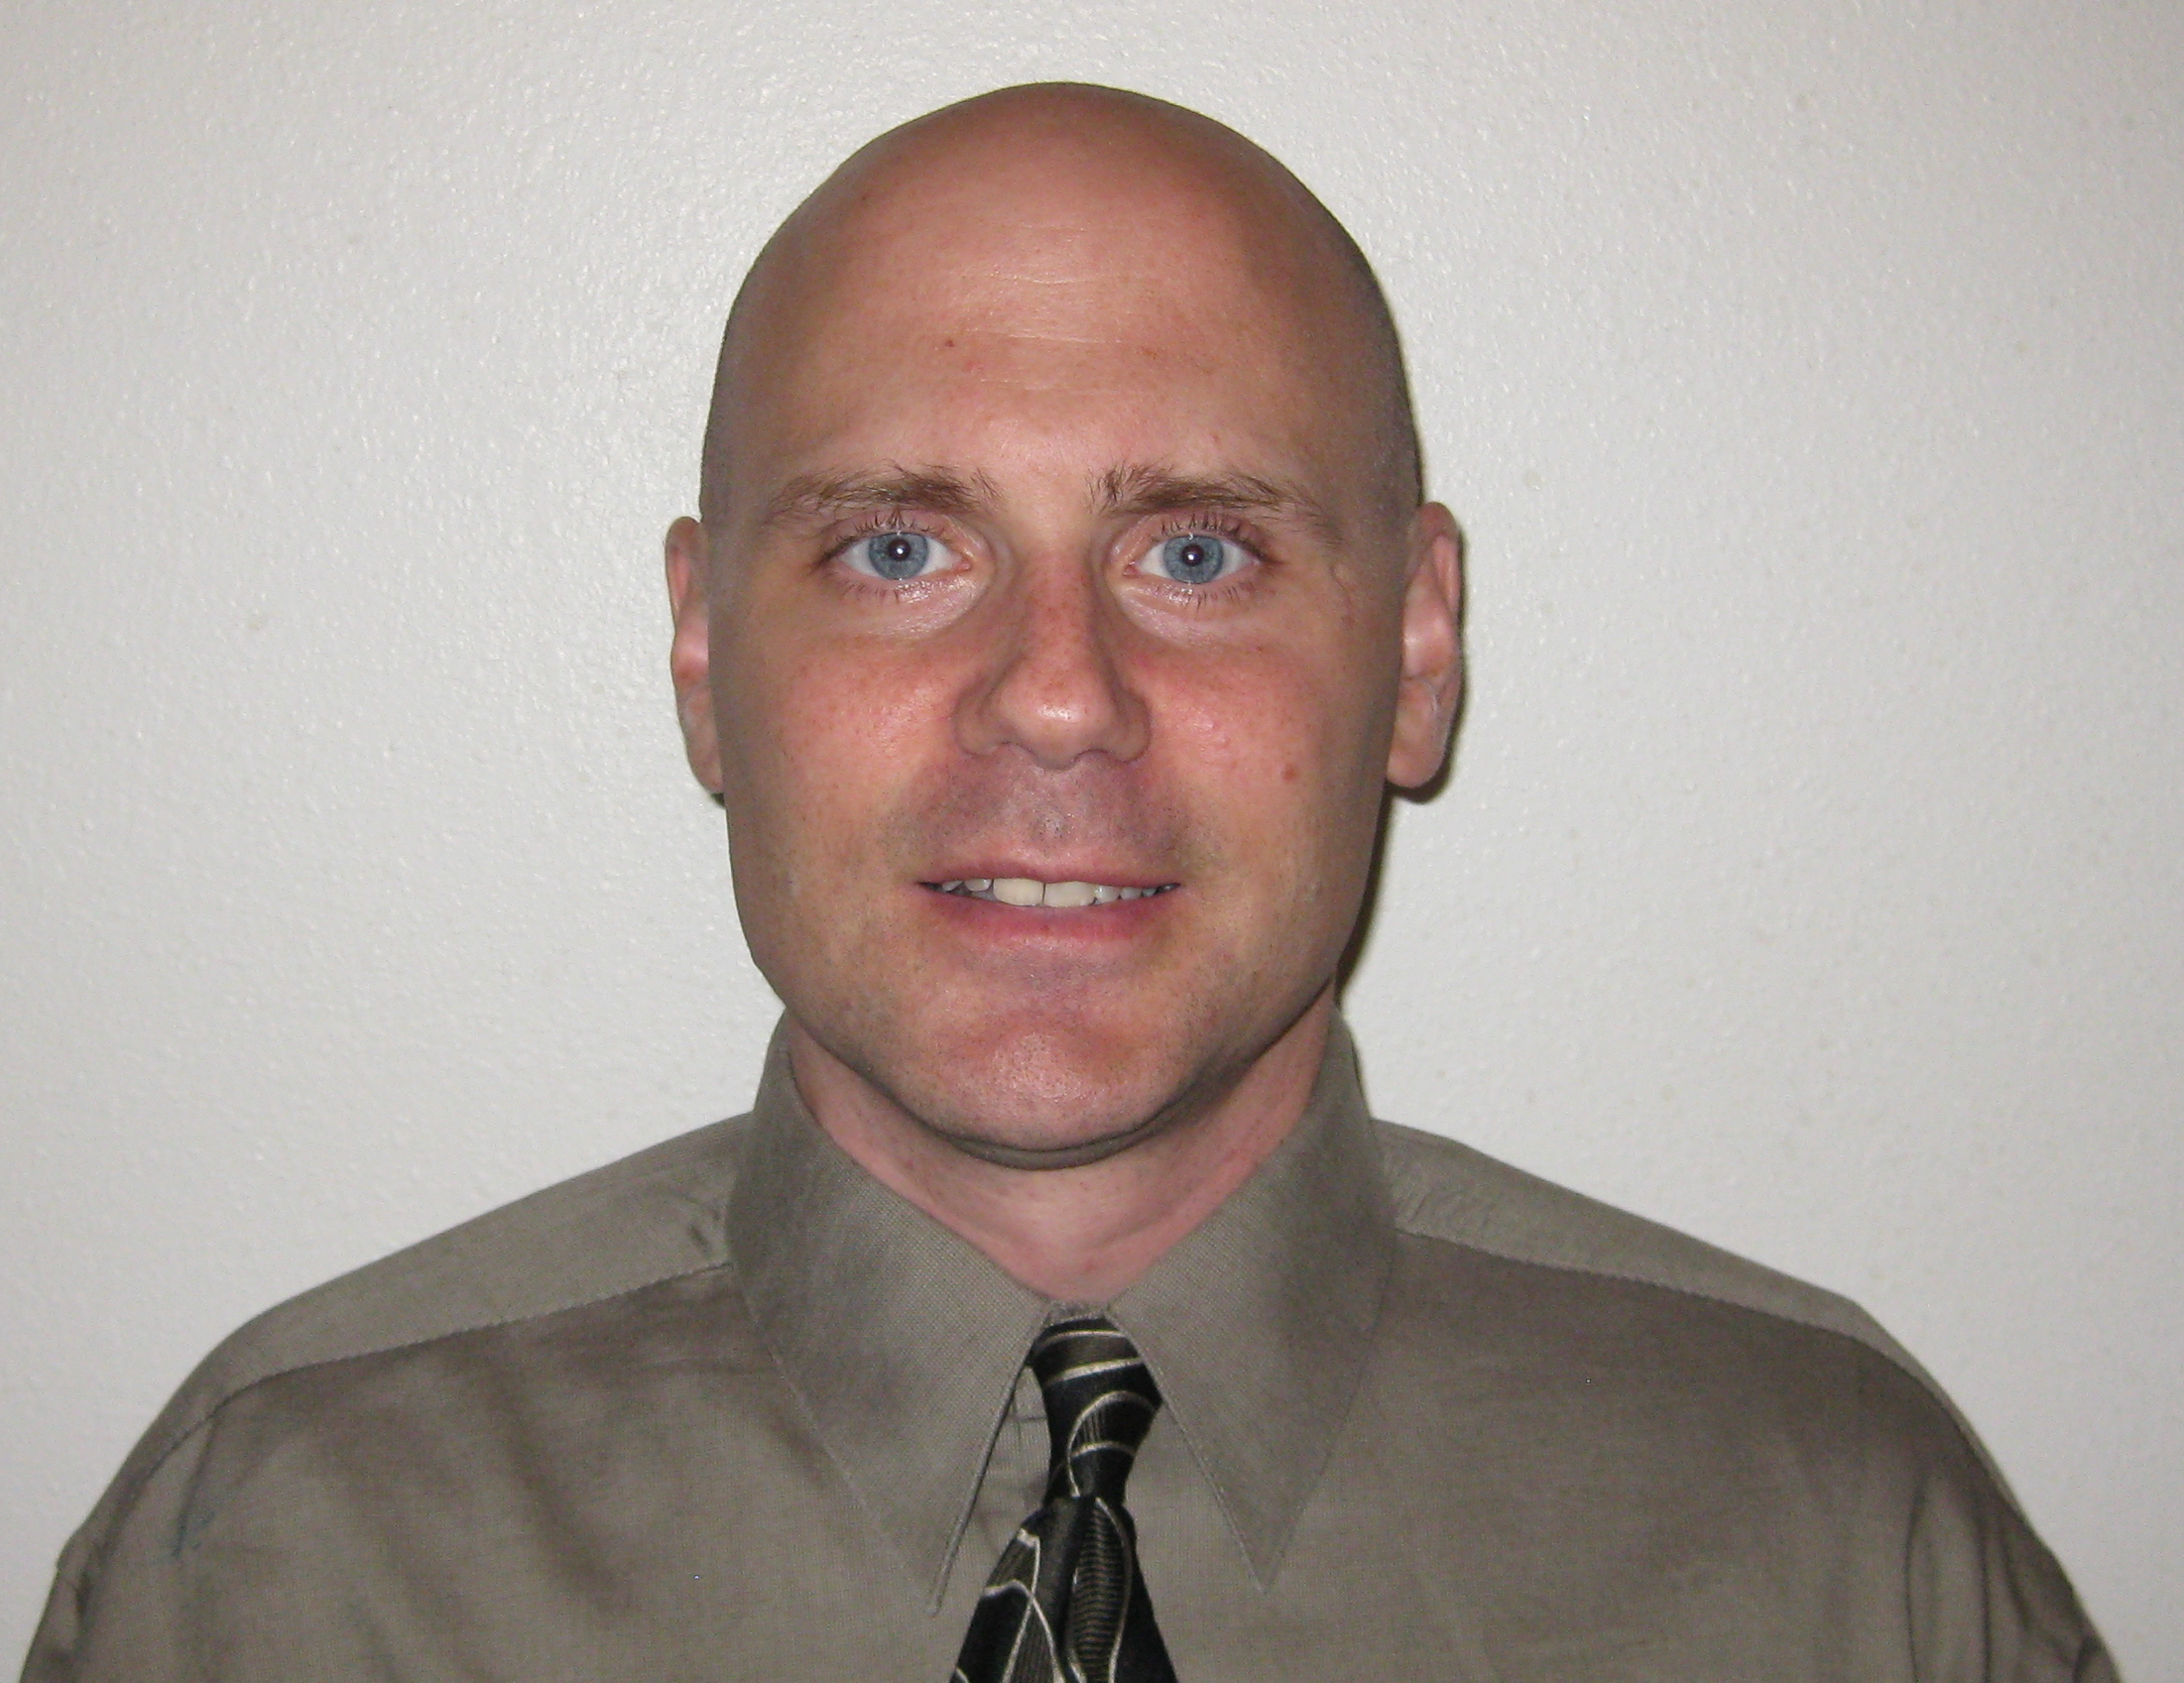
Jason Scott Siverson (Jay)
315 Hyundai ITEL
Dunsan 1Dong 1457, Seogu
Daejeon, Korea 302-831
Mobile Phone: 010-9162-9183
jss1919@hotmail.com

Work Experience:

Chungdahm-April Institute; Daejeon, Korea – 09/10-09/11 and 11/11-Current
● English Teacher
Teaching elementary aged students at a school that puts added emphasis on creativity.

Ewha ALS English School; Daejeon, Korea – 03/09-/03/10
● English Teacher

K & M Music; Sioux Falls, SD -- 07/96-09/98
● Buyer, Floor Sales/Service
Responsible for ordering, inventorying, and displaying music accessories. Responsible for special-order (un-stocked) items. Sales and service for musical instruments, sheet music, gifts and accessories. Long-range inventory planning and technical knowledge of musical instruments.
● Instrument Technician, Floor Sales/Service -- 05/94-07/96
Responsible for service and repair of brass and percussion musical instruments.
Attention to detail and repair craftsmanship. Assisted as a sales representative.

Midwest Office Systems; Sioux Falls, SD -- 05/93-05/94
● Marketing Agent
Hired to assist in the development of a new marketing department. Compiled and organized information on clients. Set-up sales presentation appointments for sales team.

Austad’s Golf Company; Sioux Falls, SD
● Equipment Specialist (Customer Service – Phone sales) -- 01/91-05/93
● Floor Salesman [Part time] -- 02/87-01/91

Education (and teaching):

► University of Nebraska – Lincoln (Doctoral coursework finished - music.)
- Graduate Teaching Assistant (Fall 2006-Winter 2008)
• Teaching: Trombone and Tuba/Euphonium methods classes (1 semester each)
• Teaching: Individual trombone and brass chamber lessons.
• Conducting (assisted): Trombone Choir

► Cleveland Institute of Music 2004-2005

► Western Michigan University MM in Trombone 2004
- Graduate Teaching Assistant
• Teaching: Taught Trombone methods class (2 semesters)
• Teaching: Individual trombone lessons.
• Studio: Assisted with trombone choir. Inventoried studio solo and recording library.
• School of Music office assistant: Primary responsibilities were compiling data for the National Association of Schools of Music (NASM) visit.
• Additional: Orchestra Librarian 04-05; Music composition study.

► Western Michigan University BM in Trombone 2002, Summa cum laude
• Scholarship: Russell Brown Honors Brass Quintet
• Additional: Orchestra Librarian 01-02

► Augustana College (South Dakota) BA in Business Administration 1990
• Four-year track & field scholarship (Division II All-American 1989)
• Pro Musica music scholarship (1986)

Additional Honors:
Phi Kappa Phi (Western Michigan University) 2005
Pi Kappa Lambda (Western Michigan University) 2001
Community Activities:
Private trombone instruction (Elementary through High School level) 1992-2004
Organized & programmed community trombone choir concerts 1995-1997
Business, School, Church solo and chamber performances
Professional Membership/Activities (Select List):
International Trombone Association 1994-2009
- 2001 ITA Festival (Student Assistant)

Sioux Falls (SD) Municipal Band
Sioux Falls Community Playhouse
South Dakota Symphony [substitute]
Michigan Bach Collegium
Kalamazoo (MI) Civic Theatre
Southwest Symphony (MI) [substitute]

