
이에스엘 에이전트
박우경(Rosa)
02-2675-0582

Sam Paterson
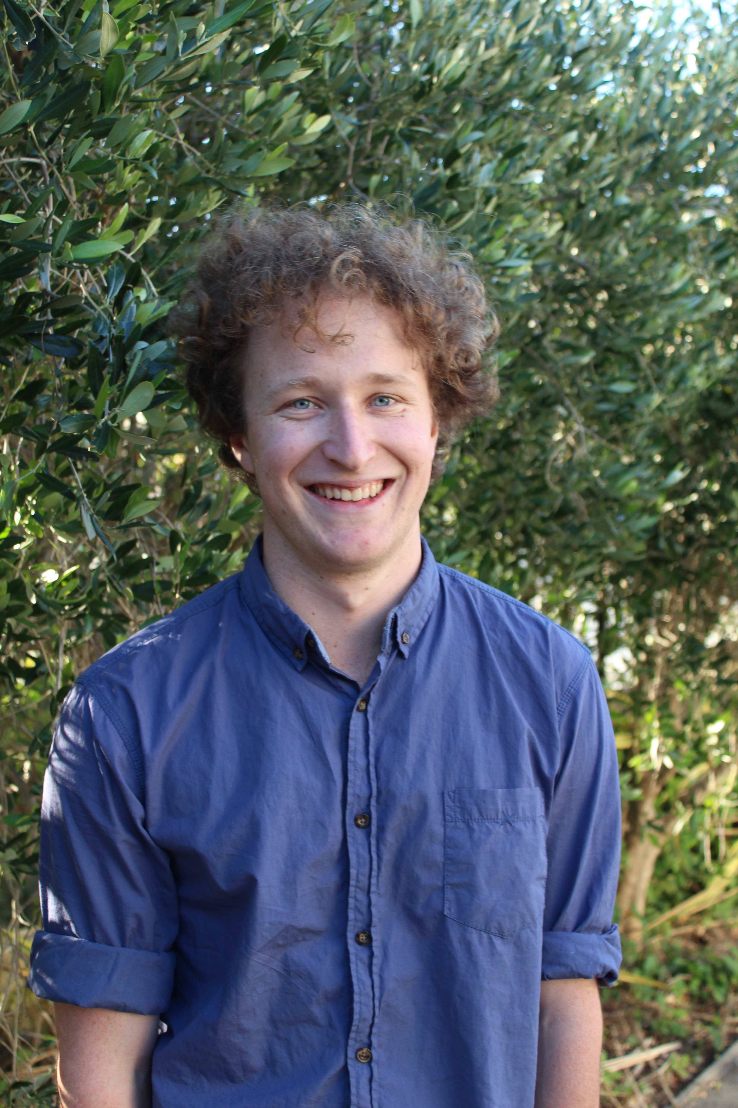

I am a 22-year-old male New Zealander. I graduated in May of 2012 with a B.A. in English Literature and Media Studies from Victoria University.

Key Skills

- Able to work under pressure and to deadlines with ease
- Able to work solo and unsupervised as well as in a group

- Able to consistently type at 70wpm+

- Positive and outgoing, constantly seeking new opportunities and challenges
- Highly literate and able to communicate clearly and coherently, both verbally and in writing

- Strong grasp of standard office software

- Even-tempered and patient

- Hardworking and dedicated

Education Summary
Stratford High School 2003—2008
NCEA Level 1 & 2: Graduated with Merit
NCEA Level 3/University Entrance

Victoria University of Wellington 2009—2012
B.A. in English Literature and Media Studies

Employment History
Salient – volunteer reporter
2009-2010
-This was a volunteer position for my university's magazine, Salient, which stemmed from my longtime interest in journalism. I conducted interviews and wrote articles. Although the position was unpaid, I was happy to give up my free time in exchange for a chance to hone my writing skills.
New World Thorndon
April 10 2012 – November 9 2012

-Retail-based position in a supermarket – primarily customer service.
- I dealt with large numbers of customers in a day-- the supermarket is one of the largest in the city.
- I developed excellent communication and teamwork skills in this position, as well as the ability to keep my temper and sense of humour at all times.

Referees

Employment:

Nick Connor (New World Thorndon)
+64 4 499 9041
Tony Gibb
+64 6 7623879
Character/academic:
Susan Hazen-Hammond (see letter of recommendation below)
susanhazen@cybermesa.com
telephone (U.S.) 505-670-1308

February 8, 2013
To Whom It May Concern:
I write this letter to recommend Mr. Sam Paterson for a position teaching the English language. In him I see combined the best elements of a fine teacher: an outstanding intellect, an excellent grasp of the nuances and varieties of the English language, an ability to express himself clearly, a talent for seeing the world through other people’s eyes, and an openness to new ideas and experiences. These qualities will allow him to work well with students, both in groups and as individuals. He will grasp quickly the dynamics and needs of the group. He will also be able to assess the needs of each student and find the best way to help each one. You will, I believe, find no one better suited and better motivated than Mr. Paterson. Students will learn quickly and well. They will leave the course far better prepared in their language skills, and with a broader understanding of the English-speaking world.
I first met Mr. Paterson in early 2012, when I was teaching a special writing class in fiction at Victoria University in Wellington, New Zealand, entitled the Iowa Workshop. This is a juried course, limited to twelve students, and difficult to gain admission to. I had asked that the evaluators select those whose writing showed sparks of genius. Mr. Paterson was one of those chosen. Over the course of the 42 hours we spent in class, I had a chance to observe him closely, and was always impressed. He is kind. He is honest. He is a hard worker, and he is quietly and patiently working his way towards wisdom.
My credentials to evaluate Mr. Paterson include the following:
--I am multi-lingual (primarily English, German, and Spanish). I have taught both English and German at the university level, and have spent much time pondering the most effective ways to help students learn a language that is not their native tongue.
--I am the author of nine non-fiction books, including the prizewinning Thunder Bear and Ko, published by Penguin, which received a South Carolina book award and a starred review in Publishers’ Weekly. My non-fiction writing was also honored with a special Primer premio nacional de periodismo in Mexico.
--I hold an M.A. degree in German from UCLA and an M.F.A. from the Iowa Writers Workshop at the University of Iowa. In Iowa I studied under Marilynne Robinson and with generous help from her am writing a long novel whose themes relate to cross-cultural and international issues.
I wish you all the best in making the final decision regarding candidates for the position. I urge you to give Mr. Paterson serious consideration. You will, I am confident, be pleased with his work and with the progress of your students.
Please feel free to contact me directly. My email address is susanhazen@cybermesa.com. My telephone in the United States is 505-670-1308. (Please note that I do not do texting.) My mailing address is 340 Cheryl Avenue, Los Alamos, NM 87544 USA.
Sincerely,
Susan Hazen-Hammond

