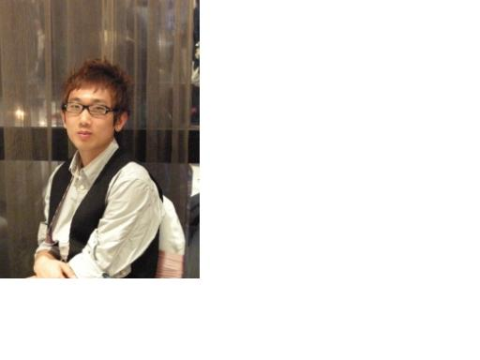
Alex Kim (김규성)
Address: 10 James Street Lidcombe 2141
Mobile: 0423 835 419
Email: beyond_ur_dream@hotmail.com

Personal Information____________________________________________________
Sex: Male
Date of birth: 20th of February 1990
Age: 20

Objective_____________________________________________________________
To develop my career as a customer serviced assisstant and pursue my interest, as this will greatly assist in my future career.

Education_____________________________________________________________
2002 – 2007 Concord High School
Higher School Certificate
2008- 2010 Macquarie University
Bachelor Of Commerce & Law
Languages____________________________________________________________
English (fluent)
Korean (fluent)

Qualifications
Provisional Driver’s License P2
RSA (Responsible Service of Alcohol)

Availability
MON - SAT FULL TIME

Work Experience_______________________________________________________
2003-2005 Cyber Internet Café Burwood
Cashier Part-time – after school hours (Monday – Friday)
-Serve in the front counter
-Assist in the customer’s inquiries
2005 – 2006 Mcdonalds, Burwood Westfield Shopping centre
Cook Part-time – after school hours (Monday – Saturday)
-Taking orders from customers
-Making burgers and other menus
-Serving the customers
-Helping out in the after-hours cleaning
- March ~ september Magazine and Newspaper Delivery , City
Every Friday
-Carrying out duty service to customers
-Taking responsibility
2007 Nov ~ 2008 Feb Poongnapdong Korean BBQ Restaurant (Eastwood)

-Serving the customers
-Taking orders from customers
-Helping out in the after-hours cleaning
-washing the dishes
-preparing simple foods

2008 Feb~ 2008 May Pumpkin Café/Restaurant (Strathfield)

-Serving the customers
-Taking orders from customers
-Helping out in the after-hours cleaning
-washing the dishes
-making cold beverages

2008 May ~ 2008 August The Coffee Club Rhodes
-Serving the customers
-Taking orders from customers
-Helping out in the after-hours cleaning
-washing the dishes
-making cold beverages
-make coffee when busy

2008 August ~ 2009 Feb Eastwood Karaoke
-serving the customers
-Cleaning the shop
-Cashier duties

2009 Feb ~ 2009 May Newington Newsagency
-serving the customers
-working at the cashier

Teaching History

2008-2010 Private Tutoring,
I have taught more than 20 students through private tutors. Subjects I taught were maths and English. I have helped my students with their school assessments and improved their weak parts of English.

2006-2010 Kalos Prebyterian Church Sunday School teacher

제가 10년째 섬기던 교회에서, 4년간 주일학교 보조교사로 봉사하며, 아이들을 돌보고 양육하며 이민2세대들을 위해 영어예배를 매주 드렷습니다. 또한 매주 월요일 저녁 교회에서 매주잇는 무료 영어교실 교사로서도 섬겻습니다

2009-2010 Ebenezel Mission School (After school programs)
At Ebenezel Mission School, I was a teacher for English and Drums for children aged from 8-14.

Hobbies & Interests_____________________________________________________
Shopping
Movies
Socialising
Basketball
Soccer
Going to Gym

References____________________________________________________________
Jennifer Kim Owner of Magazine delivery
0430 278 418
William Kim Owner of Cyber internet cafe
0422 839 952

Robin Lee Owner of Pumpkin Restaurant/café
0415 878 525

Abby Franchise Owner of Rhodes Coffee Club
0416 220 705
Andy Eastwood Karaoke
0411 171 786

Jim Newington Newsagency
0424 548 887

위 내용은 모두 사실을 근거로 하였으며, 저는 제가 호주에서 11년간 부딪히며 배우고 익히고 피부로 느낀 영어의 관한 모든 지식과 노하우, 가르침의 경력을 통하여서, 한국에 수많은 영어로 인해 고통하고있는 사람들을 위해 제 의지를 불태워서 그들을 섬기고 싶습니다.

Alex Kim

