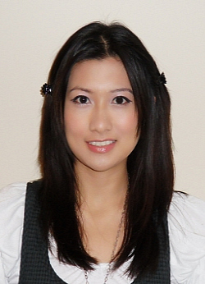
Arlene May Martinez
1003-5088 Kwantlen Street
Richmond, British Columbia
Canada V6X 4K5
ammartinez87@gmail.com
(604) 644-2841

PERSONAL DETAILS
Birth: Legazpi City, Philippines 07/16/1987
Marital Status: Single
Citizenship: Canadian
Mother Tongue: English

EDUCATION
2005 – 2009 University of Toronto, St. George Campus
Toronto, ON, Canada
- Honours BA, English Language and Literature
With a Minor in History
With a Minor in East Asian Studies

TESL/TESOL TRAINING
2009 Oxford Seminars
Toronto, ON, Canada
- Oxford Seminars TESL/TESL Certificate (100 hours)
With specialization in Teaching English Grammar

EXPERIENCE

2008- 2009: Sensational Servers
Assisted with preparation of wedding receptions, business meetings, and private party functions. Duties included setting up buffet tables, greeting and serving guests, and attending to their needs.

2008: Private Tutoring
Tutored children ages 12 and 13 in the subject of English language and literature. Duties included teaching lesson plans that touched on grammar, spelling, vocabulary, essay-writing, and thesis-building.

2007-2008: East Side Mario’s Restaurant
Attended to the needs of the guests in the restaurant. Duties included greeting and serving guests, and ensuring prompt and reliable service.

2007: Mr. Greek Restaurant
Attended to the needs of the guests in the restaurant. Duties included greeting and serving guests, and ensuring prompt and reliable service.

RELEVANT SKILLS & EXPERIENCES

Editor-in-Chief of the Clarkson Clarion, Clarkson Secondary School’s student-run newspaper
Peer Mentor for P.A.G.E.S. at Clarkson Secondary School
Regularly volunteer a minimum of 10 hours every month at my local church congregation
Travel Experiences: United States, Philippines, Japan
Interests: reading, writing, photography

REFERENCES

Available Upon Request

