C U R R I C U L U M

V I T A E

A l a n B u r t e n s h a w

Personal Details:

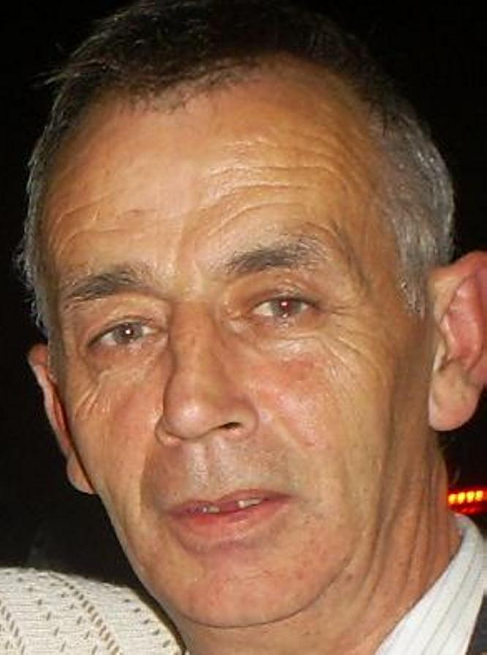

Name: Alan Burtenshaw

Address: 36 Cabra Road
Dublin 7

and

1760 St. Evins Park, Kildare
Monasterevan
Co. Kildare

Telephone: 085 - 8136620

PPS Number 1615154P

Email: burtenshawalan@hotmail.com

Car Owner \ Licence: Full (B, C1, E+B, and E+C1)

- National University of Ireland Teaching Degree

- C.E.L.T Certificate in Teaching English (Department of Education)

- FAS / Fetac Registered Trainer

- Irish Computer Society of Ireland:

ECDL
ECDL Testers Certification
ECDL Advanced Certification
(Word, Excel, Access & PowerPoint)
ECDL Expert Certification
ECDL Web Page Design Certification

- First Aid Certificate

Work Details:

Academic Director & English and IT Lecturer Success College
IT Lecturer (Dublin and Dubai) Royal Canal Terrace
(Delivering IT Lectures in Dubai) Phibsboro
ECDL & London City & Guilds Dublin 7
July2008 – August 2009

IT Lecturer Kildare Computer Academy
Teaching (8 – 28) ECDL (Fetac Lev 2 / Fas Course) Centre Ltd
Part Time Academy St
Kildare Co Kildare

IT Lecturer Medway College
Teaching City & Guilds IT Diploma Nth Cumberland St & Abbey St
Full Time Jan 07 – June 2008 Dublin

Computer Tutor Portarlington Computer Centre
Teaching Staff, Laois County Council Portarlington
ECDL & ECDL Advanced Computers Co. Laois
May/ June 2008 (Part Time Contract Work)

IT (E.C.D.L.) Tutor Kildare Computer Academy
Fas / Fetac Level 2 Course Academy St
Feb / March / April 2009 Kildare, Co Kildare
Phone: 045/535907 or 085/7314122

Hobbies:

Athletics (Coaching) \ Swimming \ Travelling \ TV Sports \ Driving

Chairman
Monasterevan Community Games 2006/2007/2008
Co. Kildare

P.R.O. & Club Head Coach 2000 – 2009
Monasterevin Athletic Club
Monasterevin Co. Kildare
Coaching Athletes for National & International Competition

Referees:

Mr. Emi Akatobi
Success College
Phibsboro
Dublin 7
Phone 01/8828885 or 085/1421519
Email: successcollege@dublin.com

Ms Lynda Kennedy
Course Director
Dublin School of English
5 Wellington Quay
Dublin 2
Phone 01 / 6773322

