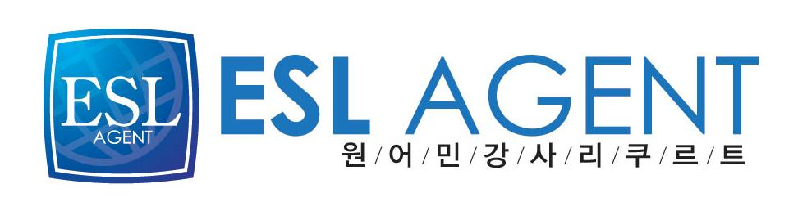
이에스엘 에이전트
김민수대리
02-2675-0582
017-569-6666
Amanda KATE Lee
Personal Information
▪ Nationality: Australian
▪ Place of Birth: Sydney, Australia
▪ Date of Birth: 14/11/84

Education
2003-2007 Griffith University Brisbane, Queensland
Bachelor of Biomedical and Biomolecular Science
▪ Major: Biotechnology
Extracurricular activities
▪ Member of the Australian Biotechnology Society
▪ Member of CARE Australia
Professional experience
Tutored exchange students to Griffith University to help improve their English, both conversational and business English. Also proofread their essays and helped correct grammatical errors
March 2007- December 2007 Taught English to students of all levels from Kindergarten children to Adults at Washington English Academy in Gireum, Seoul.
May 2008 - March 2009- Taught English to elementary and middle school students at Hagye English Academy
April 2009 - February 2010- Teaching English to elementary school students in an after school program at Balsan Elementary School
.
August 2009- Hwagok Cultural Center English Camp- Organised science classes for elementary school children for a summer program. Curriculum development involved.

2007 - 2009-Private tutoring of students of all ages, and thesis editing of university students.

Languages
▪ English (Native speaker)
▪ Korean (Beginner level)
Interests and activities
▪ Reading, Language Studies, Music

