RESUME

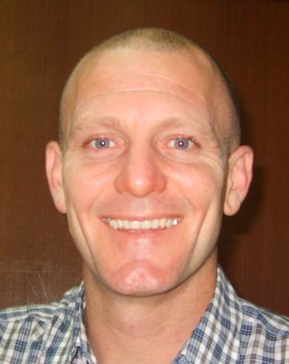

Name: | Aaron David Cant
Date of Birth: | 04/07/1972 (Age 37), Australian
Address: | 서울특별시 양천구 신정4동 964번지 8호 1층
Phone:  Email: | (휴대) 010-2734-7821  moonlight98@hotmail.com

EDUCATIONAL QUALIFICATIONS

Secondary

1989 | Senior Certificate – Wavell State High School

Tertiary

1998  2000 | Bachelor of Arts (Humanities)  Majors – Asia/Pacific and European Studies  Bachelor of Arts (Honours)  Area of research – Global political economy

Selection of Credit to High Distinction Undergraduate Units

- Australian Politics
- Asia/Pacific Political Studies
- Latin American Studies
- Modern Indonesian Studies
- Modern Japan
- Rise of Modern China
- Australian Studies
- Texts & Meaning
- Foundations of Modern Europe

OTHER SKILLS & QUALIFICATIONS

Communication and Speaking Skills

- Negotiating out-of-court settlements with insurers and solicitors

- Attending WorkCover Queensland Medical Assessment Tribunals

- Liaising with plaintiff clients

- Briefing and instructing legal Counsel

- Addressing team meetings and training seminars

- University lecturing and tutoring

Research Skills

- Accessing Internet and CD-Rom databases

- Researching public and court records

- Library research

- Individual interviews and factual research

- Report writing

- Preparation of legal briefs

Technical Skills

- Microsoft Windows and associated programs

- Some DOS Applications

Clerical Skills

- Drafting correspondence

- Drafting legal pleadings

- Administering legal files

- Assessing legal costs

EMPLOYMENT HISTORY
July 1995  to  July 1998 | Study at QUT – Attained Bachelor of Arts (Humanities) graduated September 1998
February 1998  to  January 1999 | Runcorn Tavern – Liquor Barn Attendant
Duties: | Customer service  Cash handling/balancing  Stock control
January 1999  to  January 2000 | McInnes Wilson Lawyers – Paralegal Clerk
Duties: | Administering plaintiff files  Court attendances  Drafting correspondence  Drafting court documents  Attending settlement conferences  Liaising with solicitors, barristers and insurers  Preparing briefs for counsel
2000 | Bachelor of Arts (Honours) at QUT – Graduated February 2001
April 2000  to  Dec. 2001 | Hotel Indooroopilly – Liquor Store Attendant (Casual)
Duties: | Customer service  Stock control  Cash handling and balancing
July 2000  to  Dec 2004 | Queensland University of Technology – Casual tutor and lecturer
Duties:  August 2005  to  Dec 2006  Duties: | Preparing and presenting lectures  Leading tutorial discussions  Participating in course and curriculum development  Marking student essays and examinations  Hi! English Academy, Buyeo – ESL Teacher  Teaching elementary to adult level English  Assisting students with TOEFL and SLEP preparation  Outside contract teaching at elementary and middle school  Teaching to English Club at Buyeo County Offices
March 2007  to  Present  Duties: | KNC Hyunjae Academy Mokdong – ESL Teacher  Teaching B4 to B6 Level middle school students  Teaching TOEFL and TEPS preparation  Teaching entrance examination preparation classes for International and Special Subject High Schools

VOLUNTEER WORK

1998 | Volunteer Tutor – Brisbane State High School
Duties:  2006 | Tutoring students with special needs  Teacher and staff support  Preparation of resource materials  부여군 청소년상담센터
REFEREES

- Dr Gary Ianziti
Associate Professor, School of Humanities and Human Services
QUT Carseldine
Beams Road
Carseldine QLD 4034
Phone: (Office) 61+7+31384581 (Home) 61+7+33781891
Email: g.ianziti@qut.edu.au

- Dr John Ainsworth
Lecturer, School of Humanities and Human Services
QUT Carseldine
Beams Road
Carseldine QLD 4034
Phone: (Office) 61+7+31384678 (Home) 61+7+32636836
Email: j.ainsworth@qut.edu.au

- Dr Elizabeth Ferrier
Lecturer, School of English, Media and Art History
University of Queensland
St Lucia QLD
Phone: (07) 3365 2552
Email: l.ferrier@mailbox.uq.edu.au

