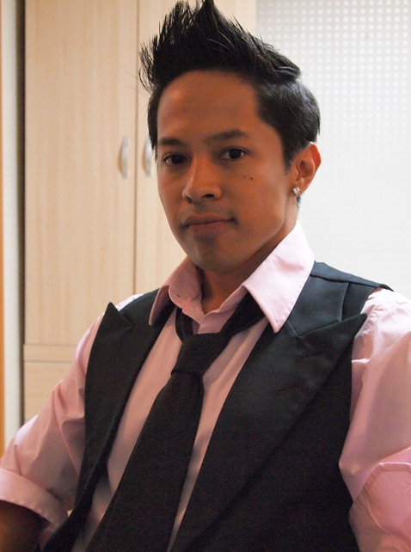

Aaron Batara
1508 Jinnexvil 706-20 Yeoksam Seoul, S.Korea - Tel: (010) 4081 - 6075 email: aar1877@yahoo.com

SKILLS I am proficient with MAC OSX, and Windows. I have knowledge with
such programs as DigiCel Flipbook, Adobe Photoshop, Adobe Premiere,
Adobe After Effects, Power Point.

EDUCATION Academy of the Art University, San Francisco, Ca.
2D Animation Major, Spring 2000-Winter 2007
Graduated with a BFA in Illustration/Animation

iTTT, International TEFL 100hrs training program certificate

EXPERIENCE

5/12-Present Iljuk Elementary School, Anseong City, South Korea
English Teacher - My responsibities are teaching English to elementary students. My tasks included organizing lessons, preparing class lessons, and doing activities and games to help students have a better understanding of the English language. I also teach an after school class in the evenings to students using English and Art.

09/11-4/12 Hope for Japan, Ala Moana Center, Hawaii
My duties include sales and customer service for a clothing company which donates a portion of the profits to the Japan relief effort. Proceeds from the clothing sales are donated to the Akaihane Kyodo Bokin charity, that accepts contributions on behalf of the Central Community Chest of Japan for relief efforts.

08/10-11/11 The Walking Company, Waikiki, Hawaii
My duties were servicing and assisting many tourists for comfort footwear. My responsibilities also include opening/closing the store, meeting sales quota, cashiering, and providing excellent customer service.

09/09-01/10 Ralph Lauren Polo, Waikele, Hawaii
Seasonal Floor Sales Associate, customer service, stocking, and maintaining the stores visual appearance.

06/09-07/09 American Renaissance Academy, Kapolei, Hawaii
Summer Animation Instructor - I guided students from ages 9-16 in the fundamental basics of hand drawn animation at a private college preparatory school. My duties included organizing lessons, assigning in-class assignments, and doing demonstrations.

07/08-01/09 Hawaii Film Partners, LLC. Hawaii Kai, Hawaii
Storyboard Artist - Contract work for “Guardians of the Power Masks”. An animated tv series co-produced with GIMC animation studio in Korea.

REFERENCES: Available upon request

