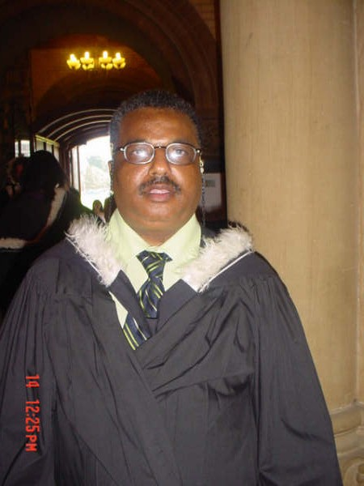

Name

Abdalla Alwi BAFAGIH.

Date and Place of Birth

December 14th 1958.

Mombasa. Coast Province.

Kenya.

Marital Status

Married.

Nationality

Canadian.

Address

5 Brahms Avenue Suite 203,

Toronto, Ontario M2H 1H2. Canada.

Telephone/Cellphone

011-416- 491-4786./ 011-647-928-4782.

Email address

abdalla.bafagih@utoronto.ca Alternative email address: abafagiha@gmail.com

Education
2006 - Rotman School of Management, University of Toronto, Toronto, ON.
Bridge to Business Graduate (B2B).

2005 - University of Toronto, St. George Campus, Toronto, ON.
Bachelor of Arts (Hons. with Distinction).
Specialization in African Studies Program and
Major in Equity Studies Program.

2000 - Transition Year Program at University of Toronto (TYP).
Graduate Transitional Year Program.

Awards, Fellowships, Grants
2006 - Scotia Bank Entrance Scholarship.
2005 - The Ruth Reiffenstein Book Prize in African Studies.
2005 - TYP Graduate Achievement Award.
2005 - Karen Braithwaite Award.
2005 - Gordon Cressy Student Leadership Award.
2003 - NCCA In-Course Scholarship (OSOTF).
2003 - Paul Mathew Memorial Scholarship in Humanities.
2001 - Golden Key International Honor Society.
2000 - Transitional Year Program Academic Award.
2000 - Dr. Keith Allen Award.

Employment Experiences
2006 - 2007 – On Contract as Voice over Reorder and Swahili Translator.
Audience Communication and Events. 17 Isabella Street, Toronto, ON. M4Y1M7.
- Translated text from English to Swahili language.
- Translated video clippings from English to Swahili.

2000 - 2002 - Student Relief Worker (Work Studies Program).

Transitional Year Program, University of Toronto, 49 St. George Street.

Research/Library Assistant for Dr. Wanja Gitari and Dr. Belle Leon.

Photocopied and organized course material for professors at TYP.

Relieved front office when on lunch break/vacation/holiday or sick.

Referred students to various resources and services offered by the University.

1990 - 1999 – Lead Hand/Senior Machine Operator
The Stewart Group Inc. 259 Steelcase Road West, Markham, ON.
- Responsible for the entire night shift.
- Answered telephone calls for our international and local customers.
- Trained new employees on running machines safely and also to produce quality products for our customers.
- Prepared production reports, weekly and monthly targets and assisted Shipping and Receiving Department when required.
- Sat on both Quality and Safety Committees.

1989-1991 – Senior Machine Operator
Fasco Products Division of Indal Limited. Mississagua, ON.
- Team Leader of production department cutting aluminum bar for shower doors.
- In charge of assembling and packing finished shower doors.
- Managed a team of twenty seven (27) employees.

Related Experience

2008 - Assisting Women in Kenya in creation of Women Empowerment Program (KWEP).

2007 - Contributed with others to create an online Kiswahili resource ─

The Kamusi Project: http://kamusiproject.org/sw/prepositions
2005-Present – Organizer/ Workshop facilitator.
UMOJA Women Association (UWA), Mississauga, ON
- Organized fundraising events for projects in Kenya.
- Assisting in outreach work to build awareness on Women’s issues in Africa.
- Prepared PowerPoint presentations on behalf of UWA.
- Facilitated Workshop on the importance’s of community based organizations.

2003 – 2006 - Tutor and Mentor.
New College at University of Toronto.
- Tutored and mentored undergraduate students.
- Providing essay editing, library and internet research and presentation skills.

2003-June 2005 – Coordinator.
- Mum’s and Dad’s Student Group, New College at University of Toronto, Toronto, ON.
- Advocated and acquired an office and resource center for Mum’s and Dad’s Group.
- Arranged and conducted monthly social gathering and meetings.
- Provided members with resource and strategies of how to deal with stressful situations.

2002 - 2003- Tutor and Mentor.
Transitional Year Program at University of Toronto.
- Tutored and mentored undergraduate students.
- Providing essay editing, Library and internet research and presentation skills.

Computer Skills
- Word, Excel, Power Point, Access and Outlook.

Languages
- Fluency in English and Kiswahili.

Portfolio
- Portfolio available upon request.

References
- References available upon request.

