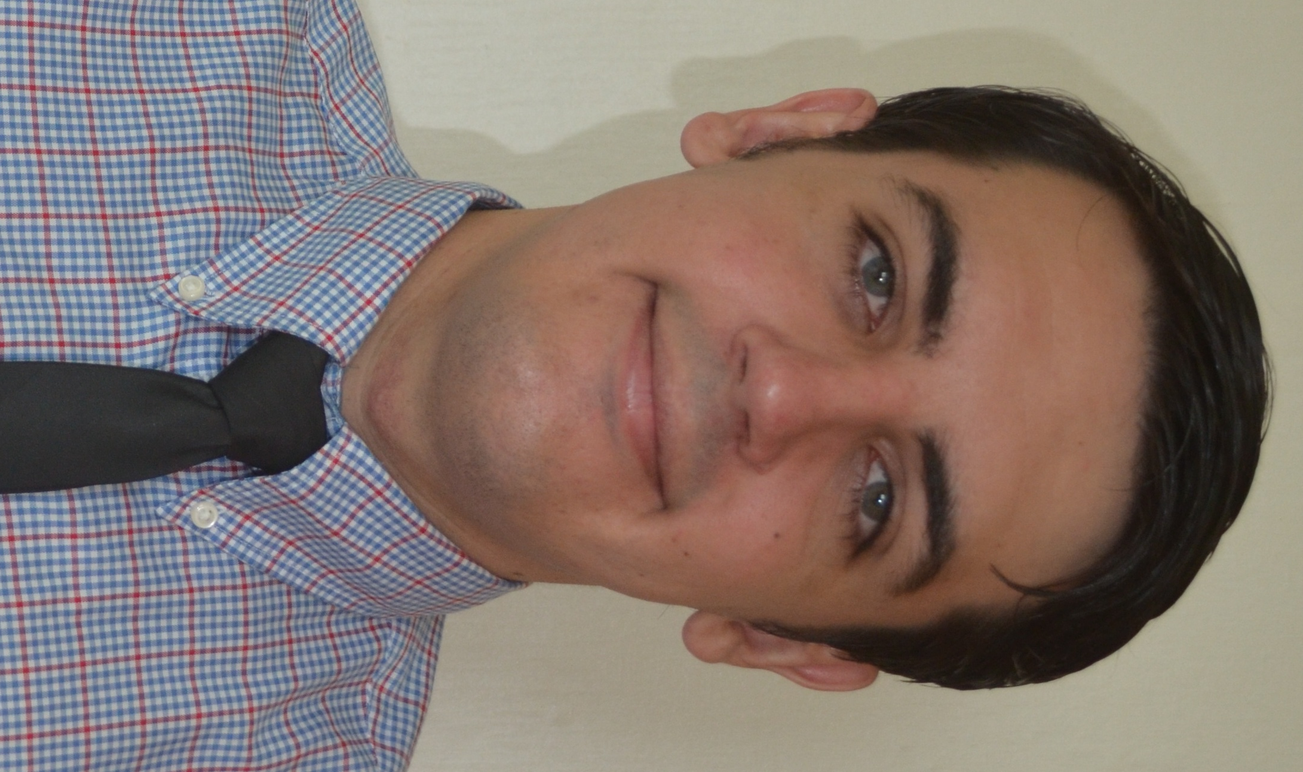

Adam Park

Education
TESOL Certificate III, Teach International, Brisbane, Australia.
Graduate of Bachelor of Business (Majors: Employment Relations & Management) Griffith University, Brisbane, Australia.
Graduate of McAuley Catholic College, New South Wales, Australia.

Experience

TEFL Teacher: For the last year I have been a TEFL teacher at ECC in Jinju, South Korea. I have taught children of all ages from kindergarten to high school students. I am very enthusiastic and enjoy helping students. I have gained many new skills during this time such as classroom management and better communication skills. My responsibilities include, writing student evaluations, correcting written work, conducting speaking tests and some class preparation.

Student: During my time as a student at university I worked in many group assessments with both local and International students. Having this opportunity helped me to gain experience working and learning with people of many different cultures and seeing how they learn. This experience has been useful in the TEFL classroom as I have been able to use this knowledge while teaching to help students learn effectively.
Call Centre Operator: I worked for BUPA which is a health insurance company in Australia. During my time in this position I learned how to solve many different issues in a timely manner and working using telephones helped to improve my communication. These skills have assisted in the TEFL classroom as it helped my communication skills and time management is essential to any class.
Sales Assistant: I was a sales assistant at Liquorland which is a liquor outlet in Australia. While I was there I took on some supervisory roles that included training people. This part of the job helped me to familiarise myself with teaching. I thoroughly enjoyed teaching and instructing new staff and helping them to learn the business practices. I believe this experience has been a great asset to the TEFL classroom as it gave me both some experience and enthusiasm for teaching.
Checkout Operator: I worked for Coles which is a supermarket chain in Australia. While I was working there I politely conversed with people whilst operating a checkout. I learned from this how to work with customers and also multitasking skills. These have been great elements to have in the TEFL class as I am used to conversing with customers of all ages and as a teacher I always use my multitasking skills.
References
Seuyon Chung – Head Teacher ECC Academy
E-mail: seuyon@hotmail.co.kr Number: 010-8595-330
Trinity Jeong – Head Teacher ECC Academy
E-mail: jbrimsuk@hanmail.net Number: 055-763-0509

