ADRIAN MATTHEW ALIM
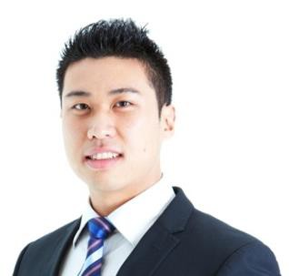

Address: 1/71 Frances Street, Lidcombe, NSW 2141, Australia
Nationality: Australian
DOB: 28/09/1988
Mobile Phone: +61 413 351 199
Home Phone: +61 (02) 9643 7899
Email: alim.adrian@gmail.com

Employment History

November 2012-Current Westfield Sydney (Flagship Centre) Customer Service Representative
- Sell and assist Westfield Sydney services to customers.
- Communicate and collaborate with Head Office, Marketing and Centre
Management staff on numerous projects.

February 2012-June 2012 Korea Advanced Institute of Science and Technology (KAIST, Daejeon, South Korea) KAIST Engine Laboratory
Internship Program
- Setting up and performing experiments on specific engine concepts (Spray and Combustion Characteristics under Ultra-High Injection Pressure).
- Associated industry projects (Doosan Heavy Industries, Hyandai Motors)
- Applying programs (MATLAB, Photoshop and Microsoft Excel) to obtain experimental results.
- Exercise strict laboratory safety standards.
- Proofread and edit technical documents.

August 2012-November 2012 TOLL People – Commonwealth Bank of Australia
Mailroom Clerk – Commonwealth Bank Mailroom (Darling Park 1)
- Deal with over the phone and face to face enquiries or issues.
- Organise incoming and outgoing mail in CBD office environments.
- Use Microsoft Access and other Microsoft programs to process mail.

October 2012 Australian International Motor Show (Sydney) 2012
Promotional Host
Holden (Car Brand)
- Promote the Holden range.
- Assist with inquiries regarding Holden and the motor show.
- Maintain high levels of customer service at all times of the show.

July 2009-October 2010 Online electronics business
- Communicating with international clients from China.
- The ability to import and organise products from international clients from
China.
- Provide careful handling of products and efficient Australia wide postage.
- The ability to manage the finance, market research, design layout of product descriptions, sales of products and customer enquiries or issues.

July 2008-February 2009 Luna Park, Sydney
Merchandise Store Team Leader/ Sales Assistant
- Setting up and balancing the till whilst opening or closing the store.
- Handled customer complaints, enquiries and resolved issues in a professional manner.
- Train/supervise staff and monitor performance and appraisal.
- The ability and initiative to develop and apply sales and service skills.

Aug 2004-April 2008 Woolworths, Newington
Service Operator
- Cash handling and balancing, including EFTPOS Work unsupervised.
- Applied Occupational Health and Safety Standards.

Educational Qualifications

2007-2012 University of New South Wales – Bachelor of Engineering (Aerospace)
School of Mechanical & Manufacturing Engineering
(Graduated with Honours) (Converted Average GPA: 3.0/4.0)

2007 TAFE NSW - Certificate II in Engineering
- Metal and Engineering Industry Training

2006 Homebush Boys High School - NSW Higher School Certificate

Extra-Curricular Activities/Achievements

Member 2009-2012 Member of The Institution of Engineers Australia
Volunteer 2007-2011 Indonesian Night Market (UNSW)
Prefect 2006 Member of Homebush Boys’ High Prefect Body
SRC 2004-05 Member of Homebush Boys’ High Student Representative Council Peer Mediator 2005-2006 Member of Homebush Boys’ High Peer Mediation Group Certificate of Merit 2005 1st in Engineering Studies, Homebush Boys’ High School
Grade Sport 1st Grade Rugby
Senior & 1st Grade Knockout Hockey Team (Captain)
AMEB 2002-2004 Australian Music Examinations Board – Pass with Honours (Piano)

Skills & Interests

Technical Skills: Microsoft Word, Excel, Power Point, MATLAB, PATRAN/NASTRAN, CATIA (High Level)
Language Skills: English (native) Indonesian (background) Korean (basic)
Interest: Korean Culture and Language, Business, Gymnastics, Piano, Song Writing

References

Choongsik Bae
Professor
KAIST Engine Laboratory
Department of Mechanical Engineering, KAIST, Daejeon, South Korea
Office Phone: +82 42 350 3044

Dr.Maruf Hasan Thesis Supervisor Lecturer
School of Mechanical & Manufacturing Engineering, The University of New South Wales
Office Phone: +61 (02) 9385 5692

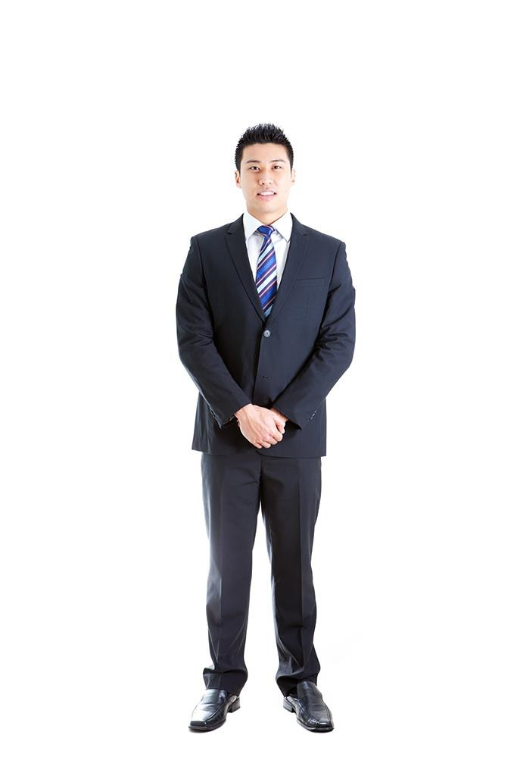



PASSPORT AUSTRALIA DC T

Type rype Code
p Sl3te AUS


a e/Nom
ALIM
ADRIAN MATTHEW

AUSTRALIAN

28 SEP 1988

M

22 DEC 2008
22 DEC 2018
AUSTRALIA
M9243997

ST LEONARDS



P<AUSALIM<<ADRIAN<MATTHEW<<<<<<<<<<<<<<<<<<< M9243997<3AUS8809287M1812224<30074470F<<<<84



I.Paula Teague,NOTARY PUBLIC,herebythat
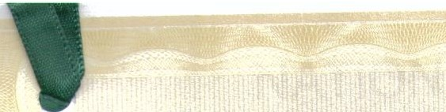

this copy document of Ipagels is a uue copy of the original
document of which it pwports to be a copy, which original document )(a,s today been produced anti.shovJn to me
1>u I qf 'Dec 12-


t.JNSW T

THE UNIVERSITY OF NEW SOUTH WALES pULA TEAGUE

SYDNEY · GANBERRA ·AUSTRALIA . UBLIC NOTARYP
Identification No.1051


LevelS, 65 York Street
SydneNSW 2000
This is to certify that + 61 2 8215 1585 pt@siriuslaw.


ADRIAN MATTHEW ALIM

has this day been admitted by the Council to the degree of

BACHELOR OF ENGINEERING
in Aerospace Engineering
with Honours Class 2 Division 2



Chancellor

Pro-Vice-Chancellor (Students)
and Registrar

By authority of the Council, the Seal of the University is hereunto affixed this seventeenth day of December 2012
f:t.

Vice-Chancellor

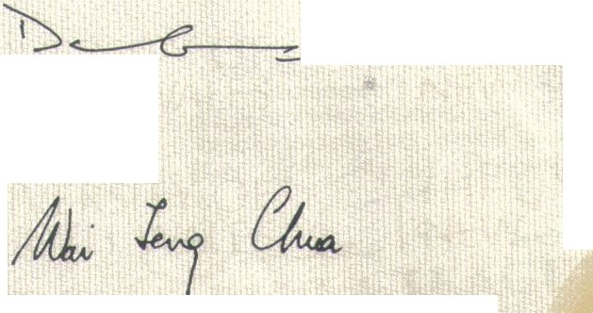



NATIONAL POLICE CERTIFICATE

AFP Ref: 82706PC Client Ref:

11 December 2012
Australi<:m Federal Police Criminal Records Locked Bag 8550
CANBERRA C!TY ACT 2601
Ph: 02 6140 6502
ABN 17 864 931143



ADRIAN MATIHEW ALIM

1/71 FRANCES STREET
UDCOMBE NSW 2141

Standard Disclosure
All recorded unspent offences released
Name Check Only

This is to certify that there are no disclosable court outcomes recorded against the name of:

AUM, Adrian Matthew born on 28 September 1988

in the records of the Australian FederalPolice and the police in all Australian States and
Territories as at 11 December 2012.

This document is not issued as a fonn of aentification.



Co-ordinator I, Paula Teague, NOTARY PUBLIC,hffeby that this copy document of I pagels is a true copy o.f theginal document of whiCh it purports to be a copv which anginal
CriminalRecords eerti1't
document,ba;s today been proC\!Ced ani'n to me
1h1S lli'"- c.,....jOu 1

T,
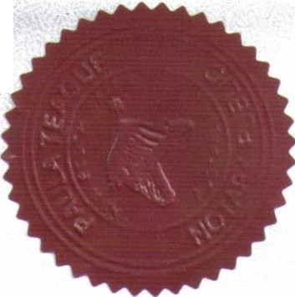

NOTARV"'PUB lC Identification No.1051
Level S, 65 York Street
Sydney NSW 2000
+ 612 8215 1585
pt@siriuslaw.com. u

Page 1of 1
1 The information contained in this document is valid as at date displayed. ( 1
/
f
This certificate is produced on secure paper to provide proof of authenticity.
Several security features are integrated within the document, some of which are described overleaf.




The absence of any of the security features indicates this is not an original document.

.•

-o 00 :-" :t..- :-
a i5 -::r;l (")
0

2 el -·
:::>
>
"'
, s- -·
"0
":::>'

...,_
:::> CJ'O
Q.... n : l :lc:cr

.. ...
i
;; ";;'.
"i't"s-C- §g:
"' Kl &. § Q
.

:::>
• r 3 :::>

"' i
"'0 -· n n<

0::s

'i; ; a.
0.... -o<..., E!.
t;t; -- c.
E!.
i'


Q.
b;' .,

>c Z..I.:.' -!?" Q
2"02"0
> n >

en ;li :!I -.- =1 0
..
.

- g &. c-l.,-l
!!.
:I:
....,

0 - · ii'
... v.
Q,:O
- Q. !:"'
'" s..-.a.. E.i 2: n
Y'g

<o <.. -·..
c !:"'
("'I

a ;;. ;:;
a· &.e- .,
-!..
g:
;:;

1:11
.1.1.0...
...

iW -r::r :0
c

5..' ..
•
e
ii p' "'

Q. :'
-l
iZ
Q.
!"

This Apostil/e only certifies the authenticity of the signature and the capacity of the person who has signed the public document, and, where appropriate, the identity of the seal or stamp which the public document bears. This Apostille does not certify the content of the document for which it was issued.

)

