Details  Contact  Objectives  Availability  Work Experience  Education  Skills  Personal Qualities  Interests | Curriculum Vitae  조아라 (Jennie Cho)  20th of February 1991  nationality: Korean Australian (17 years in Australia)  Mobile: 010-6887-0810  Email: jennie.ahra@gmail.com  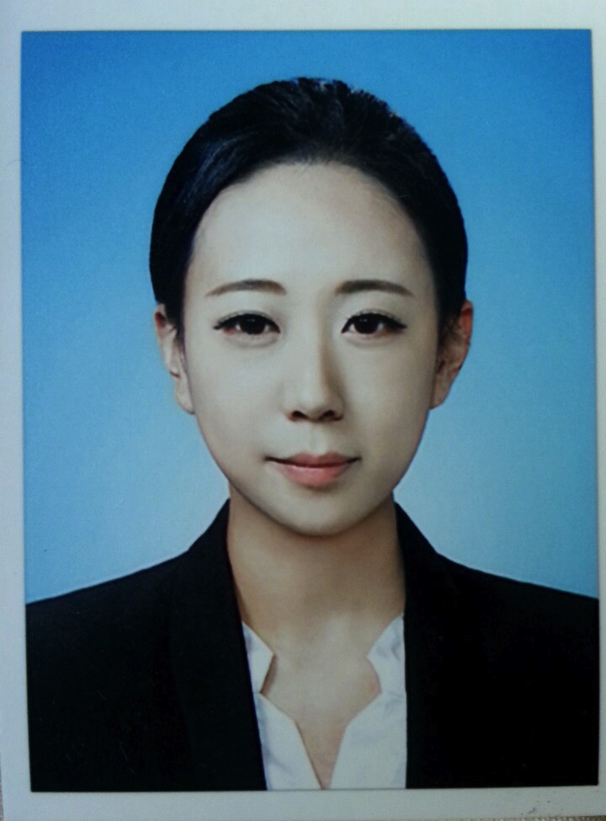  Located: Currently residing in Seoul, Mokdong  visa type: F4  As I have decided that teaching children is something that I have grown being passionate about, I have come to Seoul from Sydney to pursue my goals in becoming an English teacher for young children.  Everyday  Part-time Private English tutor, Sydney  (Early June 2011~ Early December 2012)  - Professional tutoring  - Reading and writing  - Speaking  - Working with more than one child at a time  - Professional teaching and supervision  - Ability to get along with children  Second in Charge/Sales Assistant at ‘Ice Design’, Rhodes Shopping Center Sydney  (Early August 2012- Early December 2012)  - Professional communication skills  - Reaching set budget  - Outstanding customer service skills  - Management skills  - Visual merchandising  - Strong team player and leader  Work experience at Holy Cow! Design Studio, Surry Hills Sydney  (Early Aug 2011-Early September 2011)  - Efficient worker even whilst under pressure  - Meeting deadlines  - Strong worker alone and in a team  - High level communication skills  - Outstanding knowledge of design  - Experienced with Adobe programs  Part-time Private English and Ancient History tutor  (Early June 2009~ Early December 2009)  - Professional Reading writing and speaking  - Professional teaching and supervision  - Ability to get along with children  - Organized and structural teaching  Promoter for ‘Phat Entertainment’, World Square Sydney  (July 2009- May 2010)  - Professional communication skills  - Successful promoting  - Fast cash handling  - Dealing with a large number of customers  - Hosting  2009 – University of Western Sydney  Bachelor of Design in Visual Communications  Higher School Certificate completed in 2008, Cherrybrook Technology High School.  English Advanced, Mathematics, Ancient History, Food Technology and Visual Arts.  - Fluent in both Korean and English  - High level visual and verbal communication skills  - Capable with children  - Adobe creative suite program user (Photoshop, Indesign, Flash, Illustrator, DreamWeaver)  - High level skills in Microsoft Word, Excel and Powerpoint  - Fast with both Mac’s and Pc’s  - Works well in a team  - Efficient organizing skills  - Fast learner  - Children’s story book illustrating  - Fast Adaptability to change  - Loves children  - Loves to meet new people  - Honest and reliable  - Enthusiastic  - Ability to work fast even under pressure  - Teaching  - Children literature  - Meeting new people  - Trying new challenges  - Learning new things  - Illustation

