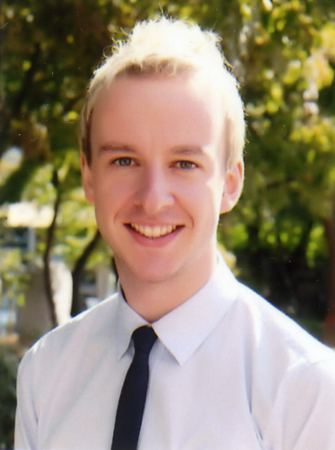
Aidan McAuliffe
Date of Birth: February 4th, 1985
Nationality: Irish

Education
2003 – 2007 Mary Immaculate College, University of Limerick, Ireland

B.A. Honours Degree in English and Media & Communication Studies
- I have completed courses in English Literature, TEFL, German, Journalism, Scriptwriting, and Voice & Speech Performance amongst various other courses.
- I studied for one semester in Frostburg State University, Maryland, U.S.A.

1998 – 2003 Scoil Phobail Sliabh Luachra, Rathmore, Co.Kerry, Ireland

Leaving Certificate Exam (State Exam)

Result: Four A grades (honours) and two B grades (honours)

Employment

2013-Present Active Centre of English Training, Cork, Ireland

- I currently work as an English teacher for the summer season in Cork’s most prestigious English language school.
- I teach adults from all over the world.
- My lessons cover all aspects of English language education including grammar, conversation, reading, and writing.

  - Freelance English Language Teacher in Seoul

- I held long-term part-time positions at three different academies.
- I was the sole English teacher at two Korean kindergartens: I-gaem Academy, Seocho-gu, Seoul and I-gaem Academy, Yongsan-gu, Seoul.
- I worked as a kindergarten and elementary teacher at Kids Brown English Academy in Nowon-gu, Seoul.
- I created English programs from scratch and taught them to first-time English language learners.
- I prepared and taught lessons to students aged from 3 years old to 11 years old.

  - Sangmyeong Elementary School, Junggye 3-dong 515-1,
Nowon-gu, Seoul 139-725.
Elementary School English Language Teacher

- I was responsible for 136 second grade students.
- I taught ‘Writing & Composition’ to students of all different levels.
- I was responsible for co-ordinating and directing drama performances.
- I assisted in organising English camps and creating English camp clubs and materials.

2010-2011 Canada Public Institute, Alumni Centre 2nd floor, No. 215, 15-1 Haengdang-dong, Seongdong-gu, Seoul 133-791.

Kindergarten & Elementary English Language Instructor

- I taught English to students aged from six to thirteen years old.
- I was responsible for approximately 50 students of all different levels.

  - Giorgio Armani Pty. Ltd., Sydney, Australia

Position held: Sales Consultant for international luxury brand Emporio Armani.

  - SPIN South West Regional Radio, Limerick, Ireland

Positions held: Presenter of the daily breakfast show
Music Director for the station

  - Bus Eireann (Irish Bus)

Position held: Customer Service Officer/Office Clerk

Additional Information

- I have a TEFL certificate, which is accredited by ACELS, part of the National Qualifications Authority of Ireland.
- I have lived outside of Ireland before (in the U.S.A., Australia and South Korea).
- I have extensive international travel experience.

Referees

- Ms. Eunice Oh, Head Teacher, Canda Public Institute, Alumni Centre 2nd floor, No. 215, 15-1 Haengdang-dong, Seongdong-gu, Seoul 133-791.
Telephone: (c)+82 11 291 9703 e-mail: 31970403@daum.net
(l)+82 2 2295 3864
- Mr. Peter Newbury, Head English Teacher, Sangmyeong Elementary School, Junggye 3-dong 515-1, Nowon-gu, Seoul 139-725.

Telephone: +82 2 9716 214 e-mail: peternewbury@me.com

