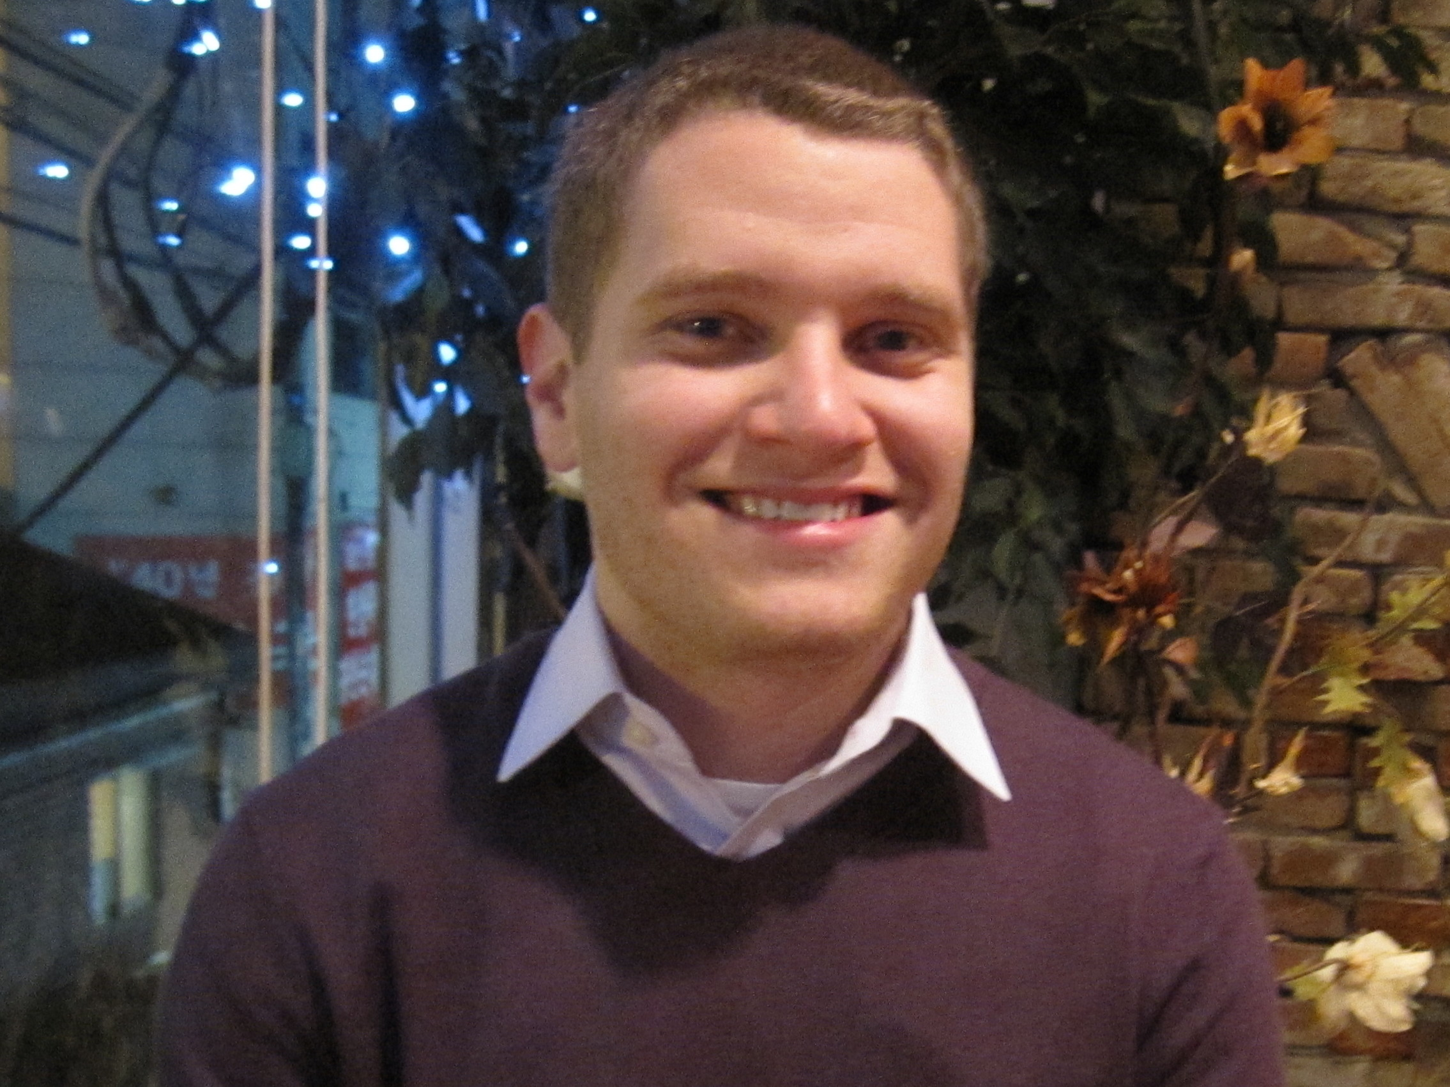

Alexander Foreman

3212 Valleybrook Dr., Champaign, IL 61822 aforeman@vikings.northpark.edu

OBJECTIVE
To obtain an English teaching job in Seoul, South Korea to both utilize my classroom learning and expand my skills while supporting the organization’s mission and goals

SUMMARY
- First skill, has experience tutoring English to beginner and intermediate students
- Second skill, very enthusiastic and outgoing with children
- Third skill, able to adapt to the classes needs

EDUCATION
North Park University Chicago, IL
B.S. in Business and Economics, Concentration in Marketing May 2013
- Cumulative GPA of 3.33 on a 4.0 scale
- Studied abroad Jan.-Jun. 2011 in Seoul, South Korea at Sungkyunkwan University

International TEFL Academy Chicago, IL
TEFL/TESOL Certificate accredited by NCFE April 2013

PROFESSIONAL EXPERIENCE
Feeding America Chicago, IL
Direct Marketing Intern Jan.-May 2013
- Assist with project management of new direct marketing efforts and national branding
- Support Direct Marketing team with day-to-day operations
- Assist with maintenance and clean-up of the donor database as needed

Norwood Crossing Chicago, IL
Marketing Intern Jun.-Aug. 2012
- Used CRM for marketing reports
- Created brochures using Microsoft Publisher
- Assisted with marketing promotional events

Chicago International Social Change Film Festival Chicago, IL
Marketing Intern May-Aug. 2012
- Used social media to expand awareness and interest
- Developed spreadsheets for possible donors using Google Drive

North Park University Chicago, IL
Statistics Tutor Jan.-Jun. 2012
- Tutored college students in statistics
Intramural Soccer Referee Oct. 2008-Dec. 2011
- Refereed indoor intramural soccer matches between student teams

VOLUNTEER AND EXTRA CURRICULAR ACTIVITIES
Vietnamese Association of Illinois Chicago, IL
ESL Tutor Jun. 2012-Jun. 2013
- Tutored basic English to Vietnamese adults
- Practiced the Citizenship Test with Vietnamese people seeking to become U.S. citizens

North Park University Chicago, IL
East Asian Student Association Treasurer Aug. 2012-May 2013
- Submitted budget plans to our student government and check requests
- Helped create and organize events

North Park University Chicago, IL
East Asian Student Association Member Aug. 2008-May 2013
- Studied cultural differences and learned basic Korean
- Volunteered in local Asian communities by assisting elderly people
Business Club Member Aug. 2008-May 2013
- Attended business seminars and student body gatherings

