Angela chung

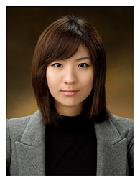

Personal Profile

Residential Status: New Zealand Citizen
Address: Yuksam-Dong 824-25, Daewoo TheOville Plus Unit 819
Email: moyomj@yahoo.com.au
Mobile: +82 10 8460 6220

CAREER OBJECTIVE

To apply my skills and experience in order to successfully pursue a career as a marketing manager with considerable advancement opportunities
- Able to work independently and also within a team environment.

Education

2008 Griffith University
Major: Chinese & Japanese

WORK EXPERIENCE

Japanese private tutoring, 2001- ongoing

- Preparing materials
- Tutoring students

English private tutoring, 2002- ongoing

CCS Consulting, 2002

- Immigration Service
- Oversea Student Service
- Translator,
- Secretary
- Customer Service

Chambers International, 2003-2005

- Translator (English ↔ Korean)

Chinese private tutoring, 2006-2009

- Preparing materials
- Tutoring students

Idean21, 2007- ongoing

- Marketing Manager

Languages

- Korean: Native
- English: Native
- Chinese: Advanced
- Japanese: Advanced
- Italian: Beginner

PERSONAL ATTRIBUTES

- Fast learner
- Able to work under pressure and achieve goals
- Reliable and committed
- Enthusiastic
- People skill
- Good communicator

interests

- Reading
- Gym
- Learning languages

references

Harrion KIM
Managing Director of Idean21
+61 48 169 818
Idean21@yahoo.com.au

