Angie KEW: young, ambitious, keen ESL teacher!

South Korea

Thank you for the provisional interest you will show in my proposal to apply for a position at your educational institution.
Should my proposal be accepted it would, without a doubt, be an achievement of my ultimate aspiration: to fuse my English and western culture with one of the most influential English schools in South Korea

Acceptance of this application would be beneficial to you for the following reasons:

- I thrive on education and knowledge and have a some what unconventional approach to teaching English. I believe that students will progress and have fun in an environment conducive to innovative ideas, laughter and action.
- I work hard
- I have 1 year teaching experience in Korea
- I understand and have adapted to Korean Culture
- Employing me would provide you with an opportunity to amalgamate Eastern and Western culture.

I am available to start work from August / September 2010.

Should you view this opportunity in a favourable light it would not only be the ultimate experience for me, but would give you and the students an opportunity to learn and have fun.

Yours sincerely

Angie Kew

Angie Kew
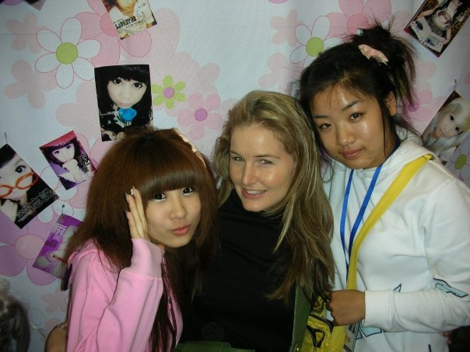

Curriculum Vitae



Angie Kew
Character Traits & Career Aspirations
Me
Those who know me often refer to me as: culturally adaptable, flexible, tolerant, unconventional, efficient, Fun, funny, Friendly, full of life, eccentric with flair, out the box, 360 degree outlook, driven, positive, social butterfly, hard worker and Hard player ...

Passion
My passion and precision for communication and marketing has kept me strong and motivated through the duration of my tertiary education. Coming first in my class for four consecutive years proves my dedication and commitment.
For the past year I have discovered the joys of teaching English as a foreign language. My persistence, patients, tolerance and fun personality has been the result of many students loving English in Korea.

I strive to be a lifelong learner
My inquisitive nature and need for information leads me to believe that I will be a teacher of ESL projection for the next 5 years.
Tolerance, an open mind and love for adventure will make my stay in Seoul a massive success.

Communication Skill
I understand that my best tools are my ears

Niche
I am a Creative fun loving girl, who loves teaching English

Contact details: A Kew

010 62 63 1402 Kew_angie@yahoo.com
Personal Information

Date of birth: 14 February 1985

Nationality: South African

Marital status: Single

Mobile number: 010 62 63 1402

E – Mail: kew_angie@yahoo.com

Criminal record: None

Language: Fluent in English and Afrikaans
Basic Korean

Education

Institution: Graduate School of Marketing
Program: IMM, Degree
Time period: February 2006 - 2008

2006 subjects: Business communication
Business law
Business management (distinction)
Marketing 1
Macro economics
Micro economics
International marketing 3
2007 Subjects: Marketing 2
Consumer & buyer behaviour
Marketing communications
Statistics
Marketing 4
2008 Subjects: Financial aspects of marketing
Marketing research

Achievements: IMM academic award for Economics
Chair lady of the student liaison body
Head of the debating team
Social Project manager

Institution: Varsity College
Program: Certificate in Advertising
Time period: 2004 - 2005
Subjects passed with 8 distinctions: Advertising, Account Management, Advertising Research, Consumer & Buyer Behaviour, Communication Science, Personal Computing, Marketing Communications, Marketing, and Media Planning
Achievements: 2004 Varsity College Top Student
Communications Officer
Student body member

Institution: Varsity College
Program: Diploma in Advertising
Time period: 2005 - 2006
Subjects passed with 6 distinctions: Advertising, Communication Science, Marketing, Copy Writing, Financial Management, Marketing Communication, New Media Concepts, Production Management, and Strategic Planning.
Achievements: 2005 Varsity College Top Student
Miss Varsity College 2006
Communications officer of the Student liaison body

Teaching Experience & qualifications

Current position: English teacher
Start date: 1 June 2009
End date: 1 June 2010
Program: GEPIK
Location: NamYang, S Korea

Previous experience: English teacher
School: Protea
Program: volunteer work
Location: South Africa
Duration: 6 months

Qualifications:
- Experienced TOEFL teacher
- Experienced business English teacher
- Certificate of excellence from the Korean government
- Experience with elementary & adult levels
- Diploma in advertising
- Degree in Marketing & communication
- TEFL
- Gepik coordinator assistant
- 8 weeks on the job teacher training
- 10 Weeks Korean language
- 10 weeks Korean culture training
- 15 Workshops and seminars attendance

Marketing Internships & industry experience

Company: Labour Wise & Kempston Group

Time period: 2002 - 2004
Position: Receptionist

Company: SAB, DIESEL JEANS, SMINT,
&QUERVO
Time period: 2001 - 2006
Position: Sales Promotions / Activation
Tasks: - Project Development
- Marketing Research
- Promotions

Company: Mauro’s Restaurant

Time period: 2002 - 2006
Position: Manager
Tasks: event Coordination

Company: AVIS

Time period: 09 Feb– 20 Dec 2007
Position: Marketing Intern
Tasks: - Assisting: Ned bank Golf Challenge
Woman’s World Cup of Golf
- Kurland Ball (Polo Plett)
- Hospitality: Avis box NGC & Lanseria airport JHB
- Correspondence with key accounts & clients
- Order & Distribution of promotional apparel

Company: Algoa Fm

Time period: Jan 2007 – August 2008
Position: Hit squad member / Freelance marketer
Tasks: Promotions
Brand Building
Brand communication
Launches
Brand amplification

Company: Grey worldwide Advertising

Time period: 09 June `08 – 23 May`09
Position: Client service intern
Tasks: Client service / account management
Briefing
Client interaction
Activation
Status reports
Contact reports
Brain storming & conceptualisation

References:

Reference letters, documents & qualifications will be faxed on demand

