Anna So-Young Na

12 Solander Close Turramurra N.S.W 2074 Australia
0422 839 162 • 02-9488 7743
soyoung0305@gmail.com

To:

Hello, my name is Anna So-Young Na. I was born in Seoul, Korea. My family and I immigrated to Sydney, Australia when I was 7 years old. I am an Australian citizen and have been a resident in Sydney for over 20 years.

I have studied in Sydney University studying Bachelor of Nursing for 2 years. In my 2nd year of nursing I wanted to visit my home country, Korea. I have taught children in Korea for a year and then moved back home. After teaching children in Korea I realized I had great passion towards children and enjoyed working with them. So when I moved back I applied to study Bachelor of Early Childhood. I graduated from Macquarie University that specialises in Early Childhood Education. In 2008 I completed my Bachelor of Early Childhood Education 0-12years, a 4 year degree. In my 2nd year of study I did some causal work for Ku-ring-gai Kindergarten and a permanent position was offered to me that year. I studied on a full-time basis and worked full-time as a room leader, teaching 2-6 year olds along with my assistant. Already 4 years have past working as early childhood teacher hence a leader. Every day has been a new experience and new learning as an early childhood advocate.
I also work part time for Macquarie University as a Masters Teacher. I work as a cooperative teacher and take on student teachers. I guide the student teacher by checking their lesson plans, observations and current & future goals. The practicum can go from 2 weeks to 4 weeks. I also meet up with the Macquarie University adviser to discuss the student’s progress.
I hold a first aid certificate and attended a child protection seminar to develop my professional development.

After finishing my studies and working as a professional with children I developed more interest to work in Korea. I especially want to teach young children in Korea and also experience the education system.
I believe this will allow me to further develop my philosophy in early childhood education and care.

I believe that children are cable, competent and resourceful learners and the early childhood teacher’s role as a professional is to scaffold and foster children’s strengths, interests and knowledge.
Have a browse through my resume. My resume reflects my passion and love to work with children. I am keen to look forward to your replies, thank you for your time.

Yours sincerely,

Anna So-Young Na

Anna So-Young Na

12 Solander Close Turramurra NSW 2074 0422 839 162 soyoung0305@gmail.com
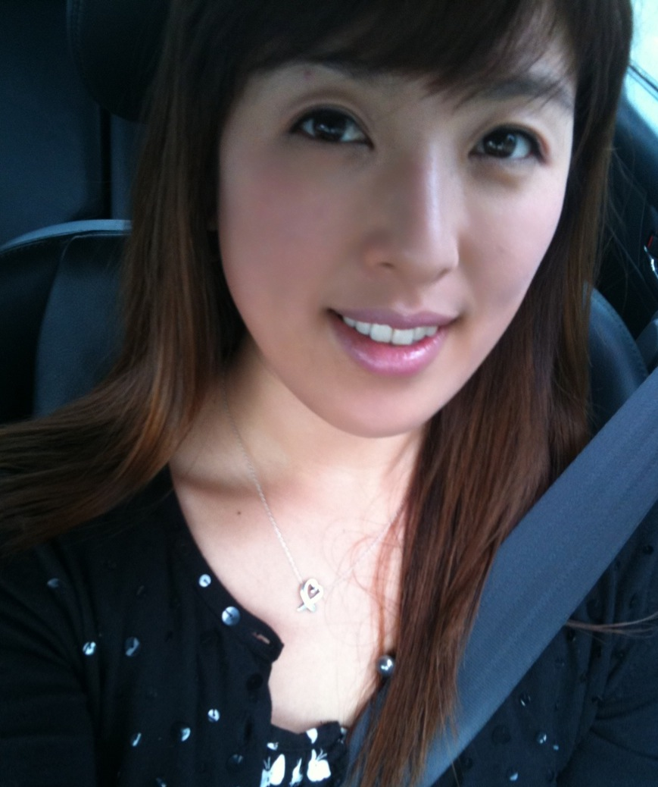

Profile
Name: Anna So-Young Na
Gender: Female
D.O.B: 05.05.1982
Age: 29 years
Nationality: Australian

Objectives
To explore the culture of Korea and experience teaching young children of another culture

Education
Macquarie University, North Ryde, Sydney 4 year degree 2005 to 2008
Bachelor of Early Childhood Education (0-12 years)

The University of Sydney, Sydney 3 year course 2000 to 2002
Bachelor of Nursing

Experiences

Macquarie University reflective practice

Sarah’s long day care centre 1st Semester of 2006
- 1st practicum for 2 weeks and 3 full observation days
- Experience working in childcare centre with 0-2 year olds
- Develop a rapport between staff, children and families
- Be aware of the centre’s policies and procedures
- Develop portfolios for a few children and practice writing developmental summaries
- Plan one experience a day and implement the objectives of the experience

Ku-ring-gai Kindergarten 2nd Semester of 2007
- 2nd year practicum for 2 weeks and 3 full observation days
- Planning and implementing experiences for children
- Gathering observations of 4 children and develop a child portfolio of each child
- Take part in modifying the learning environment for children
- Quarter to half days teaching responsibility and a full day teaching responsibility

Hornsby Hospital Long Day Care Centre 1st Semester of 2008
- 3rd year practicum for 3 weeks and 3 full observation days
- Gain experience with the infant age group, 0-2 years
- Observe babies and plan experiences that are age appropriate for this age group
- Practice observation techniques to develop portfolios and developmental summaries
- Provide a learning environment for children with additional needs
- Quarter to half days teaching responsibility and 2 full day teaching responsibility

North Turramurra Public School 2nd Semester of 2008
- 3rd year practicum for 3 weeks
- Implement lesson plans for grade 2 students covering the Key learning areas
- Working alongside the teacher and assisting her in preparing learning materials for students
- Adapting early childhood practices and teaching strategies in the classroom
- Playground supervision with classroom teacher
- Participate and attend staff meetings at required times
- Develop a pedagogical documentation on children’s learning, mathematical concept- capacity

Ku-ring-gai Kindergarten 1st Semester of 2009
- 4th year practicum for 4 weeks and 3 full observation days
- Develop teaching formats e.g. program, observations and focus child systems for documentations
- Practice guiding children through the routine e.g. managing transitions and leading the room
- Plan and implement language and music experiences
- Increased number of full day teaching
- Develop a pedagogical documentation on the children’s spontaneous learning, friendship

Volunteer work

- South Turramurra Heaven Nursing Home 2002 to 2003
- Open door Presbyterian Church Sunday school teacher, primary 2003 to 2006
- Open door Presbyterian Church Sunday school teacher, kindergarten 2006 to 2008

Working experience

NP Metro Management P/L 1998 to 2003
- Telemarketer and Contractor

Taylor’s Pharmacy 2003 to 2005
- Sale assistant, stock new items on rack, mange customer complaints, serve customers and provide appropriate advice to customers regarding the goods and services of the product,
- Dispensing of medication

Child minding for families (Part time job) 2006 to 2008
- Carer, meeting individual needs of children and families through the care of children

Ku-ring-gai Kindergarten 2008 to present
Early childhood teacher/room leader

Caring for children 2 to 6 years, child portfolios, daily journals, programming, recording observations, advocating as a team leader, providing developmental feedback to parents and families, providing a stimulating environment for indoors and outdoors, modelling positive behaviour and planning experiences to extend children knowledge and learning in a play- based environment

Macquarie University 2010 to present
Master Teacher (Take on students from Macquarie University twice a year)
- Student teacher education program. Guiding the student teacher, enhance growth and development.
- Working as cooperating teacher. Observing the student on practicum.

Reference contact

Please feel free to contact Annie Lodwick, Director of Ku-ring-gai Kindergarten on
(02) 9144 3742 or 0411 261 792.

