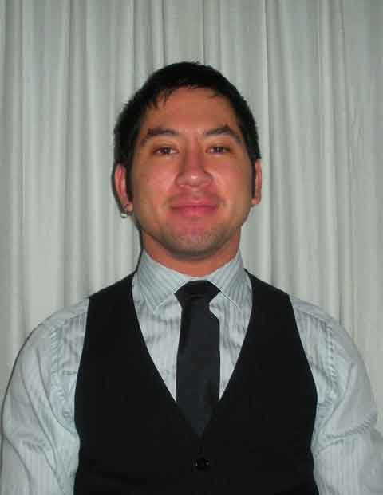
Anthony Leon Guerrero
PERSONAL INFORMATION
First Name: | Anthony
Surname: | Leon Guerrero
Address: | Attn: Anthony S. Leon-Guerrero,  Wonderland Buk Gwangju, #1425-2 Yongbong Dong, Bong Eun B/D  3F, Buk-gu, Gwangju, Republic of Korea
Mobile: | +82.010.8689.5425
Skype: | ErnieLG
E-mail: | ErnieLG@GMail.com
Birthplace: | Trenton, New Jersey, USA
Date of birth: | 28-10-1984
Gender: | M
Nationality: | USA
Native Language: | English
Driving License: | Current California state driver's license holder.
OBJECTIVE
 | A Busan or possibly Seoul ESL teaching position as early as February 9, 2011 that could benefit from years of ESL instructing experience across three different continents with students as young as preschoolers or advanced as adult CEOs earning a minimum of 2.3 million KRW.
TEACHING EXPERIENCE
12/2009 - 12/2010
Wonderland Buk Gwangju, #1425-2 Yongbong-dong, Buk-gu, Gwangju, Republic of Korea
 | - ESL Teacher
 | Instructed children aged three to fourteen years old. Taught all aspects of conversational and written English in as many as nine classes daily. Taught supplemental materials in English such as art, science, social studies, and math. Motivated as well as disciplined students. Took children on field trips and helped plan monthly fun events. Wrote grades and individual evaluations on a monthly basis. Wrote theatrical productions and directed rehearsals with children for annual talent shows and graduation ceremonies. Dined with children while supervising lunchtime and snacks.
 | 09/2009 - 12/2009
 | TEAM Ed, POB 6617, Folsom, CA 96763, USA
 | - Private High School Tutor
 | Tutored one-on-one Algebra II and English Literature.
 | 12/2008 - 05/2009
 | Open Foxá, C/ Agustín de Foxá, 25, 28036, Madrid, Spain
 | - ESL Teacher
 | Taught English classes to business executives of varying skill levels in areas ranging from general conversation to finances to religion. Prepare relevant course material in-advance, assigned homework, and kept attendance.
 | 08/2008 - 12/2008
 | Sandemans New Madrid, C/ Toledo, 69, 4º, E, 28005, Madrid, Spain
 | - English Tour Guide
 | Sought clients interested in city tours of Madrid in various hostels and locations, and led fun, educational four-hour walking tours on a daily to weekly basis.
 | 02/2008 - 06/2008
 | Lindamood-Bell Learning Processes, Inc., 1610 Arden Wy, Suite 277, Sacramento, CA 95815, USA
 | - ESL Teacher
 | Tutored non-native English-speaking children aged five to nine in English skills including reading, spelling, and pronunciation. Led classes for one to six students. Logged progress of students in various skill sets on daily basis. Created fun and active ways to learn. Administered snacks and breaks.
 | 03/2007 - 01/2008
 | Boys & Girls Club of Auburn, 1103 High St, #300, Auburn, CA 95603, USA
 | - Teen Services Director
 | Tutored and directed activities for at-risk children and teenagers in after-school environment. Planned recreational, social, and skill-based projects for children. Contacted clients and donors via phone, e-mail, and face-to-face. Organized community service projects. Collaborated in meetings, composed monthly reports, and supervised other staff. Planned budgets, itineraries, and staffing for week-long events and trips for local youth.
 | 06/2006 - 12/2006
 | UCSC Learning Support Services, 1156 High St, Santa Cruz, CA 95064, USA
 | - PreCalculus & Algebra Teaching Assistant
 | Taught one-on-one and in classes of up to fifty adult college students. Prepared lesson plans, review sessions, study guides, and hand-outs. Participated in weekly teacher meetings. Proctored and graded exams. Communicated with students via e-mail in regards to course materials.
 | 08/2005 - 09/2006
 | Merit Educational Consultants, LLC, 2392 North Rodeo Gulch Rd, Soquel, CA 95073, USA
 | - Private High School Tutor
 | Tutored one-on-one Spanish, writing, and SAT mathematics.
 | 10/2004 - 06/2006
 | Natural Bridges State Beach, 2531 West Cliff Dr, Santa Cruz, CA 95060, USA
 | - Docent & Receptionist
 | Produced fun and interactive presentations. Led tours through forests and tidepools for elementary classes and general public using various technology and resources. Organized community events and activities for local youth such as games, arts & crafts, animal petting, making ice cream, plays, and parades. Greeted large volume of patrons, designed brochures, operated cash register, answered phones, and maintained contact database.
 | 09/2005 - 12/2005
 | Gault Elementary School, 1320 Seabright Av, Santa Cruz, CA 95062-2597, USA
 | - 2nd Grade Teacher’s Aide
 | Aided in class work, graded assignments, and organized recreational activities.
 | 07/1998 - 08/2002
 | Roseville Parks & Recreation, Spanger Adventure Club, 699 Shasta St, Roseville, CA 95678, USA
 | - Day Care Aide
 | Tutored and cared for children ages 3 to 12. Prepared meals, took active role in organized activities, and performed maintenance work on a daily basis. Read books, prepared arts & crafts projects, and played sports & games. Collaborated with other teachers and parents to best meet children’s needs.
EDUCATION AND TRAINING
 | 11/2008 - 05/2009
BridgeTEFL, Bridge-Linguatec, Inc. d/b/a Bridge, 915 S Colorado Blvd, Denver, CO 80246, USA
- 120-Hour TEFL Diploma
Business Learners.
Young Learners.
The Roles of the Teacher and Learner, Approaches and Methods; Classroom Management; Language Awareness; Planning Lessons; Productive Skills; Receptive Skills; Teaching Grammar; Vocabulary, Meaning, and Context; Pronunciation; ESL/EFL Audio/Visual Aids; Testing for the ESL/EFL Student; Culture and the ESL/EFL Classroom.
 | 09/2002 - 06/2008
 | University of California at Santa Cruz, 1156 High St, Santa Cruz, CA 95064, USA
- Bachelor of Arts Degree in Mathematics
3.1 GPA
Additional studies in: Education, Computer Science, and Ethics
 | 1300 GRE: 750 Quantitative (83rd percentile), 550 Verbal (75th percentile)
SKILLS AND COMPETENCES
Other Languages: | Intermediate Spanish
Personal Skills: | First Aid Certified  Cardiopulmonary Resuscitation (CPR) for Youth and Adults Certified
Social Skills: | Taught from pre-school up to university in individual and group settings in academic subjects such as Math and English. Instructed topics including diversity and arts. Coached sports and recreational activities. Proven effective educator, speaker, and entertainer through private and occupational public speaking opportunities. Come from a very diverse and accepting background with extensive experiences interacting with all different cultures through work, education, friendships, and family. Enthusiastic and creative.
Organizational Skills: | Finely tuned analytical and research skills with dedication to clear communication and presentations. Adept at maintaining an exceptional rate of productivity and developing processes that reduce redundancy. Have planned budgets, staffing, and itineraries for business trips and events. Introduced and led many community service projects of varying scope. Well-organized.
Computer Skills: | Type 90 WPM.  Operating Systems: Windows, Macintosh, Unix, DOS.  Office Suites: Microsoft Office, Works, Wordperfect.  Internet Software: HTML, Dreamweaver, Frontpage, Outlook.  Multimedia Applications: Photoshop, Paintshop, Movie Maker.  Hardware & Peripherals: desktop system assembly, digital photography.
Interests: | Improving my marathon time and competing in as many as possible (Hawai’I, Spain, and South Korea). Extreme sports such as sky-diving, bungee jumping, rafting, and canyoning in exotic locations. Visiting historical monuments including the West Wall in Jerusalem, the Royal Palace in Madrid, Meiji Shrine in Tokyo, and the Great Wall in Beijing.
Additional Information: | References furnished upon request.

