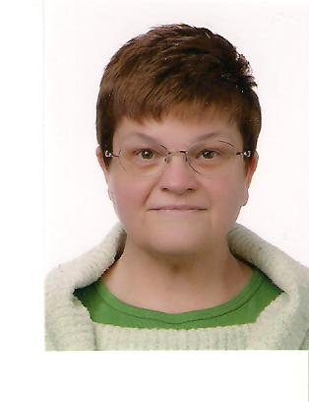
Karen Wolfgang Millam

Nampung-ri YeonHee Villa 101-103

Yeongam-gun, Yeongam-eup Jeollanam-do 526-801

010-8242-3863/cell profmillam@yahoo.com

Last Position
Kongyang University English Language Instructor Mar 2009-Dec 2010

Main tasks: to deliver conversation and presentation instruction to university students; preparation and delivery of instructional materials, as well as program development; coordinator and facilitator of the Honors Program; instruct Korean teachers of English in an intensive teacher training program; assist department administrators with various tasks, as requested, IETTP trainer.

Education
Master of Arts English: TESL/TEFL (Teaching English as a Second/Foreign Language)

1994-1997 Central Washington University (CWU)
Ellensburg, Washington

Bachelor of Arts Individualized Studies: Multicultural Human Resource Management
1991-1994 2nd Major: German Language and Literature

Central Washington University (CWU) Ellensburg, Washington
Teaching History
Sejong Science High School English Writing/Conversation Instructor
Seoul, Republic of Korea Mar 2008-Feb 2009

TEFL International - Kyungbuk University Teacher Trainer
Daegu, Republic of Korea Jan 2009

Kingman Unified School District Substitute Teacher
Kingman, AZ, USA Oct 2007-Feb 2008

BoSeong High School English Conversation Instructor
BoSeong, Republic of Korea Sep 2006-Aug 2007

New Toefl School Director of Education/Instructor
Taipei, Taiwan Apr 2006-Aug 2006

Woosong University English Instructor/Program Coordinator
Daejeon, Republic of Korea Aug 2003-Mar 2006

Univ.Ro Foreign Language Institute EFL Instructor/Recruiter
Seoul, Republic of Korea Jun 2002-May 2003

Kang’s English Language Institute Associate Academic Dean/ESL Instructor
Seoul, Republic of Korea Sep 2001-Apr 2002

SDA English Language Institutes English Language Instructor Seoul, Republic of Korea Jan 2000- Jun 2000

Presentations
July 2009 Imagination in Education Research Group Conference Presenter - Vancouver, BC

April 1997 International Diversity in Mentoring Conference Presenter – Phoenix, Arizona USA

Publications
Article Content-Based Instruction: Practical Application of Theory DHU-TESOL 12/2009

