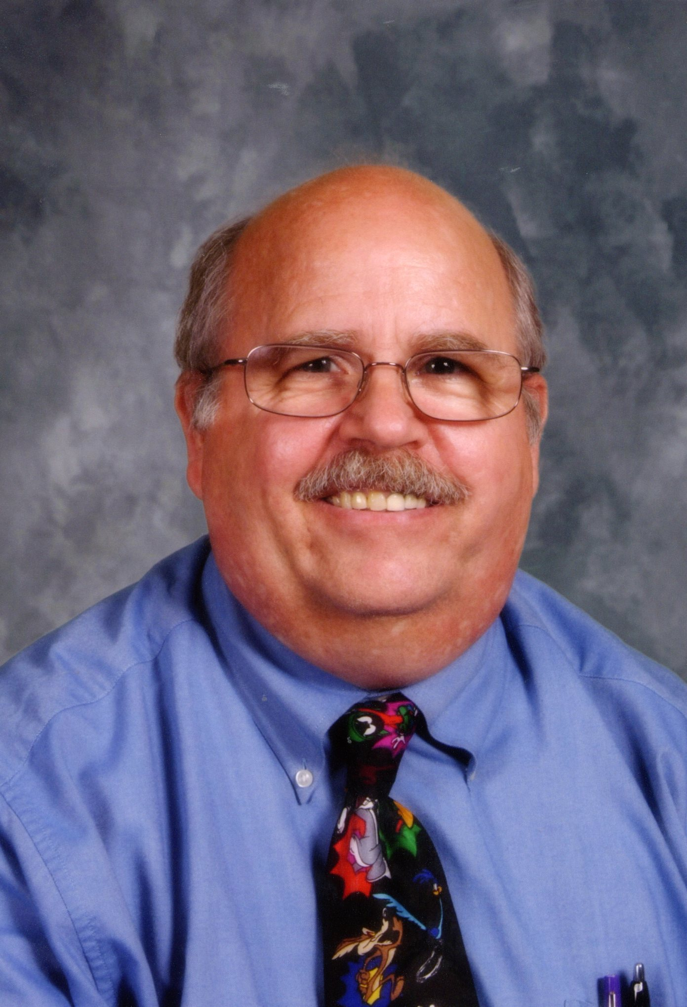
William Backer
628 Westwind Dr., Carpentersville, IL 60110, United States
Home: 001-847-426-1193, Cellular: 001-847-322-3200, webacker@gmail.com
Native English Speaker, Citizenship: U.S.A.
Date of Birth: November 22, 1953, Marital Status: Single

PROFILE
Certified EFL instructor with a diversified background over the past 35 years. Taught all ages of students from Kindergarten through Adult. Recognized for providing effective, clear, and concise information in formats that promote high learning levels. Strong desire to share my passion for languages and different cultures with my students and the global community.

EDUCATION AND CREDENTIALS
120 Hour TEFL Certification, 2010
TEFL Institute, Chicago, IL
Certification, Elementary Education, 2010
State of Illinois
MATC, Master of Arts in Teaching with Certification, 2009
Aurora University, Aurora, IL

TEACHING EXPERIENCE
Erie House, Chicago, IL
EFL Instructor, 2010 to 2010
- Prepared differentiated lessons, created curriculum, and monitored student progress.
- Instructed students in subject matter utilizing various teaching methods, including discussions, cooperative learning, demonstrations and materials to supplement presentations.
- Worked with individual students to increase their reading level by providing one-on-one tutoring
COMMUNITY UNITY SCHOOL DISTRICT 300, Carpentersville, IL
Substitute Teacher, 2008 to 2010
- Followed and taught lesson plans assigned by a permanent teacher for students in Kindergarten through 12th grade.
- Maintained effective classroom management strategies.
- Demonstrated strong communication skills and ability to address various student learning styles.
- Implemented activities and techniques for promoting quality student performance.
COMMUNITY YOUTH SERVICES, Vader, WA
Vista Volunteer Coordinator, 2006 to 2007
- Coordinated the Washington Reading Corps Program at Vader Elementary School.
- Designed volunteer training systems and instructed community volunteers.
- Constructed and implemented family literacy event activities.
EMPLOYMENT HISTORY
HSBC INC., Mt. Prospect, IL
Sr. Business Systems Analyst, 1998 to 2006
- Directed in-house technical staff to meet project deadlines and goals, successfully completing all projects on time and under budget.
- Earned a reputation as a valuable and cooperative coworker by: being fair, honest, and willing to help others when needed; effectively resolving conflicts at appropriate times; and assisting new managers and other staff to become familiar with policy and operations.
ALLSTATE INSURANCE CO., Northbrook, IL
Sr. Business Systems Analyst, 1987 to 1998
- Established new procedures resulting in increased productivity and more efficient resource utilization.
ZENITH ELECTRONICS CORP., Chicago, IL
Sr. Programmer Analyst, 1975 to 1987
- Developed system which tracked the inventory lifecycle from product receipt to distribution.

OTHER EDUCATIONAL CREDENTIALS
B.G.S., Bachelor of General Studies, 1992
Roosevelt University, Chicago, IL
A.S., Business, 1989
Elgin Community College, Elgin, IL
A.A.S., Electronic Data Processing, 1984
Elgin Community College, Elgin, IL

VOLUNTEER WORK
Up Down Kitchen, Chicago, IL
Willow Creek Church, 2001 to 2005
Hike up the Hancock, Chicago, IL
American Lung Association, 2003
MS 150 Bike Ride, Chicago, IL
National Multiple Sclerosis Society, 1998 to 2004

