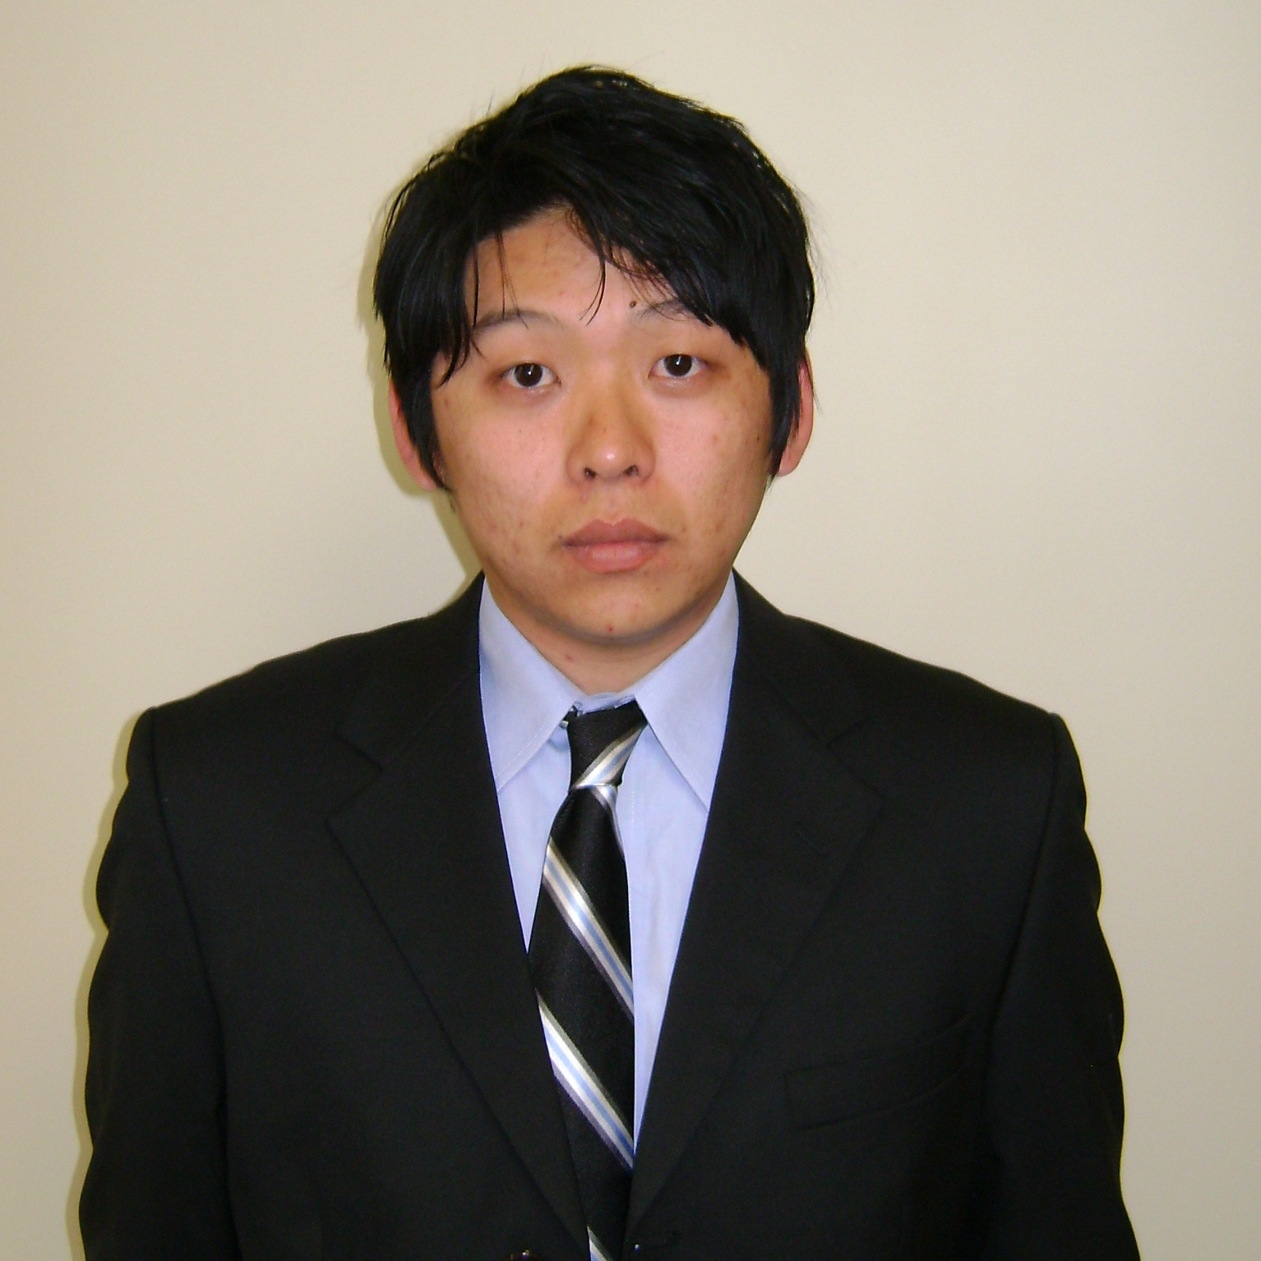 Benjamin W. Reineking
______________________________________________________

Current Address Contact Information
4124 Pipe Creek Rd. Cell # (765)-580-0367
Batesville, IN 47006 E-mail: breineki@gmail.com
Personal Information

Visa status - Current holder of an F-4 Visa
Nationality - USA
Date of Birth - February 6, 1986
Marital status - Single
Health status - Good physical health – Health check-up performed by
Dr. Paul A. Bergfelder (Richmond, IN)
January 2010 – Took drug test: Results showed negative for illegal drugs
Whitewater Valley Rehabilitation (Richmond, IN)
Miscellaneous - Able to understand and speak elementary level Korean

Work Experience

October 2010 – Kent’s Harbor Marina and the Sagamore Resort
Present Located on Brookville Lake (Liberty, Indiana)
I am currently involved with renovations, marketing, and the organization
of a P.B. Dye golf course that was recently acquired by Kent’s Harbor Inc.

February 2010 – English instructor at FasTracKids English hokwon/private school
July 2010 (FTK English - Bundang, South Korea)
I taught kindergarten and elementary school students.

Responsibilities
- Checking and correcting for grammar and spelling errors for academic books that the organization was planning to publish for their curriculum (The books were from Europe so I needed to change the British English into American English. I also checked for comprehension.)
- Checking and correcting grammar and spelling errors for packets which were comprised of short stories and homework exercises.

Work Experience Continued…

- Doing research, collected and compiled information, and simplified sentences from resources about Korean history which were going to be put together into a chapter for the academic books the company was planning to publish
- Created comprehensible lesson plans that were easy to follow and employed a variety of learning activities.
- Focus on improving listening, speaking, and pronunciation
- Focus areas: basic grammar, phonics, interactive games, and team teaching

I utilized the smartboard programs that were supplemented by
the FTK company as well as power-point slides and books to conduct classes.

Summer 2001 – Employee at Kent’s Harbor Marina (www.kentsharbor.com)
Winter 2010 I worked for my family’s business as full-time/seasonal staff.

Position: Dockstore Co-Manager
Responsibilities
- Accounting: Responsible for all daily cash receipts (ex: balancing, credit card deposits, and cash deposits)
- All aspects of boat rental (writing up contracts and instructing on boat operation procedures)
- Retail sales
Related Responsibilities
- Lodging operations
- Familiarizing new customers to our facilities
- Safety procedures
- Boat handling

Fall 2007 Boys & Girls Club (Bloomington, IN)
Responsibilities
- Clean and organize building/area to maintain both a clean and safe environment for kids
- Plan activities and supervise to make sure there were no problems
- Give awards and punishments in accordance to children’s behavior

Note* I only worked for about three weeks because I was ineligible to continue work due to the policy set forth by Indiana University that I had to be on financial assistance.

Education

August 2009 Graduated from Indiana University (Bloomington, IN)
Completed a BA in East Asian Studies

August 2008 – Attended University of Hawai’i at Manoa (Honolulu, Hawaii)
January 2009 *Considered one of the best universities in the
USA for students majoring in East Asian Studies

August 2004 Attended Indiana University (Bloomington, IN)

May 2004 Graduated from Culver Military Academy (Culver, IN)

May 2000 Graduated St. Michael’s Catholic Elementary School
(Brookville, IN)

Activities/Accomplishments

Summer 2009 Took a personality aptitude test for career path options
Results explain I am a well-rounded person who shares characteristics
with people who have a career as a teacher and professors at universities.

Fall 2008 Joined KAHI which is an adoption group of Korean Americans in Hawai’i
- Attended Asian Adoptee Gathering in Honolulu, Hawai’i

Spring 2004 Mission trip to Puerto Rico through Culver Military Academy

Fall 2004 – Joined an intramural soccer team at Indiana University
Spring 2007 The soccer team was mostly comprised of international students from Korea.

Fall 2003 Received offensive MVP award for soccer (High School)

Other activities/sports
- Golf - Lacrosse
- Hunting - Fishing
- Snow skiing - Wakeboarding & water skiing
- Scuba diving - Horsemanship

Summer 2003 Spader Management Marine Consultants (Sioux Falls, South Dakota)
- Personality profiling through Kent’s Harbor Marina
*Exploration of personality types and tendencies
Study to aid in comprehending motivation and improving communication
with the various personality types

Activities/Accomplishments Continued…

2002 Certified lifeguard through YMCA (Batesville, IN) *expired*
Certified scuba diver through YMCA (Batesville, IN) *expired*

2001 Played in the Franklin County High School Jazz Band (saxophone)

2001 Office helper at Franklin County High School
I answered the phone and relayed messages to and from the receptionists,
teachers, and other school faculty.

