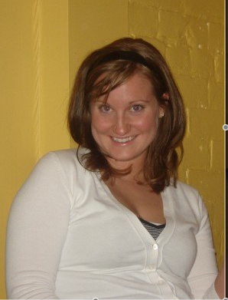
Beth Zimmer

T: 010-8490-1737
E: beth_zimmer@msn.com

Personal Details
Birth: Canada, 12-May-1984
Citizenship: Canadian
Mother Tongue: English
Martial Status: Single
Health: Excellent

Education

2007 TESL Certification - Oxford Seminars
2007 Bachelors Degree - University of Waterloo Major in History
Minor in Political Science
2006 Academic Exchange Program - Sussex England
International Study Center at Herstmonceux Castle
Work Experience

2007- Present
ESL Teacher
- Teach all levels of students from kindergarden to middle school.
- Lesson plans

2006 – 2007 Server - Symposium Café

2006 – 2007 Residence Don - University of Waterloo

2000 – 2005 Accounting Assistant - L. Cordell Accounting

Skills and Experience

Residencies: United Kingdom (5 months)

Travel: Germany, Belgium, England, Netherlands, France, Wales, Italy, Germany, Hungary, Spain, Poland, Czech Republic, Bahamas, USA.

