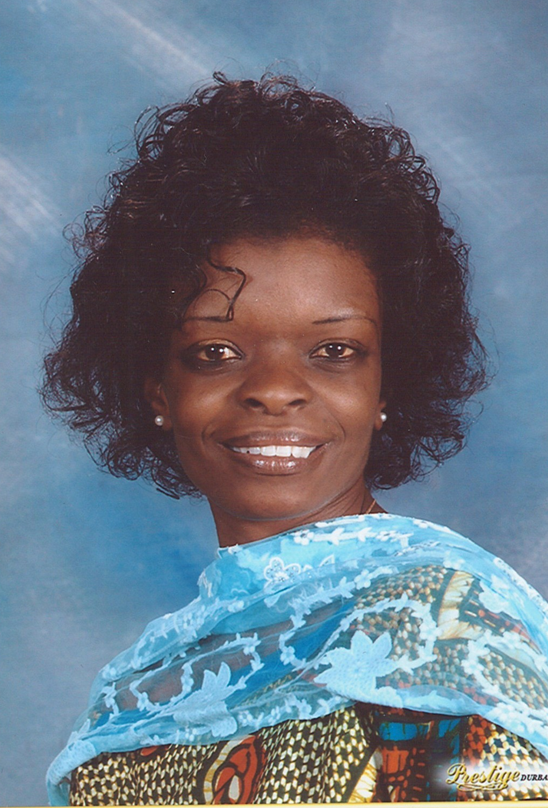
Betty Yeboah
Objective
My objective is to provide my students with the highest standard of teaching tools, techniques and relevant information to ensure that they are well prepared and empowered to make positive contributions in their own lives and the communities that they reside in.
Personal Details
SURNAME: YEBOAH
FIRST NAME: BETTY
RESIDENTIAL ADDRESS : VILJOEN HOUSE
NELSON MANDELA DRIVE
UMTATA
5099
SOUTH AFRICA
POSTAL ADDRESS : UMTATA HIGH SCHOOL
P.O.BOX 243
UMTATA
5099
EASTERN CAPE
SOUTH AFRICA
IDENTITY NUMBER : 7OO817 0841 080
NATIONALITY : SOUTH AFRICA
RELIGION : CHRISTIAN
PROFESSION : TEACHER
HEALTH : GOOD

Summary of qualifications
- - DIPLOMA IN EARLY CHILDHOOD DEVELOPMENT.
FROM ACCESS COLLEGE (DISTANCE
LEARNING)

- - BACHELOR OF ARTS- UNIVERSITY OF VENDA

1993-1995- COURSES PURSUED AT THE UNIVERSITY OF
VENDA:

ENGLISH I,II AND III
LITERARY THEORY I, II AND III
LINGUISTICS I, II
ENGLISH LANGUAGE PRACTICAL
SOCIOLOGY I

ASSIGNED DUTIES AT THE UNIVERSITY OF VENDA

- TREASURER OF THE ENGLISH SOCIETY
- SECOND EDITOR OF THE UNIVEN NEWSPAPER COMMITTEE

Education- SCHOOLING YEARS
1981 – KABWE DOMINICAN CONVENT
1983- JUNIOR SECONDARY SCHOOL-KABWE- ZAMBIA
HELEN KAUNDA SENIOR SECONDARY SCHOOL
KITWE – ZAMBIA
1990 - UMTATA HIGH SCHOOL- UMTATA -EASTERN CAPE
SOUTH AFRICA
Career Highlights
- TEACHING LEARNERS TO SING IN MY LANGUAGE (RECEPTION -5 TO 6 YEARS OLD AND THE DRAMA SOCIETY OF UMTATA HIGH SCHOOL).CO-ORDINATOR AND ORGANIZER OF THE DRAMA SOCIETY.
- INIATIATOR AND EDITOR OF THE ST JOSEPH’S SCHOOL NEWSLETTER – TO RECORD EVENTS TAKING PLACE IN AND AROUND THE SCHOOL.
- INVITED TO GIVE A SPEECH ON BEHALF OF ST JOSEPH’S SCHOOL AT MY FELLOW COLLEAGUES GRADUATION CEREMONY, HELD AT UMTATA INTERNATIONAL SCHOOL.
- PREPARING LEARNERS TO ORGANIZE AND STAGE PLAYS.
- TO EQUIP LEARNERS WITH SKILLS AND KNOWLEDGE FOR THE FUTURE.
- MR DARLINGTON MICHEALS (PAPA G OF ISIDINGO-SABC 3) CONTACTED THE DRAMA SOCIETY AND PERFORMED TWO PLAYS FOR THE SCHOOL ON TWO SEPARATE OCCASIONS.
- THE DRAMA SOCIETY OF UMTATA HIGH SCHOOL PERFORMED AT THE 47TH GHANA INDEPENDENCE CELEBRATIONS. PERFORMED AND RENDERED ITEMS FOR MOTHER’S DAY.
- ELECTED AS A CLUSTER LEADER FOR GRADE 9- ENGLISH CIRCUIT 1 TEACHERS, DURING MODERATION AND ASSESSEMENT OF WORK DONE FOR TWO YEARS.[TRINSET COLLEGE- UMTATA- THE FACILITATOR IS MRS JOMBILE]

- TAUGHT A LEARNER CALLED KARIN VALVERDES FROM CUBA, FROM GRADE 8 TO GRADE 9 ENGLISH.
- KARIN VALVERDES IS PRESENTLY AMONGST THE TOP FIFTEEN ACADEMIC STUDENTS AT UMTATA HIGH SCHOOL.
Employment
[1996 ] ASSIGNED RESPONSIBLITIES

- ST JOSEPH’S SCHOOL – NORWOOD- UMTATA, EASTERN CAPE.
- CLASS TEACHER FOR PRIMARY PHASE –GRADE 5A, FORMERLY KNOWN AS STANDARD THREE.

SUBJECTS TAUGHT :

ENGLISH
HEALTH EDUCATION
NEEDLE WORK
PHYSICAL EDUCATION
RELIGIOUS INSTRUCTION

DUTIES:

- TEACHING THE PRESCRIBED CURRICULUM
- SETTING AND MARKING EXAMINATION SCRIPTS
- EXECUTING ADMINISTRATIVE DUTIES
- SUPERVISION OF EXTRA-MURAL ACTIVIES.

[1997 -2002] : TAUGHT THE RECEPTION CLASS
CLASS TEACHER FOR THE FOUNDATION PHASE

PROFESSIONAL QUALIFICATION:

SOUTH AFRICAN COLLEGE FOR TEACHER EDUCATION
CERTIFICATE IN EARLY CHILDHOOD DEVELOPMENT

INSTUITION: ACCESS DISTANCE LEARNING AND TUTORIAL
COLLEGE

REPONSIBILITIES: TEACHING THE PRESCRIBED CURRICULUM

DUTIES :

- ORGANIZING CHEER-LEADERS FOR ATHLETIC MEETINGS FOR TWO YEARS.
- INIATIATOR AND EDITOR OF THE ST JOSEPH’S SCHOOL NEWSLETTER FOR TWO YEARS.
- TREASURER OF WINTER WALK [FUNDRAISING PROJECT FOR THE SCHOOL]
- MEMBER OF THE WELFARE COMMITTEE [VISITING SICK STAFF MEMBERS AND LEARNERS.
- INITIATOR AND A MEMBER OF THE ST JOSEPH’S TEACHER’S CHOIR AND ALSO PERFORMED AT DIFFERENT FUNCTIONS.

[ 2003 - 2008 ] [ UMTATA HIGH SCHOOL ] [UMTATA]

[ Job Title ]
- [EDUCATOR]
- REPONSIBILITIES : CLASS REGISTER TEACHER OF GRADE 9 AND 10.
- SPECIALIZED IN TEACHING ENGLISH
- TEACHING THE PRESCRIBED CURRICULUM WHICH IS KNOWN AS OUTCOME BASED EDUCATION [OBE]. THE REVISED NATIONAL CURRICULUM.
- SETTING AND MARKING OF EXAMINATION SCRIPTS AND EXECUTING ADMINISTRATIVE DUTIES.
- ISSUING AND COLLECTION OF TEXTBOOKS.
- ATTENDING PROGRO WORKSHOPS [UPDATING OF THE LATEST STRATEGIES AND TECHNIQUES IN TEACHING ENGLISH.
- STAGED FIVE PLAYS TITLED:

- “CHRISTMAS PLAY”
- “CINDERELLA”
- “ONE GOOD TURN DESERVES ANOTHER”
- “NO CHILD”
- “LOVE TODAY”
- ORGANIZING STAFF FUNCTIONS –FAREWELLS AND BIRTHDAYS.
- COUNSELLING FELLOW STAFF MEMBERS AND LEARNERS
- RECORDING RESULTS AT ATHLETIC MEETINGS
- ASSISTING LEARNERS WITH TADA[TEENAGERS AGAINST DRUG ABUSE]
- ASSISTED WITH THE COMPUTER LAB DUTIES
- WORKED IN THE GRADE 10 BOOKROOM

Volunteer experience
PART – TIME JOBS
- : RECEPTIONIST AT VENDA SUN INTERNATIONAL HOTEL, VENDA – LIMPOPO PROVINCE
1990 : RECEPTIONIST IN HOLIDAY INN UMTATA AND AT
CALEDNDAR GIRLS BOUTIQUE UMTATA, EASTERN
CAPE.
1989: MEMBER OF THE UNIVERSITY OF TRANSKEI-
SURVEY TEAM ON MIGRATION FROM RURAL TO
URBAN AREAS [GEOGRAPHY DEPARTMENT]
KNOWN AS THE WALTER SISULU UNIVERSITY.

Languages
ENGLISH AND AKAN
References
MR THOMAS THOMAS
FORMER PRINCIPAL
UMTATA HIGH SCHOOL
P.O.BOX 243
UMTATA
5099
EASTERN CAPE
WORK NUMBER [047 – 5312981]
CELL 0845 801 167 [COUNTRY CODE+27]

SISTER ANN PATRICIA FLYNN
FOMER ST JOSEPH’S SCHOOL PRINCIPAL
UMTATA EDUCATION DESK
P.O.BOX 845
UMTATA
WORK NUMBER [047 – 5323714]
CELL [082 8311 386] [COUNTRY CODE +27]

MR KEITH FELIX
HEAD OF DEPARTMENT
UMTATA HIGH SCHOOL]
P.O.BOX 243
UMTATA
5099
EASTERN CAPE
WORK NUMBER [047 – 5312981] [COUNTRY CODE - +27]
CELL [084 2201 018]

