Brandon Shelby
USA Native English Speaker / Teacher
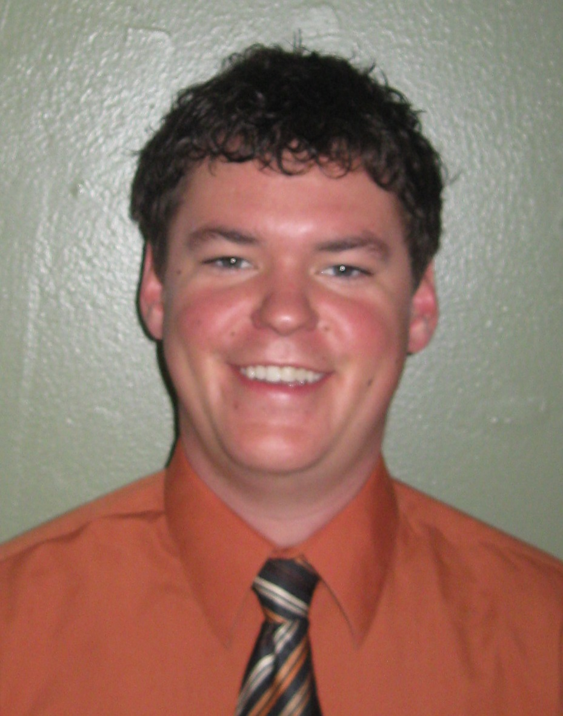
Brandon.Shelby@nebraska.gov
1324 S. 10th Street
Lincoln, NE. USA 68502
(402)314-8873
________________________________________________________________________
Objective
I am an enthusiastic young professional seeking employment teaching English in South Korea.

Education
Bachelor of Science Degree: Missouri State University, USA
- Comprehensive Major: Recreation & Leisure Studies with Therapeutic Emphasis, 2001-2006.
TESOL Certification 100 hour: International TESOL Teacher Training Center

Clinical Teaching Experience
Recreation Therapist July 2008 – Present
Beatrice State Developmental Center: Lincoln, Nebraska. USA
- Utilized an interdisciplinary team approach to support individuals with disabilities, in achieving meaningful leisure lifestyles.
- Instructed courses on the cognitive benefits of healthy living.
- Developed new and innovative community outreach programs.

Recreation Therapist April 2007 to July 2008
Research Psychiatric Center: Kansas City, Missouri. USA
- Utilized an interdisciplinary team approach to assess, plan, implement, and evaluate therapeutic recreation services to patients in an acute care psychiatric hospital.
- Instructed educational classes on effective communication in relation to mental health.

Student Volunteer December 2000 to December 2001
Sherwood Center School for the Exceptional Child: Kansas City, Missouri. USA
- Developed the skills and work ethic necessary to be an effective classroom leader.
- Assisted Teachers in educational services for children with autism.

Special Considerations / Skills
I’m a dedicated young professional with a strong foundation in private school education, an excellent rapport with coworkers, and the ambition to make a difference in people’s lives.

