Brendan M. Whitaker-Burke
361 West 36th Street
New York, NY 10018

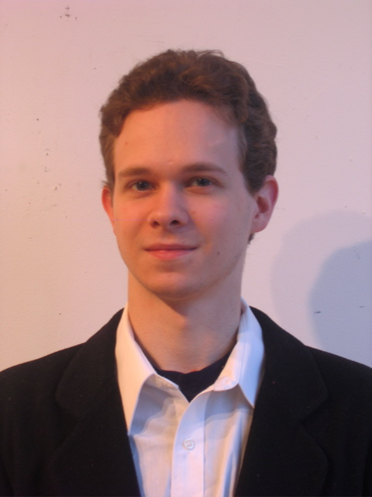
Phone: 917-882-9132
Email: brendanwburke@gmail.com

PERSONAL DETAILS
Date of Birth: December 10, 1984
Citizenship: American
Mother Tongue: English
Marital Status: Single
Health: Great

EDUCATION
Dec. 2008 Oxford Seminars New York, NY
TESOL/TESL/TEFL Certification

May 2007 Hunter College, City University of New York New York, NY
B.A. in English Literature

June 2002 Baruch College Campus High School New York, NY
Diploma with Regents Certification (A.P. English Literature, Score: 4/5)

EXPERIENCE
Jun 2008 – Oct.2008 Butler Hill Group New York, NY
Freelance Associate Data Annotator
- Analyzed the relevancy of internet queries on the Butler Hill Group’s online database. This required the assignment of ratings to each query appropriate to the level of accuracy of the site, based on the search terms given
- Communicated with team leaders concerning technical and administrative issues

Mar 2007 - Oct 2007 CATS East Side New York, NY
Administrative Assistant
- Participated in all duties relating to the operation of the front desk at a children’s athletic center
- Coordinated finances relating to the Bikram Yoga program

May 2006 – Aug 2006 Karen’s on Astor New York, NY
Barista
- Operated cash register, credit card machine and various stations in the store
- Prepared and served sandwiches, salads, soups, coffee, smoothies and shakes

May 2004 – Oct 2004 Seamless Web New York, NY
Data Entry Technician
- Entered and organized data on an internet-based system run from the company’s website

2001 – 2002 Golub Household New York, NY
Tutor/Child-Care Provider
- Supervised a twelve year-old regularly, picking up after school and participating in sports and recreation
- Tutored and assisted with homework

Jan – Jun 2000 World Hunger Year New York, NY
Jan – Aug 2001 Intern
- General office work including telephone calls and data entry
- Communicated with contacts by telephone, fax, and email regarding their information

June – July 2001 Il Cicolo degli Artisti Savona, Italy
June – July 2000 Stelle Cadenti Arts Festival Bassano in Taverina
Installation Assistant
- Assisted in construction of outdoor sculptural installation

June – Aug 1999 The Ovens Natural Park Nova Scotia, Canada
Assistant to Park Director
- Assisted in all campground and recreational activities

RELEVANT SKILLS AND EXPERIENCE
Travel: India, Canada, Italy
Interests: Guitar, electronic music production, online journal/blog

References
Available upon request.

