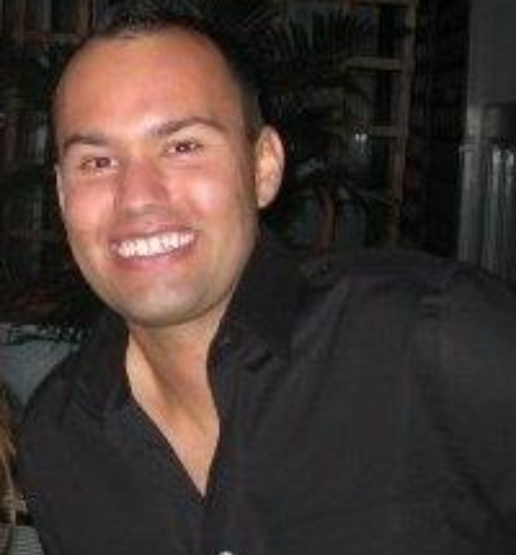

Brian Archuleta

Objective | To gain employment and complete an Associate Degree in Nursing program (I have one more class to complete) to augment my Bachelors of Science in Psychology with a minor in Sociology.
Experience | Guest Services  07/04-current United Supermarkets LLC, Amarillo, TX  - Volunteer coordinator for the store  - Extensive cash handling experience  - Daily constant interaction with the public  - Train new team members  - Ability to work in high pressure situations  - Ability to work in fast paced work settings  - Excellent oral and written communication skill  - Ability to work independently or as a team  - Bookkeeping experience
Cashier
06/03-06/04 Wild Oats, Boulder, CO
- Ring up customers purchases
- Extensive cash handling experience
- Certified cashier trainer
Guest Services
01/02-6/03 United Supermarkets LLC, Amarillo, TX
- Extensive cash handling experience
- Daily constant interaction with the public
- Train new team members
- Ability to work in high pressure situations
- Ability to work in fast paced work settings
- Excellent oral and written communication skill
- Ability to work independently or as a team
Education | Amarillo College, Amarillo, TX  01/10-present  - Currently enrolled in the ADN  West Texas A&M University, Canyon, TX  01/07-05/09  - Bachelors of Science in Psychology  - Minor in Sociology  West Texas A&M University, Canyon, TX  01/02-12/02  Colorado State University  09/99-12/01  Weld Central Jr./Sr. High School, Keenesburg, CO  01/97-05/99  - High School Diploma  - National Honor Society
Interests | After graduating from West Texas A&M in May of 2009 with a Bachelors in Psychology and a Minor in Sociology, I found my true interest and passion in the healthcare field. I decided to enroll in Amarillo College to work on a second degree. After completing all necessary requirements, I applied to the RN program and was accepted to the program. Nursing school is fascinating and I have more class to complete. I will be transferring to a college in the Houston area to finish my schooling. After obtaining my ADN, I would like to obtain a BSN then subsequently a MSN. Later on I would like to return to school also and get my Master’s degree in Psychology or Public Relations.
References | References are available on request.

