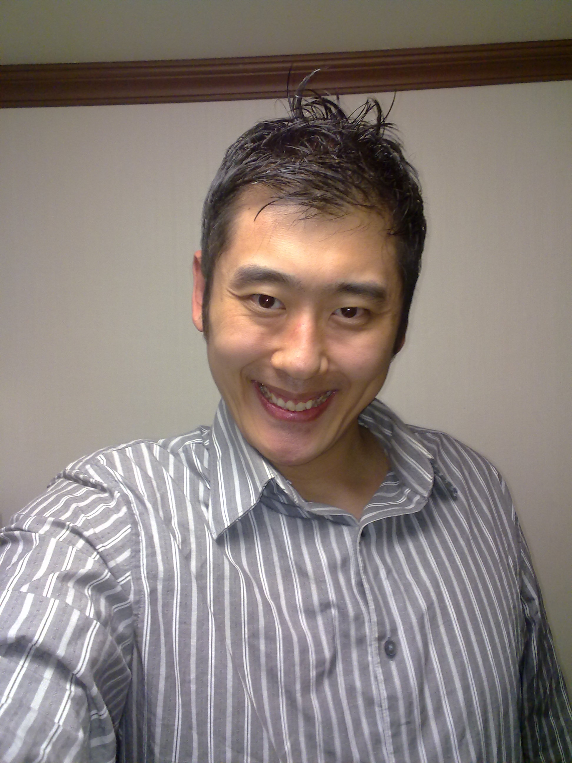

Brian So

240-237 Gongneung 2-dong Seoul, KR 139-800  Cell: (010) 8999-4097  soze40@gmail.com

EDUCATION The University of Texas at Austin

Aug. 2007 BA in Asian Studies ▪ Minor: Government

ACADEMIC Culture and Communication
PROJECT
May 2005 Conversational Chinese
- Gathered information about cultural history in order to have a better understanding of a foreign language.
- Collected data through conversation to conclude that knowledge of one's government helps to explain why they use certain words in their dialogue.
- Arranged research material to present the findings of the project in an oral demonstration to an audience.
May 2006 Politics of Regime Change

Classroom Debate
1 Participated in research to evaluate previous changes in government to prepare for a debate.
2 Developed outlines based on our individual deliberations to back our conclusion.
3 Shared statistical and correspondent information from our collective
study to persuade our classmates.

ADDITIONAL
Austin, TX Internal Tax Revenue Service, March 2007-March 2008
Tax Examiner
- Computed mathematical procedures to be inputted into the network.
- Documented errors in the computer program.
- Used templates to make corrections in concordance with the index.
Austin, TX Keystaff, March 2008-March 2009
Data Transcriber
- Found inaccuracies in forms brought in from the General Attorney's
office.
- Categorized mistakes in the database.
3 Compiled files into the system’s records.
Pohang, KR Prestige Arts Institute, March 2009-2010
ESL Instructor
1 Taught students how to read and write in English.
2 Prepared assignments and tests on the computer.
3 Gave evaluations on students’ progress.
Seoul, KR King's Point, March 2010-March 2011
ESL Instructor
- Went over materials in class with students to develop their knowledge of English.
- Made homework booklets to review what they learned in class.
- Checked students’ progress with tests.
Seoul, KR Dongyang Technical College October 2010-December 2010
ESL Instructor
1 Created lesson activities for students to comprehend information for
college credit.
2 Helped students hold discussions in different areas.
3 Developed tests for the students for grades.
Seoul, KR J.C. Hyun Patent and Law Firm December 2010-March 2011
ESL Instructor
1 Tutored a lawyer TOEFL comprehension and listening skills to
be used with clients.
- Talked about current events and translated them into English.
3 Went over conversation passages to be interpreted into common use.
Daejeon, KR Yoidea Times, March 2011-March 2012
ESL Instructor
1 Covered various topics with the students to build their understanding of
English.
2 Gave word tests to assess their familiarity of vocabulary words.
3 Monitored exams and graded essays to look for improvement.
Seoul, KR YBM, March 2012-current
- Covered passages in books with explanations in English to help
students understand vocabulary and meaning.
2. Went over listening exercises to work on comprehension.
3. Tutored an adult on how to speak English in a business
environment.

COMPUTER Proficient in Windows XP and Macintosh operating systems. Skilled in
SKILLS Microsoft Word, PowerPoint, Outlook, Excel, and Internet Research Tools.
Microsoft Office 2007 Specialist Certified Master through Certiport (Word,
Excel, PowerPoint, Outlook, and Access) 60 WPM, 6808 KPH Numeric.

LANGUAGES Conversational Korean

