Bryan C. Bendle

652 Meadow Lane (905) 637-4430
Burlington, ON, L7L 4R8 bryan.bendle@gmail.com

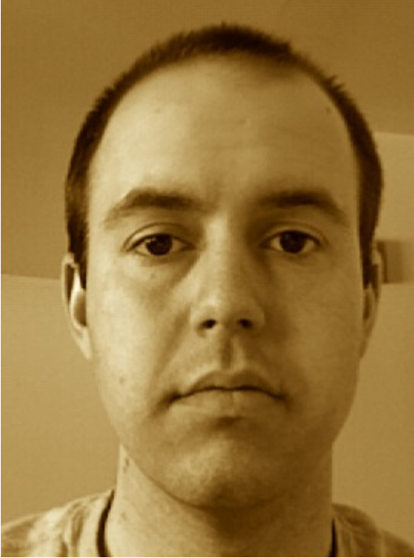
PERSONAL
Birth Canada, October 20, 1981
Citizenship Canadian
Mother Tongue English
Marital Status Single
Health Good

EDUCATION
2007 TESOL/TESL Certification
Oxford Seminars, Halifax, Nova Scotia, Canada
2004 Bachelor of Science, Advanced Chemistry
Dalhousie University, Halifax, Nova Scotia, Canada

EXPERIENCE
2007-2008 ESL Hogwan Teacher; kindergarten & elementary level
Sanbon, Gyeongi-do, iSouth Korea
2006-2007 Mathematics, science educator; grade 9 level
Halifax Regional School Board, Halifax, Nova Scotia, Canada
2006 Call centre supervisor/systems trainer
Statistics Canada, Toronto, Ontario, Canada
2005 Mathematics, chemistry educator; grade 10, 11 levels
Halifax Regional School Board, Halifax, Nova Scotia, Canada
2005 Mathematics, science educator; grade 9 level
Halifax Regional School Board, Halifax, Nova Scotia, Canada
2005 Camp counsellor, instructor, group leader
Camp Cobbossee, Augusta, Maine, USA
2004-2005 Residence Housing Assistant
University of Maine at Fort Kent, Fort Kent, Maine, USA
2004 EnviroTeam leader, tourism ambassador
Downtown Halifax Business Commission, Halifax, Nova Scotia, Canada

SKILL AREAS
Teaching experience with a variety of age and proficiency levels; excellent written and oral communication skills; creativity; patience; ability to work well with all types of people.

INTERNATIONAL TRAVEL EXPERIENCE
Canada, USA, England, France, Italy, Monaco, Vatican City, Korea, Philippines

REFERENCES & TRANSCRIPTS
Available upon request
Canadian Criminal Record Check
Copy of degree(s) & TESOL/TESL certification
Copy of Passport
Reference letters

