18824 SE 163rd ST Renton, WA, 98058 | Cell Phone: 206-755-9414  Home Phone: 425-228-5906  Email: barbeeb@cwu.edu
Bryden Barbee
Education | As of December 2009, I completed all of my credits for a B.A. degree in Japanese Broad Area. I am just waiting for my degree to arrive. I have experience living in Japan as I studied one year at Kyoto University of Foreign Studies from April 2008-April 2009. While living in Japan I worked and volunteered at local schools teaching English.
Experience | May 2009-September 2009 Grant County PUD  Grant County Lands and Recreation Crew  Was responsible for maintaining recreation areas owned by Grant County PUD along the Columbia River. Performed data collection of recreation site use, planted willow trees as part of a salmon habitat restoration project, fish counting,
June 2007-September 2007 King County Parks and Recreation South Ridge, SC
Parks Specialist II
Responsibilities and tasks included trail building, providing safe parks and fisheries to my assigned natural area, cleaning parks when necessary. Using tools such as chainsaws and lawnmowers to maintain the parks and natural areas.
August 2006-October 2006 Fry’s Electronics
Electronics Sales Associate
Responsibilities of this job included providing a strong knowledge of various software programs to customers, stocking and organizing shelves, problem solving.
December 2005-August 2006 All City Diner
Waiter/Cashier
Serve customers to the best of my ability. Was entrusted with counting the money from the tills as well as closing the restaurant at the end of the night.
Skills | - Can speak, read, and write Japanese proficiently  - Have computer software and hardware training  - Great organization skills  - Strong communication skills both written and oral  - Work well with others  - Proficient Computer skills including Microsoft Word and Excel  - Productive in high stress environment  - A punctual efficient worker
Volunteer Experience | I am currently a member of the Kittitas County Sanda City Relations Committee that plans events and cultural exchanges with Sanda City, Japan. The goal of the committee and is to facilitate relational growth between the two sister cities through public creative activities and public outreach.  I volunteered a place called Vine Maples in Maple Valley to help build homes for single mothers with limited income and their children.
References | 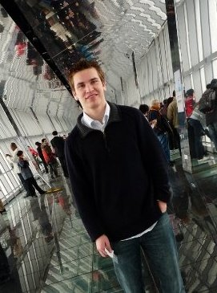  Available upon request.

