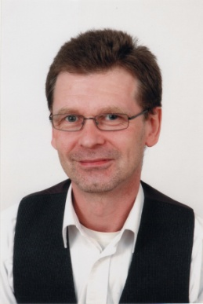
Charles Laine
178 Ribblesdale Road • London • SW16 6QY • UK
Email: charleslainelaine@hotmail.co.uk • Mobile/Cell: 07949437826

Birthday • 03/21/1964
Marital Status • Single
Nationality • British

Objective
I am a - recent university graduate with lots of life experience eager for the opportunity to develop my skills and knowledge as a teacher and explore an amazing country.
Education
University College London, London,
Bachelor of Science
•Major in History and Philosophy of Science
Teaching Related Experience
MC Hawthorne Education Services 2009
Provided Freelance Educational Services
- Teaching Physics and Mathematics
Home Education
- Provided home education for my daughter until she entered college
Training
- Teaching picture framers
Family
- Raised three children to independence
Work Experience
Laine Jewellery Commissions Since 1992
Private Jewellery commissions, making
- Tiaras, Rings, Choker, Earrings, Bracelets, A silver wand
U frame it, London 2003 – 2005
Independent picture framing business and art gallery, Store Manager
- Responsible for Customer Commissions
- Provide insight and support in the commissioning process
- Significantly increased revenue during commissioning process
- Manage full framing process
The London Picture Centre, London 1996 – 2003
Chain of independent picture framers and galleries, Chief Picture Framer
- Help in all aspects of the commission
- Frame pictures as per the commission specifications
- Manage the work of a team of 15 framers
Masters Wilkerson Manufacturing, London 1989 – 1991
Industrial picture framing business including a more specialised private commissions business, Mount cutter
- Second in command of mounting department
- Cut mounts for the commissions undertaken
- Bulk orders for larger department stores (Marks & Spencer, John Lewis)
Naylor and Root, London 1988 – 1989
Vauxhall / Opel Car Dealership
Technology Specialist
- Data Entry Clerk
- IBM systems specialist
Grayston Central Services, London 1985 – 1988
Scaffolding Company, Computer Operator
- Ran Batch file processes
- Managed the entire IT requirements of the company including automated billing, payrolls and data back up
Volunteer Experience
- Chair of school governors for four years
- School theatre lighting
Travel Experience
- Thailand - 1 month; USA - 2 weeks; Sicily - 2 weeks; Spain - 3 months; also visited Japan, Turkey, Canada, France
Awards/Certificates Received
2009
•Cambridge Celta
2008
•Physics Enhancement Course
2008
•BSc History and Philosophy of science
References
Available upon request

