Lee Hobson

5 Pickard Drive

Sheffield

Yorkshire

England

S13 8EW

To whom it may concern,

I am an enthusiastic, energetic person who is up for any task that lay ahead of me. I have proved my self in other positions to be a highly motivated, reliable, trustworthy individual, who can cope in a range of working conditions. This is all shown in my C.V.

During my time traveling I have experienced different challenges and situations; this alone gives me an advantage over others.

In summery other employers have stated that I am a dedicated individual who would be an asset to any team.

LEE HOBSON

CURRICULUM VITAE
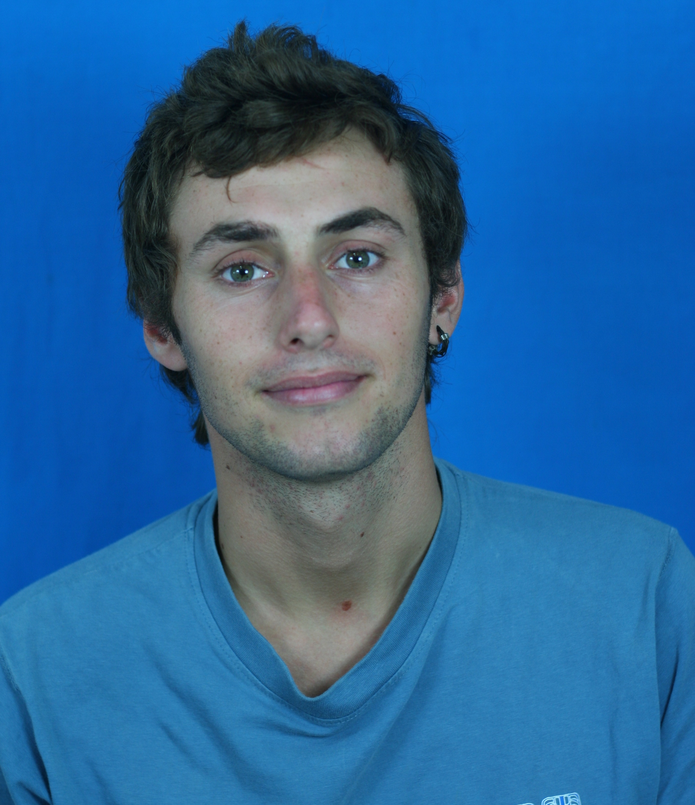
Name Lee Hobson (BSc)

D.O.B 5/8/85

Address 5 Pickard drive
Sheffield
England
S13 8EW

Education GRADE:
GCSE’s
English c
Maths c
Science (double award) c/c
German c
R.E c
D.T c
Art c
Humanities d
level
GNVQ Animal care 1
National cert Animal care 2
A level biology c

Animal science (hons) degree
80 hour TEFL course

Diving Open Water, 2006, Australia
Advance, 2007, Australia
Emergency Responder, 2007, Malaysia
Rescue diver, 2007, Malaysia
Divemaster, 2008, Malaysia
Open Water Instructor, 2008, Indonesia
Specialties completed: nitrox, deep, photography, wave’s tides and currents.

Employment

Employer Julies Kitchen
Kitchen hand
1999- Sep 2003
General food preparation and cleaning of kitchen area. Customer handling and cash handling. Till skills.

Employer White post farm
Yard worker
2003- July 2004
General care and maintenance of the animals on the farm. Management of activities. Customer handling.

Employer B n Q
Service desk
Oct 2004 – July 2005
General customer handling and care. Telesales and telephone skills. Handling refunds, Cash and till handling. Announcements to customers and staff.

Employer Crown Hotel
Bar tender
Sep 2005 – June 2006
General bar work, serving of drinks. Customer handling. Cash and till skills. Cashing up, locking and closing bar. Taking food orders and working in kitchen.

Employer Minster Veterinary Centre
Practice assistant
Sep 2005 – June 2006
General care and maintenance of the center. Cleaning of equipment and general facility

Employer Cressy station
Yard worker
Australia
Sep 2006 - Dec 2006
Mostly mustering cattle on a large station. Drafting, pregnancy testing, castrating, spaying and dehorning cattle within the herd. Yard work, tractor work and fence maintenance.

Employer Fruit picking
Australia
Picking, packing and shipping of different fruit and vegetables.

Employer Billabong Scuba
Dive Master
Malaysia
Sep 09 – Dec 07
Caring for customers at different levels of diving abilities. Guiding around living area and dive sites. Looking after and caring for dive equipment. Making sure all equipment and customers are on boat and are ready to dive. Teaching locals about the reef and how to care for it.

Employer Officers Club
Stock taker
Dec 07 – May 08
Monitoring stock that came in and out of the officers club. Making sure that stock was out on shop floor and taking part in annual stock takes.

Employer Billabong Scuba
Dive Master
Malaysia
Aug 08 – Nov 08
Caring for customers at different levels of diving abilities. Guiding around living area and dive sites. Looking after and caring for dive equipment. Making sure all equipment and customers are on boat and are ready to dive. Teaching locals about the reef and showing them how to preserve it.
Employer Billabong Scuba
Instructor
Malaysia
Dec 08 – May 09
Teaching new divers how to dive. The other roles are the same as above.
Work Experience

Work placement Bottom farm

Helping out during the lambing period. Helped with the pregnancy. Feeding orphaned lambs.

Work placement Brackenhurst Dairy farm

Helped out during the three daily milking sessions. Cleaning and general maintenance of facility. Helping out during pregnancy. Feeding calves.
`
Work placement Shamwari International conservation program
South Africa
Working with field guides at Shamwari game reserve, helping out at born free. Game capture and release. Predator identification program. Placing collars and using tracking devises. Tracking, monitoring and translocating animals. Working with veterinary practice. Local education program. Plant invader and erosion control.

Work placement Nairobi animal orphanage
Kenya
I cared for the animals within the orphanage. During my time there I was able to hand rear cheetah cubs and hyena cubs. I was involved in daily taking blood samples from a 1 year old lion. I also was involved with the enrichment programs, for the apes, monkeys and cheetahs.

Work placement Elephant Trans location
Kenya
Working with KWS (Kenya wildlife service) with the translocation of elephants from Shimba Hills to Tsavo. My main duties where to monitor the sedated elephants, collect samples from the sedated elephants and sampling them in the field laboratory. Preparing the drugs which where used on the elephants.

Work placement Friends of Thailand
Thailand
General care and maintenance of the animals within the sanctuary. I was involved with the enrichment program within the sanctuary. I also helped with the castrating and spaying of feral cats and dogs within the area.
Referees

Sarah Bottom
Nottingham Trent University
Southwell
Nottingham
Nottinghamshire
NG1 4BU
+44 (0115) 9418418

Jackie Smith
Minster Veterinary centre
Orchard lodge
Southwell
Nottingham
Nottinghamshire
NG25 0ES
+ 44 (01636) 812133
jackie.day01@gmail.com

