Cell phone : 01028917849
email: lidiya_85@mail.ru
Linda Larina
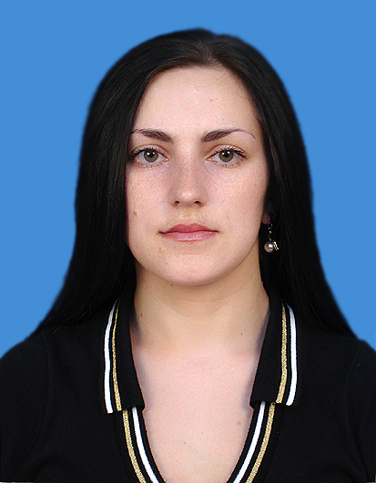

Summary of qualifications
A highly creative, goal-oriented professional with development experience. Demonstrated experience in educational program design and planning, including specialized training courses. Sound knowledge of Australian and American educational system including accreditation and certification procedures, contemporary designs for curriculum development, etc. Knowledge of international educational programs. A team player, effectively working in multinational environment. Good communication skills. Advanced computer skills, including developing teaching and assessment applications for educational purposes.
Professional Experience
Reliable, enthusiastic and motivated teacher, who is able to communicate effectively with students, experienced of teaching English for about 3 years to the different age rank of students beginning from kids to adults. Confident and motivated to bring out the best learning abilities of the students.
Experience
Secondary School, Uzbekistan – 2 years (students of 10-15 years old)
Tutoring, Uzbekistan – 1 year (students of 14-20 years old)

Willy Campus, Seoul – 3 months (students of 5-12 years old)
Education
- 1991-2002 Secondary School – high school diploma
- 2002-2003/2005-2006 World Languages University in Tashkent
- 2004 Charles Darwin University in Australia, diploma (philology)

