Dear Sir/Madam

Please accept my application for the ESL Teacher position. A completed application form and a copy of my resume are enclosed for your consideration

In 2006 I completed hotel management major at Pacific International Hotel Management School. This course has provided me with the knowledge and experience to be effective in a service role. For example, I have gained a sound understanding of, and practice in, a wide range of accounting, business administration, and marketing etc.

Along with having the relevant knowledge and experience for this position, I believe that I also possess the key personal qualities, which will enable me to contribute successfully. I am a highly self-motivated individual. Time management and organizational skills have been well developed during my time in tertiary education, and I have consistently completed high quality work under pressure. Further my work experience has given me the opportunity to develop strong interpersonal and communication skills.

I would value the opportunity to undertake a challenging role. Thank you for your consideration and I look forward to hearing from you.

Yours Sincerely

Jae-Hoon (Jeff) Kim

Curriculum Vitae

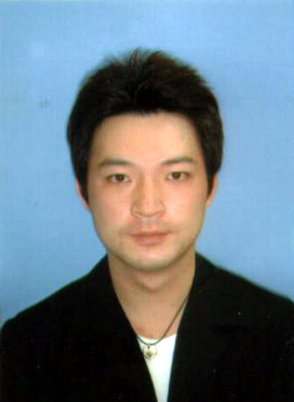

Jae-Hoon (Jeff) Kim

Phone No: 010-8100-8005

E-mail: jh_kim0323@hotmail.com

Curriculum Vitae

PERSONAL INFORMATION

Name: Jae-Hoon (Jeff) Kim
Postal Address: 302 / 222-68 Gui Dong, Seoul, S.Korea
Telephone: 010-8100-8005
E-mail Address: jh_kim0323@hotmail.com
Residency: New Zealand Citizen

CAREER OBJECTIVE

To obtain the position to extend my career.

WORKING EXPERIENCE

- 2008~ ESL Teacher
Child U Academy
Gu-Ri, S.Korea

- 2008~2008 ESL Teacher
Queens Academy
Auckland

- 2007~2008 Assistant of Operation Director / Property Manager
Kiwi International Airport Hotel / Prince Corporation Ltd
Auckland

2006~2007 Front Office
Waipuna Hotel
Auckland

- 2002~2005 Food and beverage Manager
Shochiku Japanese restaurant
Auckland

SPECIFIC SKILLS AND STRENGTHS

- Languages Spoken/ Written: English, Korean and Japanese
- Effective and patient in dealing with problems
- Dedicated and highly motivated
- Very organized and able to maintain a high workload
- Adapt to new environments and people easily
- Honest and totally reliable
- Energetic and goal orientated
- Keen on learning new knowledge and fast learner

EDUCATION

  - Pacific International Hotel Management School (2001-2006)
Advanced Diploma of Hotel Management
Major in Hotel Management

  - Auckland University of Technology (2004-2005)
Certificate of Japanese

  - Queens Academy (2008)
Certificate of TESOL

INTERESTS

- Traveling
- Sports
- Socializing with friend

REFEREES

Jin Operation Director
Kiwi International Airport Hotel
150 Mckenzie Rd
+64 9 256 0597

Trevor Todd Operations Manager
Pacific International Management School
+64 6 755-0025

Dong-won Back Shochiku Restaurant Director
460 Queen St. Auckland
+82 119014387

Leigh Payne General Manager
Kiwi International Airport Hotel
150 Mckenzie Rd
+64 9 256 0597

