 | Temay Rigzin  Phone: 010 4952 2035  E-mail: temayr@gmail.com  Address: 101-1501, Hangang Daewoo Trump World III,  65-230 Hangangno-3ga, Yongsan-gu, Seoul | 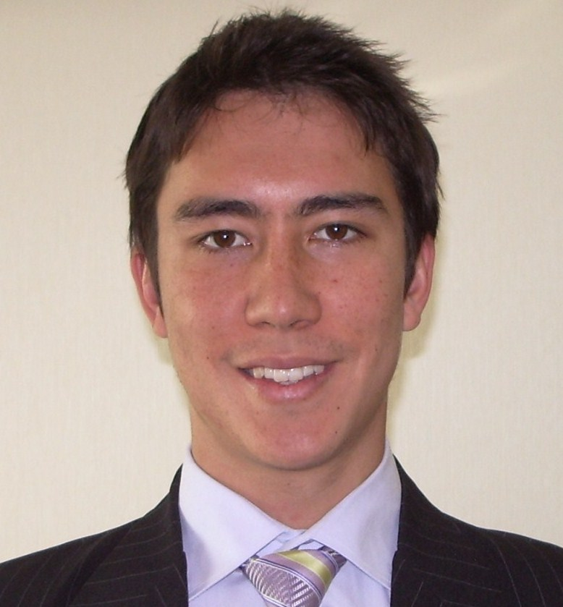

Introduction
I am an Australian, native English-speaker. I currently live in Seoul as the spouse of an Australian Government diplomat. I would be happy to teach English to adults and children at any level in Seoul.
I do not need travel, accommodation or insurance expenses from an employer, because I already live in Seoul. I am available from mid-February, for three months. I can be flexible to meet an employer’s short-term needs. As I am the spouse of an Australian Government diplomat, I require employment permission from the Korean Ministry of Foreign Affairs and Trade, but not a visa.
Education
Bachelor of Commerce (Honors, economics), University of Melbourne (2001-2005)
- First place 2005, economic honors students
- First place 2004, bachelor of commerce students
- Deans honors list (top 3 per cent of students ) 2001, 2002, bachelor of commerce students
Experience
Economic Policy Analyst (February 2006 – November 2008)
Australian Government Department of Treasury (Canberra, Australia)
As a policy analyst I prepared detailed advice to Australian Government Ministers on a range of issues, including the Commonwealth Budget, industry policy and climate change. This position involved working closely with senior management, coordination of policy products (15 people) and managing contracts with consultants (valued in excess of A$100k).
University Tutor (February 2005 – June 2005)
University of Melbourne (Melbourne, Australia)
In this position I led macroeconomics tutorials for the University of Melbourne, working in close contact with the university professor. I taught three classes, of 20 university each, including marking assignments and exams. In this position I developed skills for effective classroom communication and explaining difficult concepts to students.
Private Tutor (various, 2003 – 2005
Various (Melbourne, Australia)
During my university studies I tutored primary and high school students part time. I taught a range of studies, including English (ESL), mathematics, economics and accounting.

