GREEN Carolyn 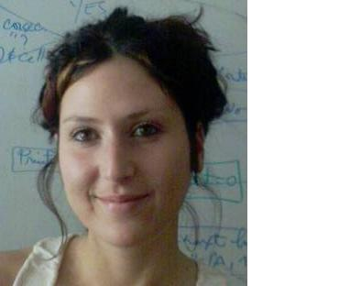
73 Ayr Road
Newton Mearns
Glasgow
G77 6qu

phone :  Email : | 00447533901527/0044141 639 3597  carolynkategreen@hotmail.com
Date of birth :  Marital status:  Citizenship : | May 10th 1982  Single  British.

Clinical experience
Victoria Hospital:
Caseload – Voice/Adult neurology/head and neck cancer.
Duration: 8 weeks

Community learning disabilities team:
Caseload - Adults with learning disabilities
Duration: 8 weeks

Community based team:
Caseload – Mixed: Paediatric special needs and adult mental health
Duration: 7 weeks

Community based clinic:
Caseload – Mixed paediatric
Duration: 12 weeks

Employment

Jan 2008 –
November 2008 Three Mobile Phones, Glasgow, Scotland
Position: sales advisor
Working in a highly targeted sales environment I was responsible for promoting the company’s products and
maintaining a high sales record.

July 2008- University of Nebeul, Tunisia (summer position)
September 2008 Position: English teacher
During this time I held communication workshops for the university students, as well as holding events and activities to
promote the use of the English language.

June 2007-October 2007 |  | Berlitz Language School: Ave Louise, Belgium  Position: English Teacher:  I was responsible for teaching English to students aged 16 +who had varying levels of both spoken and written language abilities as well as different learning styles. I was required to maintain a teaching style unique to the Berlitz school focusing on the total immersion of the English language. Duties included developing creative and interesting ways to teach new vocabulary and grammar in an engaging, interactive and practical manner, designing lessons that were focused on the student’s interests and learning needs, and meticulous record keeping.

Oct 2005-June 2007 |  | One Call Direct, Glasgow, Scotland  Position: Sales advisor  One Call direct are an outsourcing company and generate sales for many leading organisations. As part of the team I am constantly working towards sales targets, and finding new and creative ways to sell a wide range of products.
May 2005- Sept 2005 |  | Morgan & Stanley bank Glasgow, Scotland  Position: Collections advisor  I was responsible for educating cardholders and assisting in bringing their accounts up to date. Duties included:  ◊Call handling  ◊Providing information whilst maintaining an assertive yet professional and friendly manner.  ◊Consistently working towards my own personal and company targets
Jan 2004-Nov 2004 |  | Royal Bank of Scotland – Sales & services advisor- Glasgow, Scotland  As an advisor for the Royal Bank of Scotland, I was responsible for ensuring a high level of customer satisfaction. I learnt of my ability to sell well and this was evident in the consistent reaching of high sales targets.  ◊handling customer complaints and promoting new products.  ◊representing the company and maintaining an equilibrium between its needs and that of its customers.
1999-2000 |  | Parklands Country Club  Sports Club Secretary  I was the first point of contact for the member. Whilst conducting tours of the club for visitors I explained its facilities. Acting as the mediator between the visitors and the management I organized appointments where both could meet and discuss membership further.  I learned to work under pressure whilst always providing the best service possible for the clients, and reaching targets in face to face selling.

Education

2005-2009 Bsc Honours Speech and Language pathology – Second class upper division

2000-2003 | BA Honours Social Anthropology – Second class lower division
1994-2000 | Scottish Higher Grades- A,A,A,B,C

Languages

- English : Native
- Spanish : Conversational
- French: Beginner

Other

- Member of The Royal College for Speech and Language Therapists (RCSLT)
- Certificate in Total Communication

Additional information

- Driving license
- References available on request

