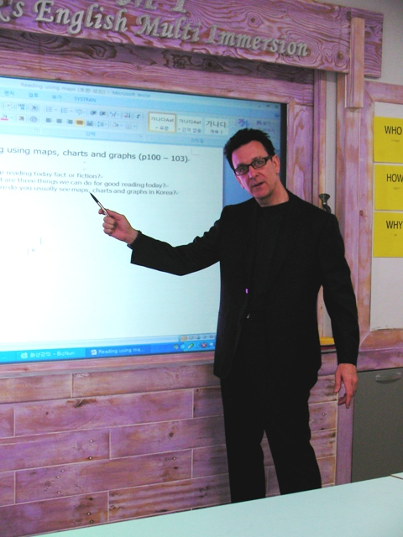
“Enrich students with excellent English language”

Stephen Brian Gee
c/o Buksung Elementary School
203 – 7 Street
Masan-Si
Gyoungsangnamdo
South Korea 603-012 Tel ~ 010-4038-4222 Email : stephen1302@gmail.com

Educational Achievements

- Post Graduate Diploma of Teaching ~ University of Technology, Auckland, New Zealand, 2002.
- Bachelor of Social Science Degree (A average) ~ Waikato University, New Zealand, 1984.
- Post Graduate Certificate in Men’s Health ~ Curtin University, Perth, Western Australia, 2000.
- Master of Education Degree Certificates ~ Waikato University, New Zealand 1986. Group-work & Program Design, Counselling Skills, Counselling Theory.
- TEFOL Certificate – International College of Applied Linguistics 2004
- Portfolio of Technical College Certificates in Communications and Human Relations Hawkes Bay Community College, New Zealand 1982 – 84.
- Certificates in Training and Group-work, Communication Skills and Family Systems therapy, Auckland Training Institutes, 1987 – 92.

Relevant experience.

- English Teacher – Recent prize winner for excellence amongst EPIK teachers nationally. 6 years fulltime including senior teacher at Sogang University Language Program,
Seohae Sahmyook Elementary and recently Gyoungsangnamdo Office of Education.
During that time I have enjoyed coaching students from age 5 – 18 and other teachers towards winning local speech contests. I have successfully revamped and fully referenced 2 faculty rooms education resources, and decorated 2 entire schools with educational displays whilst introducing powerful new multi~media learning software and classroom methods.
I have experience in teaching English as a second language through Maths, Science, Art, Music, Physical Education and Social Studies.
- Valued by many students, staff and parents as encouraging, disciplined, fun and engaging, effective.

- Probation Officer – Department of Corrections for 1 year. Senior Officer’s caseload within first 3 months. Routinely giving sentencing reports to District Court Judges within very tight deadlines after interviewing criminals and their affiliates. Training to performance level in systems software use and interviewing technique 2 new Officers. Ran a monthly rehabilitation group for ex-offenders.
- Sharp motivational, assessment, evaluation and report writing skills.
- Working with a large caseload under tight deadlines.

- Rehabilitation Therapist – 1 year. Paremoremo prison. Delivering education and therapeutic group-work. Conducting extensive interviews and psychometric testing to produce evaluation reports for parole and treatment.
- Working safely in very stressful group situations. Rapidly making complex ethical decisions. Liaising with wide range of professionals to write balanced comprehensive reports.

- Group Counsellor – 2 years. Man Alive. Managing education and therapy groups for men sentenced by local Courts. Teaching wide variety of stress management and communication skills. Training 4 novice counsellors to service level.
- Using wide range of teaching methods from intense 1-1 structured interviews to action methods in group-work. Valuable experience ensuring the learning environment is safe and challenging.

- Mental Health Trainer – 18 months. Auckland Healthcare. Designed, delivered and evaluated 3~day educational workshops and 12 week long courses on psychological and social care of mental health clients. Wide ranging students – from first time care assistants through to experienced psychiatrists.
- Effectively planning, teaching and assessing at different levels.

- Community Mental Health Social Worker – Auckland Healthcare. 4 years designing and delivering life skills programs to mental health clients. Working with clients, families, allied health professionals and advocacy groups.
- Rapidly designing effective education programs - still used in therapeutic communities in New Zealand.

- Group Counsellor – 18 months. Anglican Social Services. Delivering educational group-work for men on community based sentences for the Department of Corrections. Successfully trained 3 novice counsellors to full operational level.
- Effectively overseeing program design, delivery, evaluation and redesign.

- Home Manager – Presbyterian Support Services and Haven Trust. 5 years.
Initially designed, then managed 2 community homes for 20 people with wide variety of disabilities who had previously lived for many years in hospitals.
- Successfully coaching residents to run the home and surrounding gardens independently. Then to provide outreach services to other people with disabilities in the local community.

References

Professor Alan Wescoat – 경남정보대학
부산광역시 사상구 주례2동 167
513 International Tourism Building
Tel: 010-9551-2083 E mail: alanwescoat@yahoo.com

Mrs Nam Guem Rang - Principal, Seohae Sahmyook Elementary School,
Gwangcheon Eup. Hongseong Gun, ChungNam.
Tel: 011 9763 0801 E mail: minrang@hanmail.net

