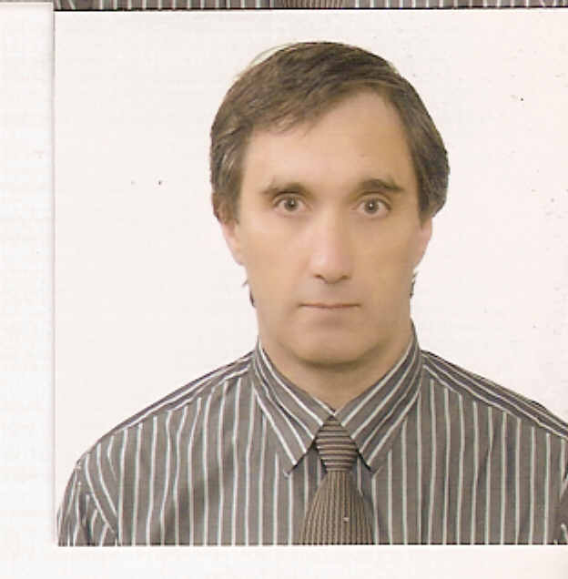
October 2009

Lee Joseph Drappier.
B.Sc. degree from Auckland University 1975.
Teacher’s Cert, expired 12/2007, Queensland, Australia.
Phone N.Z. + 64 9 4308332 Email: lee44eng@yahoo.com
Unit 2, 19 Third Avenue, The Avenues, Whangarei, N.Z.
Joseph

Employment:
Public Middle and Elementary Schools (4years)
2005/9/1 - 2009/8/31 English teacher with Jeju Provincial Office of Education
EPIK teacher (English Program in Korea) started 1 Sept 2005.

Korean academies teaching jobs:
From 2001- 2005, I worked at various academies in Korea: Ulsan, Sangju, Juchon.
I also worked in Saudi Arabia for 6 months in 2003.
Other Jobs
Clerk NZ 1998-2001
Real Estate Sales NZ95-98
Day Relief Teaching NZ: 1989-94
Middle school English Teacher in Hanasaki, Saitama, Japan 1988 (1 year)
Computer Programmer NZ 1985-1987

N.Z. Teacher: 1979-1984
I worked in secondary schools in N.Z. (4-5 years) as a math teacher.
D.O.B 18/01/53
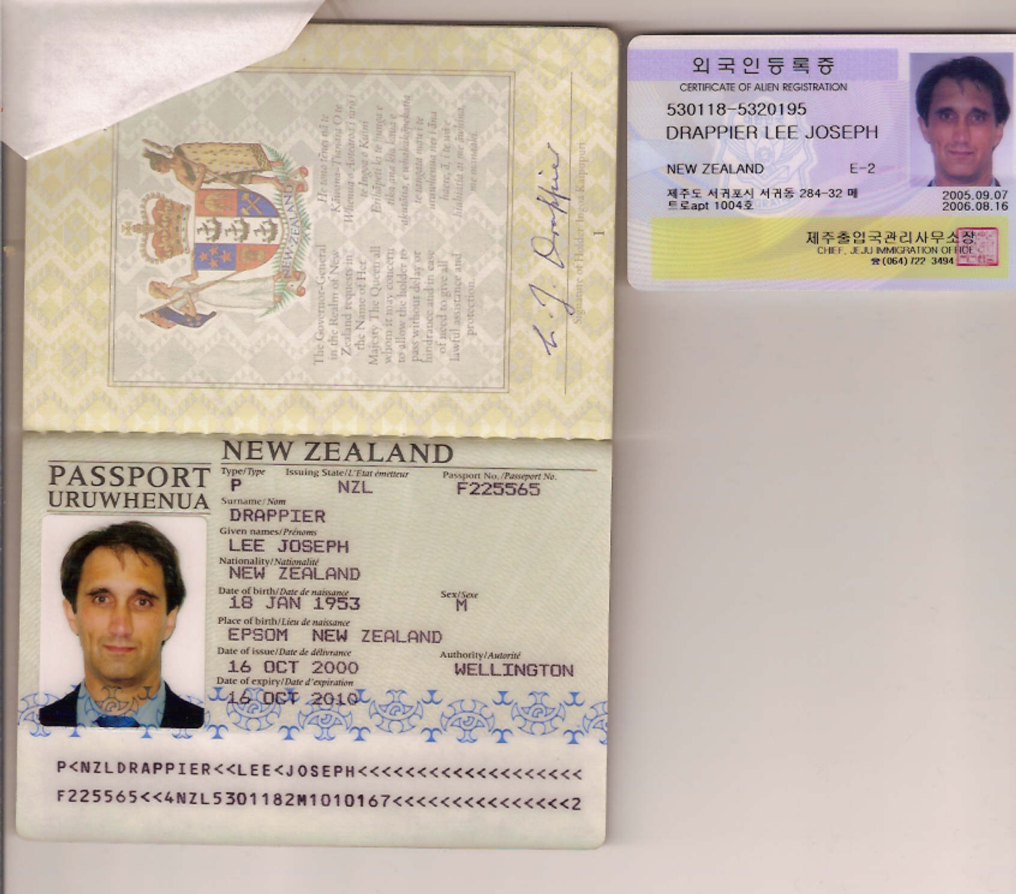 NZ Passport 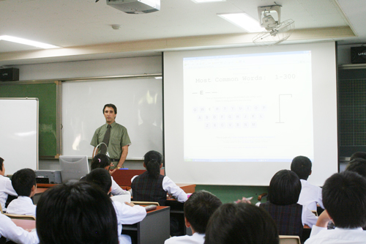 Middle School

Available: 1 October 2009.
Apostil CRC, transcripts, degree ready.

