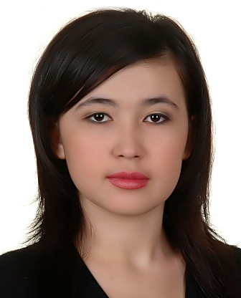
Lobar Nadjimova
Name: | Lobar Nadjimova
Address: | Room 218, Nuri Hall, 3-10, Doryong-dong, Yuseong-gu, Daejeon, South Korea, 305-340
Telephone: | +82-10-7710-7083 (mobile)
Email: | lobar_missEva@yahoo.com

OBJECTIVE

I want to find part-time job because I am a student in South Korea, Daejeon (Solbridge International school of Business MBA, Woosong University), so I must earn money for my living expenses and I want to face with Korean people and be closer with them, to find friends, knowing about Korean culture.

PERSONAL INFORMATION

Gender: Female

Date & place of birth: 13 August 1984. Tashkent, Uzbekistan

Marital status: Single

EDUCATION

September 2000 to Academic Lyceum of Foreign Language , Tashkent,
Uzbekistan
June 2003 Major in Foreign language Philology, Guide

September 2003 to Tashkent State Technical University, Tashkent, Uzbekistan
June 2007 International Marketing & Finance

September 2008 to Solbridge International School of Business (Woosong
University), MBA, Daejeon, South Korea
June 2010 Major in Business Management and Marketing

WORK EXPERIENCE:

August 2006 to “Reyhan TIL” Company
2006 November POSITION: Office manager
RESPONSIBILITIES:
- Database Administrator
- Calls, faxing, reporting information
- Organizing duties

April 2004 to Tashkent International Airport
October 2004 POSITION: IBM Operator
- Cargo service
- Report information
- Handling cargo reservation

October 2003 to Uzbek “Navoi” Theatre
April 2004 POSITION: Controller
RESPONSIBILITIES:
- ticketing

Language &
IT proficiency: Uzbek – native, English – excellent,
Russian – excellent, Korean – Basic.

PC knowledge, Internet explorer, MS Suite.

Hobbies: swimming, listening music, tennis, chess, collect coins.

SUMMARY OF SKILLS:

- Ambitious and hardworking, with commitment to excellence
- Friendly with positive attitude
- Good listener with outgoing
- Effective communication both written and verbal
- Excellent customer service and client retention standard
- Willing to assume high level of responsibility

Reference is available upon request.

Dear Sir / Madam

Please find my enclosed resume of my job history and academic qualification. It will furnish you with information related my experience and abilities. I am a firm believer in the “Hands on” type of operation with a focus on setting-up, motivating, and improving service standards. In addition I support the utilization of all team members’ contribution. You will find me to be an honest and dedicated addition to your team.

I am happy to discuss at any time how I might be of future service to your Company.
You may reach me on my mobile: +998 97 4667377

Thank you for your consideration

Respectfully Yours,

Lobar Nadjimova

