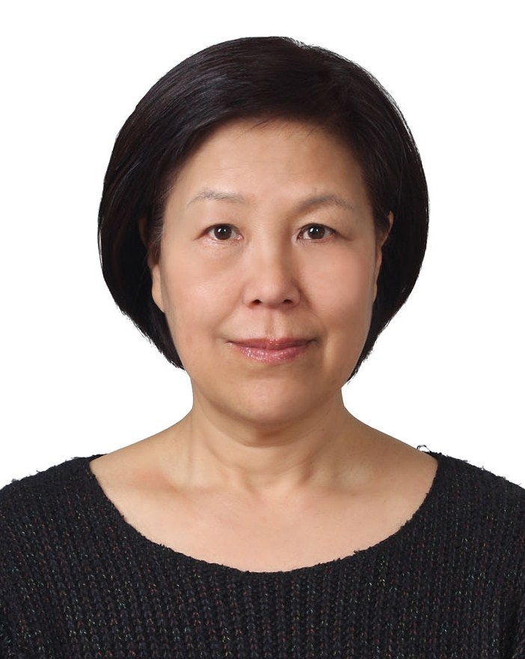
Michelle Morrison

Permanent Address: 2285 Polyview Drive Turlock, Ca. 95823
Current Address: 334-19 Mapo-ku, Seokyo-dong, Seoul, Korea
121-836
E-mail address: myungshinlee@live.com
Cell: +82-010-3575-1952 F4 VISA Holder

EDUCATION
2009—2010 Study Abroad to South Korea at Yonsei University
2007—Present CSU Stanislaus, Turlock, Calif. Grad School History/East Asia Studies
2003—2007 CSU Stanislaus, Turlock, Calif. History
2000—2003 Merced College, Merced Calif. Liberal Arts

WORK EXPERIENCE

2010 Seoul Foreign School – Substitute Teacher

2000 - 2009 Self employed and part-time works

2007—2008
Project Specialist
Stanislaus County Child Support Division, Modesto, Calif.

1999—2000
Parent Advocate
Challenged Family Resource Center, Merced, Calif.
Nonprofit County Agency

1994—1999
Project Coordinator
Blue Magic Products Inc., Stockton, Calif.

1989—1991
Grossman’s Warehouse, Ventura, Calif.
Internal Auditor/System’s Administrator

1988—1989
Applause Inc. Woodland Hill, Calif.
Senior Adminstrator

Volunteer Activities & Others
Job coach for disable children and adults.
Member of historical honor societies
- Alpha Gamma Sigma & Phi Theta Kappa honor society, Officer/Historian.
- 2005-2009 Phi Alpha Theta (PAT) Alpha Epsilon Lambda Chapter Officer/Historian
- Awarded honor society scholarship. Trained in leadership classes and TA for those classes.
Volunteer works in Korea (2009-2010)
Member of Seoul International Women's Association (SIWA)
- SIWA & Diplomatic-Community Bazaar for a Global Cultural Experience major fundraising event – In charge of translation
- Assist Bazaar Committee.

Member of American Women's Club of Korea (AWC)
- Got English Coordinator – Gale International Korea (GIK) is supporting underprivileged children in Incheon by sponsoring a monthly Play Day at after-school centers. These are the children who are not fortunate enough to attend academies or receive tutoring. Yet they are Korea’s citizens of tomorrow who will be expected to thrive in a global environment. This program is designed to give exposure to the children to native English speakers.
- Hello Friends participant – Hello Friends sends volunteers to visit schools throughout Korea and introduce English to young schoolchildren. This program is designed to give a wonderful opportunity to visit elementary schools in rural areas and meet some unforettable kids. It is supported by the Korean government’s efforts to promote early English language training nation-wide, because children outside the capital city have little or no exposure to authentic English that introduces native English speakers into provincial classrooms in the rural elementary school children.
- Charity Fashion Show – Model for the Second Hand Rose AWC Annual Fashio Show for 2009 & 2010.

G-20 SEOUL SUMMIT (제5차 G20 서울 정상회의)
- G20 Summit Foreign Language Interviewer for Seoul Volunteer Center
- Scheduled to Serve as volunteer for G20 Summit Seoul (November 8 – Nobember 12)
English Camp for Helping Others Prosper Through English (H.O.P.E.), a non-profit organization
- HOPE Summer English Camp – first summer camp of English tutoring in Haeryong Elementary School in Suncheon, South Jeolla Province.
This program is also designed to serve many disadvanted children in rural elementary schools for their English training by introducing a group of native speakers for the camp.

Itaewon/Hannam Global Village Center
- Teaching English for Underprivledged Children
Teach an English class for children at study rooms at “One Household Village School” in Yongsan area.

Seoul Volunteer Center
- 2010 Symposium on International Volunteering
- Joint event with Gangnam Volunteer Center - Global Tour Project (9/11 Eco-Voluntour)

Citizens’ Institutre Environmental Studies (CIES)
- Antarctica Environment advocacy
- ECO Study

Member of Association for Teachers of English in Korea (ATEK)

