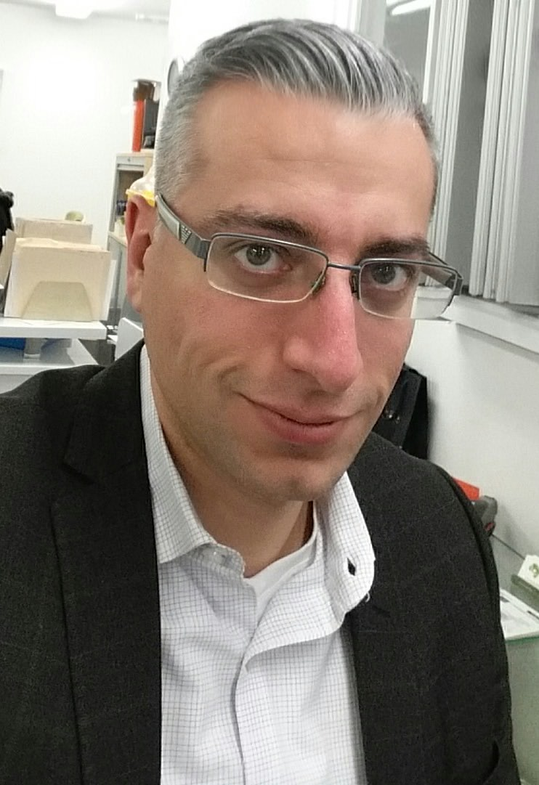
Ralph Tohme
2322 Bourgoin
Montreal, Quebec
H4R 1M9
Telephone: 1-514-240-3494 / e-mail: tohme.ralph@gmail.com

EDUCATION
End Date: 2002 Vanier College, Mtl, Quebec Health Science, Diploma of College Studies (DCS)

End Date: 2005 Concordia University, Mtl, Quebec BSc Exercise Science

In the process: TEFL 120 hours (electronic certificate available)

POST GRADUATE TRAINING
End date: 2014 Centre Osteopathie du Quebec.
Diploma of Osteopathy D.O.

EMPLOYEMENT
2005-….. Urgence Physiotherapy
Management
Treatment in osteopathy

2014-…. CSI (Canadian Securities Institute)
Invigilator

PERSONAL DATA

DATE OF BIRTH:

- February 28, 1981

LANGUAGES
- English
- French
- Spanish (intermediate)
- German (beginner)

MARITAL STATUS
- Married

OTHER ACTIVITIES/ INTERESTS

Since 2007, I have volunteered for an average of 70 hours a month to teach the Bible in English to adults as well as to children. This is something that is close to my heart and it has taught me valuable skills like patience, compassion, adaptability, and forethought.

This experience has also taught me that understanding the material is the key to progression. Teaching brings me great satisfaction and seeing the student progress gives me a sense of accomplishment that I have not found in any other field.

