Dr. Jorge E. Garcia
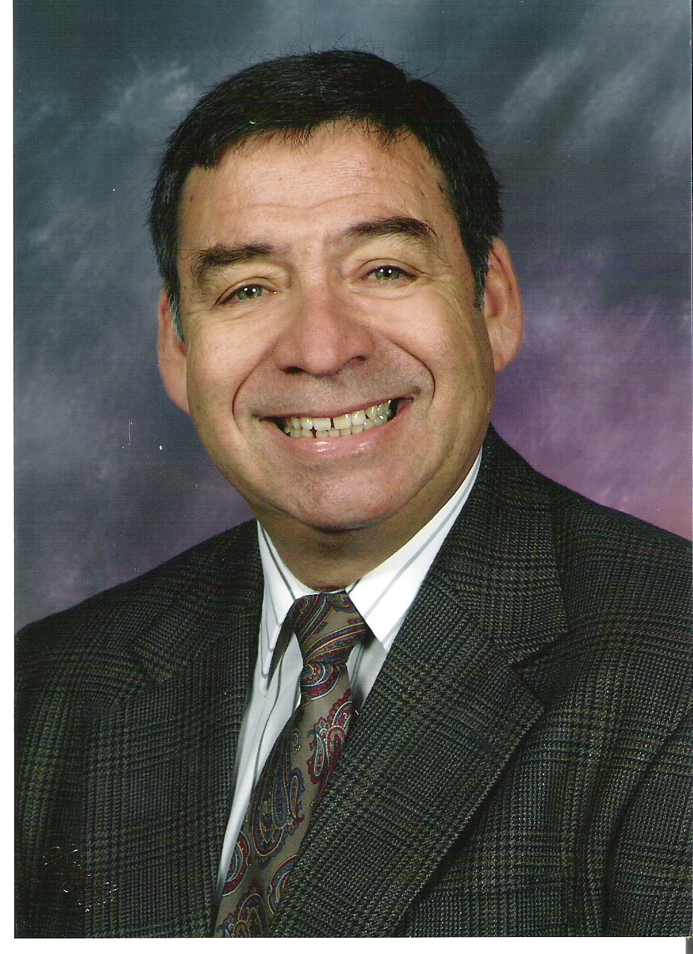
9324 Robinson Lane
Corona, California 92883
United States of America

+1 951 277-8530 (home) +1 951 314-3895 (mobile) tuba66@gmail.com

CONDUCTOR • COMPOSER • LECTURER

Guest Lecturer ♦ Contributing Author ♦ Editor ♦ Teacher

I have successfully taught Music, English, and Social Science on all educational levels from kindergarten to college/university in both public and private educational institutions. I speak fluent Spanish. I have served as principal, assistant principal, dean, and director of activities on the high school level. I have served on many committees including mentor teaching, curriculum revision, school site councils, and accreditation. I was founder and president (CEO) of the American Drum Line Association, a 401c3 organization. I am a published composer for Talent Music Company.

AREAS OF EXPERTISE
Curriculum Development  Mentoring  Staff Development  Extra Curricular Activities Management | Fund Raising  Business Management  Cooperative Education Consulting  Classroom Management Consulting
PROFESSIONAL DEVELOPMENT
California Standard Secondary Teaching Credential

Doctor of Music Education
University of Southern California/Canyon College

Master of Education
Azusa Pacific University
Azusa, California

Bachelor of Music and English
Westmont College
Santa Barbara, California

PROFESSIONAL EXPERIENCE & ACHIEVEMENTS
Instructor of English as a second language – Hope International University.
Instructor of Chinese School Administrators

Student Teacher Supervisor – University of Southern California.

Mentor for Master and Doctoral Programs - Crossroads University

Guest Lecturer, University of Southern California

Instructor of English as a second language - United States Information Services, Taiwan
Coordinated Adult classes

HONORS AND PUBLICATIONS
President of All American Association of Contest Judges

President-Emeritus American Drum Line Association

Percussion Editor, “World of Pageantry” Magazine

Contributing Author, “Let’s Cheer” Magazine

Guest Lecturer, “Motivation in the Classroom,”
Lutheran Schools, Southern California and Taiwan

Panel discussion participant
American Guild of English Handbell Ringers National Symposium, 2005

Panel discussion participant - International Handbell symposium, 2006, Brisbane, Australia

Presenter, International Conference on Lifelong Learning, Pecs, Hungary, 2007

Presenter, International Conference on Lifelong Learning,
Vancouver, British Columbia, Canada, 2009.

